Green Lifestyles Alternative Models &

Up-scaling Regional Sustainability/ GLAMURS

WORK PACKAGE 2: Knowledge Co-production and Scientific Integration

Deliverable 2.2: Report on the ontology generation and data and knowledge integration

EU FP7 SSH Call: 2013.2.1-1- Obstacles and prospects for Sustainable

lifestyles and Green Economy

Grant Agreement number (613420)

Doug Salt, Gary Polhill and Tony Craig

The James Hutton Institute

Suggested citation: Salt, D., Polhill, G. and Craig T. (2016) *GLAMURS Deliverable 2.2: Report on the ontology generation and data and knowledge integration*. GLAMURS: EU SSH.2013.2.1-1 Grant agreement no. 613420.

1 Introduction 5

2 The GLAMURS ontology supporting metadata framework 13

2.1 Metadata for top-down ontologies 15

2.2 The integration vocabulary for the top-down ontologies 18

2.3 Integrating the bottom-up ontologies with the top-down ontology 23

2.4 Mirroring the ontology 28

3 Developing the top-down ontologies 32

3.1 Core common-sense ontology 33

3.2 The on-line questionnaire ontology 35

3.3 The expert-terms ontology 47

3.4 High frequency word group terms ontology 56

3.5 The high frequency single word terms ontology 57

3.6 The glossary ontology 59

3.7 The top-down ontology 60

4 The bottom-up ontologies 68

4.1 Common features to all bottom-up ontologies 69

4.2 Ontologies from the GLAMURS regional questionnaires 70

4.3 Ontologies from the GLAMURS regional case-study interviews 77

4.4 Ontologies from the UKHLS 78

4.5 Ontologies from the GLAMURS agent-based model 80

4.6 Ontologies from the GLAMURS micro-economic models 82

4.7 Ontologies from the GLAMURS macro-economic models 84

4.8 Ontologies from the GLAMURS footprinting data 86

4.9 Ontologies from the GLAMURS regional backcasting 87

4.10 Ontologies from the GLAMURS regional social networking analyses 89

5 The GLAMURS ontology 91

6 Discussion and Conclusions 96

6.1 Discussion 96

6.2 Conclusions 103

6.3 Lessons learned and possibilities for future work 105

7 References 107

1 Textual specification of the on-line questionnaire 110

GLAMURS Terminology Definition 110

2 Examples of class linking worksheets 147

3 Manual page for create_glamurs_ontology.pl 151

4 Manual page for create_terminology_ontology_wrapper.pl 153

Preface

This report details the development of an OWL 2 ontology describing the entire GLAMURS project.

This report is essentially the narrative caused by dividing the project into a top-down specification of tasks that are required to define the project and the bottom-up implementation of each of the individual tasks that make up the project, such as modelling, interviews, workshops, questionnaires and environmental data processing.

Ontologies were produced for the common sense and expert views and vocabularies of the top-down specification of the project. These were constructed by a combination of soliciting definitions from project members and text analysis of the GLAMURS documentation corpus in the project’s content management system. It was during this process that concepts such as WordNet metrics such as “familiarity” were used in conjunction with usage statistics on words and word groups in order to identify terminology that was in common use throughout the project. Once such terminology was identified, clarification was sought from project members as to the meaning of such terms by way of an on-line questionnaire. Ontologies were constructed using a repeatable methodology based around each set of results.

Bottom up ontologies were constructed for the bottom-up, actual tasks specified to complete the project. Such ontologies were generally developed using analysis of the relevant documentation, but in particular those ontology meant to represent questionnaires and interviews were developed using a repeatable methodology developed specifically for this purpose.

An integration vocabulary was then designed to link all the above ontologies. A discovery of this investigation is that a relatively small vocabulary is required to do so. Firstly the top-down ontologies were integrated using the majority of this integration vocabulary. Then the top-down ontologies were linked to the bottom-down ontologies just using one connective, represents, which in hindsight enforced a star pattern on the project. There being a number of “shapes” for the project ontology being one of the other discoveries herein.

Lastly in a novel approach the entire ontology was transposed into individuals in order that formal reasoning could take place over the result. This was in attempt to draw new inferences about concepts within the ontology, such as linking disparate terms form different expert vocabularies together.

Summary of Main Findings

* Formal integration of projects can be achieved using the web ontology language OWL 2
* OWL 2 import and namespaces can be used to divide the project into logical sections, each with its own ontology.
* Discovery of a small vocabulary sufficient to integrate any two project ontologies.
* Projects have an ontological shape; those we have considered so far include star, hierarchical or peer-to-peer.
* Questionnaire successfully developed allowing non-expert user definition of terminology in OWL 2.
* Methodology developed to create a TBox ontology from a coding specification for an interview or questionnaire.
* Methodology developed to create a TBox ontology from a list of terms and their definitions. (in conjunction with data from the above questionnaire).
* Verification that use of the WordNet familiarity score for single words and their usage can be used to identify project ontology that should be included in the project glossary.
* Hypothesis and some verification that use of the WordNet familiarity score for word-groups and their usage can be used to identify project ontology that should be included in the project glossary.
* Identification of terms in the project glossary that were never used.
* Mirroring of the project ontology into individuals.
* Reasoning over the mirrored project ontology to uncover novel connections between disparate terminology.

Full Report

# Introduction

An ontology in information technological terms is an explicit specification of a formally represented knowledge (Gruber and others 1993). In particular such ontologies were developed to facilitate knowledge sharing and reuse (Fensel et al. 2001). The use of the word “formally” implies that these ontologies are computer-readable and some semantics of the described knowledge may also be machine automated. One of the aims of this work package has been to create an ontology spanning the entire GLAMURS project. This ontology will be a formal description of the entire project, which is comprehensible not only to human agency, but also will be tractable to analysis using computer-based logic and data-mining techniques. Using such formalised ontologies may be viewed as a reusable and methodological approach to sustainability meta-expertise (Brand and Karvonen 2007), in that it transcends and links multiple academic disciplines. Given that the final ontology aims to be inclusive, it should also have some use in analysing the project from multiple perspectives, be they global, or from a specific aspect of the project, again using the techniques above. Finally, and not least, the last benefit of using such a formal specification is that any ontology produced is notionally useful to other sustainability or environmental projects in that the any ontologies produced in this project will be standardised using the OWL 2 web ontology description language (Horrocks 2005).

There are environmental ontologies extant, but these are not applicable to describing a transition to sustainable living. For instance there are environmental ontologies such as the Envo Ontology (Buttigieg et al. 2013), which contextualises biomedical ontologies into the environment, and SWEET, an environmental ontology developed for the earth sciences (Raskin and Pan 2005), each of which is far too subject-specific for use in the GLAMURS project. Other published ontologies such as the ontology for sustainable manufacturing found in (Giovannini et al. 2012) is, at best only tangentially relevant to the description of work for the GLAMURS project. The most useful ontology we have uncovered so far is the reference ontology for the structuring of other ontologies for sustainable sciences (Kumazawa et al. 2009), but this is more a set of higher-level, meta-classes that describes sustainable science problem-solving rather providing a substantial framework on which to build.

Most of the literature so far reviewed seems to suggest approaches to creating ontologies for solving specific problems of environmentalism, but there do not as yet seem to be many concrete examples of ontologies concerned with the solutions to such environmental problems or transitions to those solutions. Neither do these ontologies attempt to link vocabularies across disciplines and through to the common-sense world (essential having a transdisciplinary foundation to the work). Thus this work is almost certainly novel in that it represents an example of trying to produce a particular, explicit conceptualisation for a solution to an aspect of environmental concern, and attempts to integrate diverse vocabularies.

The integration of vocabularies is based on a two-pronged approach. First, a ‘core’ common-sense ontology is developed based on the stated aims of the work in this work package in the description of work of the GLAMURS project: “how the project has provided a context in which citizens, policymakers, stakeholders and researchers come to know what needs to be done to transform their ways of life and ways of thinking such that they are socially, individually, environmentally and economically sustainable.” The core ontology can be expanded through encounters with other common-sense terms as the project progresses, whilst ontologies covering vocabularies in specialist domains then link their terms to the common-sense ontologies. The second part of the approach is to develop a vocabulary for integration itself, and use this to link and infer linkages among terms in various specialist and common-sense ontologies.

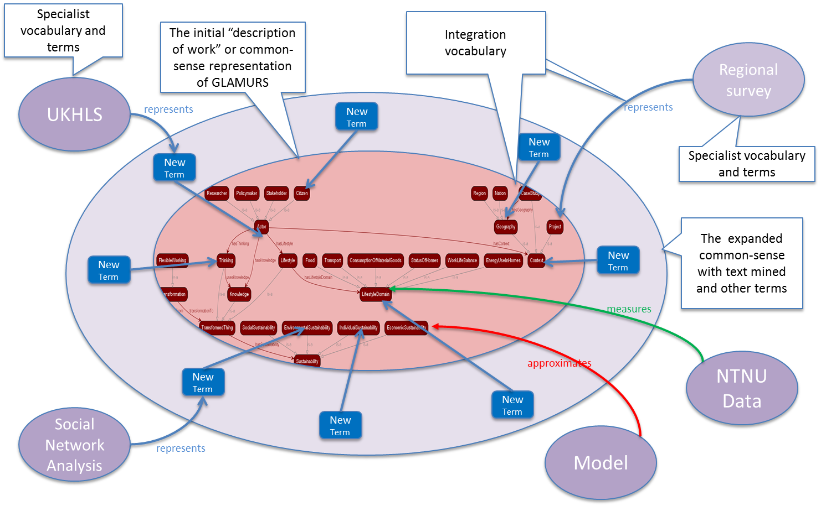

Figure 1 The GLAMURS ontology illustrated

The aim, as stated above, is to build an ontology spanning the entire project. To do so we use various methodologies in order to create an ontology that is based on the descriptions of work in the proposal for the GLAMURS project. We have denoted this kind of ontology as the “top-down,” or interchangeably as the “common-sense” ontology. We have then used standard knowledge engineering techniques to create ontologies for each data collection or analysis task of the GLAMURS project, collectively referred to as “bottom-up” ontologies. These are most closely aligned with the work descriptions for GLAMURS work packages 4-7, and will involve ontologies for the regional surveys; the regional case studies; backcasting to incorporate the visions and pathways of each of the regional initiatives; ontologies for each of the mathematical and computerised models in GLAMURS; the environmental footprinting results; social network analyses of regional initiatives, interview coding schemata for key actors in regional initiatives, backcasting results from regional initiatives, and any other supporting data sets such as the United Kingdom Household Longitudinal Survey.

The final stage is to link all these ontologies into one project-spanning ontology, mediated by what we have denoted as the “integration ontology.” This new ontology may represent a novel and we believe useful approach to project integration in GLAMURS specifically, and also to ontology interoperability more generally.

It should be noted that in the above approach we have tried to avoid overly imposing our own view of what should constitute the global ontology for GLAMURS, but rather have let the structure of the project dictate what should and should not be included. Again, this approach is probably unique (in the context of environmentalism) and further enhances the novelty (but possibly decreases the utility) of the final ontology.

All the ontologies mentioned in this document are available publicly and reside on GitHub at <https://github.com/DougSalt/GLAMURS/tree/master/ontologies/>. GitHub was chosen for its excellent revision facilities based on the distributed open source version-control tool, git and is well-known, publicly available, and widely utilised for a large number and wide variety of projects. In the spirit of open source we have published the ontologies under the [GPLv3](https://www.gnu.org/licenses/gpl-3.0.en.html), a copy left license that ensures persistence of correct attribution and maintains openness if the ontologies are used elsewhere.

Ontologies are formal, explicit representations of shared conceptualizations [1], and one popular language used to write them is the Web Ontology Language (OWL). In the GLAMURS project, we have used OWL ontologies to represent various aspects of the project’s work, with a view to enabling automated reasoning about the relationships among terms used in specialist disciplines. Creating these ontologies required a number of exercises to be conducted within the project team to find terms that needed defining, and agree ways in which they could be related.

A lot of use has been made of the facilities that OWL 2 provides to split ontologies into functionally logical and coherent components. Known as *namespaces*, these facilities allow us to make use of the vocabulary from one ontology in another. Also we have made use (generally at the same time), of the ability to import an ontology as a sub-ontology, allowing the use of the structure of that ontology within the invoking parent ontology. That is, maximum semantics are available to use for any given ontology and can be utilised in any ontology that supports that import. This facility in particular underlies the fundamental premise of the whole approach represented by this document, that it is feasible that a global ontology of the project can be built from smaller, component ontologies.

OWL 2 ontologies consist of four types of entities. These are:

* classes;
* object properties;
* data value properties, and
* individuals.

Individuals are instances of something concrete. So “Plato” might be an individual, as would “Socrates”.

Classes are groups of individuals with some commonality. So the class Human might contain the individuals Plato and Socrates. These classes are referred as concepts in description logics (DL); the underlying model on which reasoning in OWL 2 ontologies is based.

A data property value is some concrete value assigned to an individual. For instance we know that Socrates and Plato died sometime in 399 BCE and 348 BCE respectively, so we could have some class, with notional instance “Plato’s death” having a value of 348 BCE, and “Socrates’ death” with value 399 BCE. Grouping both these into a class called Dies, the it is evident that the class Dies has a data property containing a literal indicating when somebody died.

Lastly there is a relationship between the instance Socrates and “Socrates’ death’, likewise between Plato and the corresponding instance. Thus we might assert on the individual Socrates that:

* mortality(Socrates, “Socrates’ death”);

and likewise:

* mortality(Plato, “Plato’s death”).

In this assertion, there is a relationship mortality with domain Human and range Dies. The relationship mortality is what is known as an object property in an OWL ontology.

The above illustrates the essence of how OWL 2 works. Ontologies use classes, object properties and data value properties to define a formal *vocabulary*, but it is assertions about individuals that describe a specific situation.

Extending the above example, suppose we have another individual, Democritus, and Democritus is a member of the class Human. Given the above example then it seems reasonable to assume that if Democritus is a Human, then he is expected to have a relation with some instance of Dies, and indeed there are reasonably simple ways of asserting as much in OWL 2 by the use of axioms about the vocabulary (specifically, a restriction asserting that Human is a subclass of things that have a mortality relationship with Dies). However, it is also possible to *derive* further axioms through the use of automated reasoning. Reasoning in OWL 2 ontologies (which are designed for use on the internet) is bound by what is known as the *open-world assumption*. Under the open-world assumption, a proposition *P* is only true if it is asserted or inferred to be true; its falsehood is not implied by the absence of *P* in the set of axioms asserted or inferred, Rather, falsehood (¬*P*) must be specifically asserted or derived from rules that have ¬*P* as their conclusion based on available axioms. The consequence of this is that OWL 2 is a *nonmonotonic* description logic, with truth values ‘true’, ‘false’ and ‘unknown’.

The terminology for OWL 2 ontologies reflects the distinction between vocabulary and specific situations, and is used throughout this document. There are three distinct types of ontologies, which are:

* TBox (‘terminology’ box) – an ontology defining a vocabulary containing only axioms about classes, object properties and data properties and how they relate to each other, such as the restriction on Human above.
* ABox (‘assertion’ box) – an ontology containing only assertions about individuals, the data property values they have, and the relationships the individuals have with each other.
* Knowledge base – TBox + ABox.

Arguably, it is the ABox which is the more useful. TBox gives us the language to describe what the behaviour could be, but ABox provides the reality with which to work upon and the knowledge base provides the framework in which to formally reason over the two to derive new knowledge about the reality modelled with the ABox ontology.

Given the above, then it is reasonable to assume that we want as many instantiated individuals as possible, and this is a primary motive behind the methodology adopted in this document. As part of this methodology, we also want to describe the ontologies we produce to capture such information as what kind of ontologies they are and how they were produced. To do this we produce another (TBox) ontology that will effectively constitute metadata about ontologies. Although OWL 2 makes provision for ontology metadata (as what are called *annotation* classes, and data and object properties), it unfortunately makes no provision for reasoning over that metadata. Thus, although it might be argued that the metadata we produce about the ontologies within this document should be encoded using annotations, this would defeat the whole purpose of this approach: to allow us to integrate knowledge from the various areas of the GLAMURS project. Consequently virtually all our metadata is instantiated as ‘normal’ vocabulary such as those described in the bullets above, and we adopt conventions described in section 2 to denote the distinction between data from the project (sections 3 and 4) and metadata about that data.

We have adopted the following standards when writing each of the ontologies.

1. OWL 2 has various encodings that can be used in the computer files containing OWL 2 ontologies. We have adopted an encoding known as the *functional form* for the storage of all the ontologies in this document. In our opinion, the functional form is more parsimonious in notation than other encodings, and hence is a lot easier to read and comprehend. It is also for this reason easier to write scripts with.
2. Each ontology should contain an author or a link to an author, and contain a version number in the form of a decimal.
3. There should be an annotation statement indicating coding conventions and standards.
4. A comment annotation should contain a statement of what the ontology is and what it is for.
5. The underlying name of an entity, i.e. a class, object, datatype or property name is in CamelCase and should be worded to indicate the purpose of the entity. This is opposed to some ontologies that randomly name the entity and use the *label* annotation to identify the entity in some meaningful (to humans) way. Further, a naming convention is adopted in which:

* classes begin with an upper case letter;
* object properties begin with a lower case letter;
* data properties begin with a lower case letter and are suffixed with -value unless the data value is Boolean;
* data properties and object properties begin with ‘has’ unless another verb makes better sense; and
* individuals generally begin with a lowercase letter, except in the case of proper names.

1. Note these conventions relate to the underlying entity and not what is shown as its name in Protégé (which is normally the value of the label for whatever default the language is set to).

* a label must be provided (usually with a language specification) and should be make sense in the language of choice

1. [Markdown](https://en.wikipedia.org/wiki/Markdown) will be used in all free text entries.

To assist the reader in navigating the various ontologies that collectively comprise the overall GLAMURS ontology, we include a “map” showing the relationship of all the ontologies in Figure 2. Further, Table 1 provides information on the name of each ontology, a brief note on its use and where it is explained in this document.

The structure of our approach is outlined by the table of contents for this document, but may also be summarised into the following stages:

* this introduction;
* the metadata framework used to create, collate and tie each of the individual ontologies into a single entity (section 2);
* the methodology and creation of the “top-down” ontology and its component ontologies (section 3);
* the methodology and creation of the “bottom-up” ontologies (section 4);
* a brief description of the final, project encompassing ontology (section 5);
* a discussion, results and conclusions drawn from the whole process (section 6).

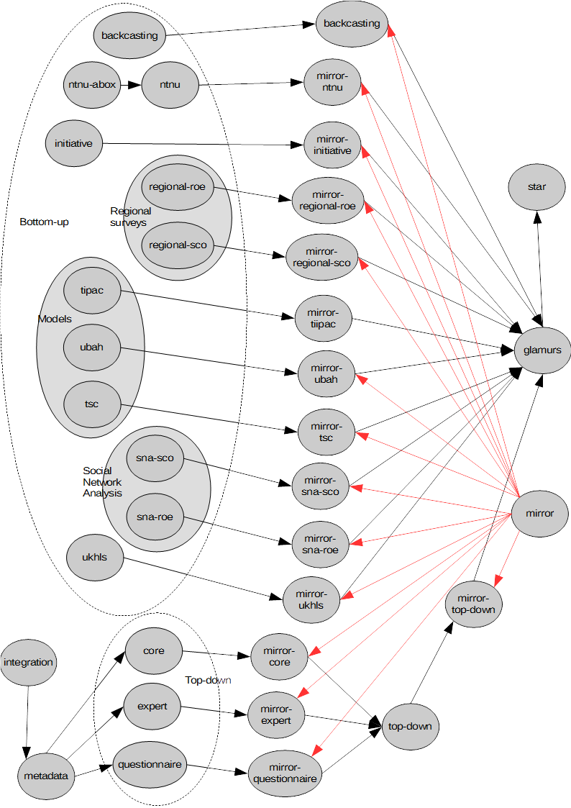

Figure 2 A map of the ontologies

Table 1 Ontologies in Figure 2 in alphabetical order by designation, their use, and where to read more about them in this report.

|  |  |  |
| --- | --- | --- |
| **Ontology designation** | **Purpose** | **§** |
| ***back-casting*** | Backcasting ontology. | 4.9 |
| ***core*** | The top-down, common-sense core view of the project. | 3.1 |
| ***expert*** | Word-groups text minded from the GLAMURS documentation with high-usage and high “familiarity.” | 3.3 |
| ***glamurs*** | The final GLAMURS ontology. | 5 |
| ***initiative*** | Regional case-study initiative interview coding TBox. | 4.3 |
| ***integration*** | The vocabulary use to aggregate the top-down ontology views of the project. | 2.2 |
| ***metadata*** | The class framework used to develop the top-down ontologies. | 2.1 |
| ***mirror*** | The ontology framework for mirroring the actual ontology as individuals in order to reason over it. | 2.4 |
| ***mirror-backcasting*** | The mirrored version of the backcasting ontology. | 2.4 |
| ***mirror-core*** | The mirrored version of core ontology. | 2.4 |
| ***mirror-expert*** | The mirrored version of expert ontology. | 2.4 |
| ***mirror-initiative*** | The mirrored version of initiative ontology. | 2.4 |
| ***mirror-ntnu*** | The mirrored version of ntnu-ontology. | 2.4 |
| ***mirror-questionnaire*** | The mirrored version of questionnaire. | 2.4 |
| ***mirror-regional-roe*** | The mirrored version of regional-roe ontology. | 2.4 |
| ***mirror-regional-sco*** | The mirrored version of regional-sco ontology. | 2.4 |
| ***mirror-sna-roe*** | The mirrored version of sna-roe ontology. | 2.4 |
| ***mirror-sna-sco*** | The mirrored version of sna-sco. | 2.4 |
| ***mirror-tipac*** | The mirrored version of tipac ontology. | 2.4 |
| ***mirror-top-down*** | The mirrored version of core. | 2.4 |
| ***mirror-tsc*** | The mirrored version of tsc ontology. | 2.4 |
| ***mirror-ubah*** | The mirrored version of ubah ontology. | 2.4 |
| ***mirror-ukhls*** | The mirrored version of ukhls ontology. | 2.4 |
| ***ntnu*** | Environmental footprinting ontology TBox. | 4.8 |
| ***ntnu-abox*** | Environmental footprinting ontology ABox. This is incorporated as data into the ntnu ontology. | 4.8 |
| ***questionnaire*** | The unsolicited responses from researchers for concepts they believed important via an on-line questionnaire. | 3.2 |
| ***regional-roe*** | The regional survey ontology for all European regions taking part in the study except for Scotland. | 4.3 |
| ***regional-sco*** | The regional survey ontology for Scotland only. | 4.3 |
| ***sna-roe*** | The social network analysis ontology for key actors in the regional, case-study initiative for all European regions taking part in the study except for Scotland. | 4.10 |
| ***sna-sco*** | The social network analysis ontology for key actors in the regional, case-study initiative for Scotland only. | 4.10 |
| ***star*** | The integration vocabulary between the top-down and bottom-up ontologies. | 2.3 |
| ***tipac*** | Agent-based model ontology for traffic in Aberdeenshire. | 4.5 |
| ***top-down*** | The aggregation of all the ontologies representing the top-down view of the entire GLAMURS project. | 3.7 |
| ***tsc*** | Macro-economic model ontology. | 4.7 |
| ***ubah*** | Micro-economic model ontology. | 4.6 |
| ***ukhls*** | The United Kingdom Household Longitudinal Study ontology. | 4.4 |

# GLAMURS ontology supporting metadata framework

Before explaining the ontologies we first have to explain the metadata supporting framework. Although this framework evolved over time it is crucial to understanding the final form and construction of each of the ontologies that combine to form the GLAMURS ontology. Indeed it is also essential to comprehend the theoretical approach in modelling the entire GLAMURS project, and what, quintessentially that model is and could be used for. Although we have faithfully tried to tell the story of the evolution of the ontology as it happened and the reasons for each decision at each point, the ontology underwent a substantial change in structure over the lifetime of the project; it has proved difficult to sequence this in chronological order. To do so would mean the reader jumping about haphazardly within this document to understand the structure and theory behind the entire ontology. As a consequence, early parts of the approach can be seen in the duplication of certain components in the construction of the top-down ontology.

The overall aim of the ontology has to be to extract new information about the project from modelling it as an ontology. Whether this information is about transformations to sustainability or whether it is metadata about the project itself, this represents the sole reason for the existence and development of the ontology. Some information may be obtained by inspecting the structure of an ontology using graph metrics (Rabinovich and Forschungsgebiet 2008, chap. 3) or magnitude measures (such as number of nodes, or number of edges), but the primary facility of any ontology must the ability to reason over it. The widespread availability of free (in both open source and fiscal senses of the word) automated reasoning software for OWL 2 is the one of the reasons that it was selected as the means of specifying the project ontology.

All ontologies were created and linked together. As stated earlier, we have metadata about these ontologies that we wish to reason with. To enable this, without interfering with the assertions in the ontologies themselves, the ontologies are manipulated to generate a ‘mirror’ of their (TBox and ABox) axioms as ABox axioms (individuals) so the resultant ontology might be reasoned over and new inferences obtained with a view to generating insights, including commonalities between disciplines, the degree to which GLAMURS has been a trans-disciplinary project, transitions to sustainability uncovered by new relationships, or project metrics covering the effectiveness of the project. This mirroring is the means by which we have circumvented the constraint that ordinary OWL 2 annotations cannot be reasoned with.

As the project is essentially organized from the top-down, that is GLAMURS was necessarily planned, inasmuch as the aims of the project were decided beforehand and then sub-tasks were decided upon in order to obtain these aims, we consider the vocabulary needed to develop the ontologies that make up these top-down ontologies. There is metadata for some of the top-down ontologies, and the vocabulary for this is denoted the *metadata* ontology.

The next step was to link these top-down ontologies together and to do so we developed an integration vocabulary, which was denoted the *integration* ontology.

The final stage in constructing the TBox representation of the GLAMURS project was to link this aggregation of top-down ontologies of a common-sense core ontology and various specialist vocabulary ontologies with the remaining bottom-up ontologies with the *star* ontology, which represented the shape and manner in which the GLAMURS project was organised.

The very last step was to reflect the entire ontology for GLAMURS as individuals, but in a manner that meant that the original ontology was recoverable from the specification of such individuals, and vice-versa. The ontology that allowed this to happen was denoted the *mirror* ontology.

Consequently this section is further sub-divided into the four sections described briefly above. So the subsections that follow this introduction are as follows:

* *metadata* ontology – This is the framework ontology used to organise and construct some component ontologies of the top-down view of the project.
* *integration* ontology – This section shows the development and assembly of the vocabulary ontology used to link the various ontologies of the top-down view of the GLAMURS project into a cohesive top-down ontology of the whole project.
* *star* ontology – This section describes the explains the reasoning in determining and constructing the vocabulary used to link the bottom-up and top-down ontologies.
* *mirror* ontology – This section describes and explains the reasoning underlying the ontology used implement the mirror of the entire GLAMURS ontology to allow reasoning with it using the above three ontologies.

This fully specifies the metadata, organisational and developmental framework used to develop, implement and reason over the eventual GLAMURS ontology.

## Metadata for top-down ontologies

The framework for developing each top-down ontology was denoted the ***metadata*** ontology and the aim of this ontology was to provide a pre-defined and rational class structure about which the component ontologies consisting of the expert terminology ontology (see section 3.3), and the on-line questionnaire ontology (see section 3.1.6) could be developed and organised. These ontologies were part of the top-down view of the GLAMURS project. The metadata ontology was imported into each *top-down component ontology* as the first step of developing each of these ontologies. This ontology was also developed in order to provide the framework for the completion of the three incomplete ontologies mentioned in the sections 3.4-3.6 as well. Indeed we believe this ontology would make a good starting point and generalised ontology for any future project requiring integration of disparate specialist terminologies. The classes for this generalised framework ontology are organised as shown in Figure 3.

The process of developing each ontology begins with each term that is to be elaborated in the top-down component ontology being instantiated as an individual as a subclass of the Term class. This individual is then annotated with its origin – the institution the term was defined by. The institutions themselves, such as JHI, corresponding to The James Hutton Institute or UDC, corresponding to Universidade da Coruña are instantiated as individuals in the Institutions class. This allows as much annotation against each institution as we like. For instance we include the whole name on the institution as annotation, but there is nothing to stop the address and contact information being added as annotation, and other useful information such as informational links to the Internet. These provide useful informational links if the ontology is made public (e.g. on the web, which it effectively has been through its release on GitHub). In general, we try to instantiate against individuals, as not only can we provide as much metadata pointing to this individual as we want, but also it is primarily against individuals that any formal reasoning normally occurs.

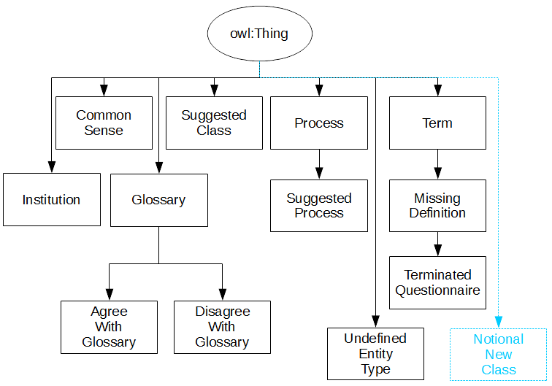

Figure 3 Top-down metadata framework classes

Other annotation is also provided such as the definition provided by the researcher when, or if the term was defined in the online questionnaire from 3.1.6. A specifically English version of the term is also provided, annotated itself as being in the English language. Indeed if the term is a word group, i.e., more than one word, then this is a good place to note this. For instance, part of our standards for creating ontologies is that we use CamelCase for any word groups, so for instance the term “green economy” becomes the class GreenEconomy. The label annotation allows the definition of the string “Green economy” which is more readable should software operating with ontologies (such as [Protégé](http://protege.stanford.edu/)) display this label in preference to the underlying entity name. (It is not unreasonable to expect this since a common practice in ontology development is that the underlying ontological concept name may be randomly generated and therefore meaningless to humans.) Although all terminology in all the ontologies found in this project are in English, it is still good practice to provide the ability to define multi-lingual versions of any ontological concept and we have tried to do so in any ontology defined within this project.

Finally, the discipline to which the term belongs is defined by use of the partOfDiscipline annotation primitive. Again each discipline is instantiated as an individual in the Discipline class provided.

Upon completion of the annotation the term is created as one of the ontological entities listed below, unless there is no definition data, and then it is subclassed in the UndefinedEntityClass.

* Class;
* Object Property;
* Data value;
* Individual, or
* Process.

If the object is defined as a class then a new class is created directly subclassing owl:Thing (every class in OWL 2 is a member of this class) as shown in Figure 3. If it is a process then a new class is created as a subclass of the Process class. If it is an individual then a new individual is created. If it is a new object property then a corresponding object property is created as a sub property of hasSuggestedProperty, and likewise if a new data value then a new data value is created as a subproperty of hasSuggestedAttribute.

If the definition data is incomplete for whatever reason, then if it is a class it is created as a subclass of MissingDefinition or the individual is subclassed to the UndefinedEntityType or one of its subclasses.

Any affected classes or processes, as a consequence of the definition, that do not exist already are defined in SuggestedProcess if they are processes, or SuggestedClass otherwise.

The above class structure has been adopted as it allows easy organisation when constructing ontology and allows easy tracking of what has been defined, what needs examination, and entities that have no provided definition. It might be argued that such classification scaffolding should be removed upon completion of construction of the ontology, but we found such classifications useful beyond the integration of the top-down ontologies and into the integration of all the ontologies.

A brief summary of the purpose of each class is provided in Table 2.

Table 2 Framework classes and purpose

| **Class Name** | **Purpose** |
| --- | --- |
| Institution | Contains individuals corresponding to each of the institutions partaking in the project. This is used for attribution rather than using individuals. |
| CommonSense | These terms have been denoted as “common-sense” and consequently do not need definition. |
| Glossary | These terms are classes that appear in the glossary |
| AgreeWithGlossary | These terms are classes that appear in the glossary and the defining researcher agrees with the definition in the glossary |
| DisagreeWithGlossary | These terms are classes that appear in the glossary and the defining researcher does not agree with the definition in the glossary |
| SuggestedClass | These are classes that have not been explicitly defined as such, but are implied by the definition of another ontological entity to be so. |
| Process | These are terms defined as processes |
| SuggestedProcess | These are processes that have not been explicitly defined as such, but are implied by the definition of another ontological entity to be so. |
| Term | This is the class containing all terms defined as individual. This is generally the first step in developing a top-down component ontology |
| MissingDefinition | No definition has been defined for the class corresponding to the term provided. |
| TerminateQuestionnaire | The term in question was defined but only up to the point by which the kind of entity was to be defined. |
| UndefinedEntityType | No definition data exists for term, only that it has been entered for definition in the online questionnaire. |

The full listing for the top-down common ontology can be on found on GitHub at <https://github.com/DougSalt/GLAMURS/blob/master/ontologies/top-down%20ontologies/integration.owl>.

## The integration vocabulary for the top-down ontologies

This has been denoted the ***integration*** ontology and not only forms the basis for the integration vocabulary in the top-down ontologies, but is also used throughout and within the top-down component ontologies to more generally link classes. This works because of the subproperty semantics of object properties. In OWL 2, any subproperty of an object property must have at least the properties of the parent property, including the domain and range. For instance in the metadata ontology from section 2.1 above we have the following property and subproperty relationships:

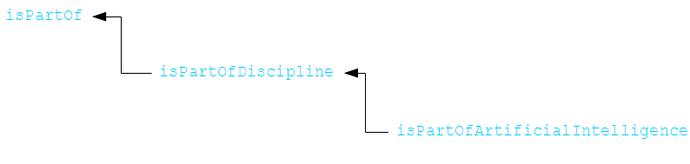

isPartOfArtificialIntelligence is a subproperty of isPartOf and any domain of the former must be in the domain of the latter, and this is also true of the range (or *codomain*). Thus sometimes very specialised relationships such as in the above example make as much sense semantically whichever relation is used. For instance,

“Machine Learning” isPartOfArtificialIntelligence “Artificial Intelligence”

is in some ways semantically similar to:

“Machine Learning” isPartOf “Artificial Intelligence”

where “Machine Learning” and “Artificial Intelligence” are ontological individuals. That is it is reasonable to assume some close semantic correspondence between these two sentences, and indeed to humans reading such constructs the similarity is apparent. Thus it should not be entirely surprising that most relationships can grouped into just a few groups, using this subproperty ontological facility. This explains the somewhat small size of the vocabulary required to integrate the given ontologies.

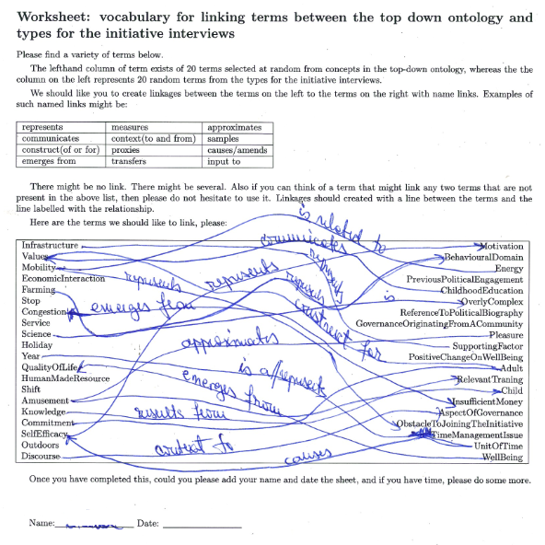

Figure 4 Ontology linking vocabulary worksheet

To a certain extent this has been verified, although informally, by a workshop undertaken on 28 September 2016 at the Leipzig Consortium meeting. We asked researchers on the project what vocabulary they would use link concepts in bottom-up ontologies with those in top-down ontologies. This was done in order to help us find connectives that we may not have considered when developing vocabulary to link different ontologies together. In order to do this we collected all the class names from the top-down component ontologies into one group, and collected all the class and individual names into groups corresponding to each of the bottom-up ontologies. A Perl script was then written to take 20 classes randomly from the top-down group of classes and 20 classes or individuals from one of the sets from the bottom-up ontologies. The Perl program then produced a LaTeX script, which in turn produced PDF worksheets. Two hundred of these sheets were created, and researchers were asked to select a sheet that reflected their specific area of research. Some examples of these are included in appendix 2. Researchers were then asked to fill these out as in the manner shown in Figure 4. We received 26 responses from which we gathered 67 completely unique linking terms, even given that we actually specified the connectives that we suggested that the researchers use. As can be seen from the list of responses in Table 3, each of the suggested linkage terms could be classified into one of the seven super-properties shown.

Table 3 Suggested linking vocabulary

|  |  |
| --- | --- |
| **Standard**  **Connective** | **Specialisation** |
| *equivalent-to* | equivalent |
| *is-a* | subclass of/superclass of |
| *part-of/has-part* | constitutes, contains, is the aggregation of, is mostly present in, of a |
| has-value | attribute of, is an attribute of, data value, expressed by, have a non-orthodox, is a preference common in the, has emission |
| modifies / is- modified-by | alters, amends, changes, determines, determines rules for, is caused by, output to, results from, mathematically instantiates, emerges from/to, causes, is to a greater degree generated in, leads to, impedes, counters, counteracts, mediates, moderates, fosters reduction of, are established by, is fostered within |
| uses / is-used-by | contribute to, input to, construct of, input to, influences, is necessary for, enabled by, is enabled by, enables, context to/for, satisfies, satisfies demand, of the consumption of a, of the use of, promotes, working for, is linked with, transfers to, transfers, is a preference common in the, are promoted by, by an, can be taxed, is regulated by, search for |
| represents / is-represented-by | described by, describes, defines, proxies, communicates, explains, is related to, measured in |

The first two rows, equivalent-to and is-a represent ontological primitives that are already present in the OWL 2 specification, and have very strict semantics to the point where some are not actually usable in less formal circumstances of problem domain description. For instance to say that the class of Adult is equivalent to the class of Person, would mean that any member of the class Adult will have precisely the same properties of the class Person. This seems reasonable until it is noted that a Child is also a Person but completely disjoint with Adult, so the equivalence is not necessarily true (although it might be with respect to the how the ontologies were initially defined). It might be better to say that Adult *represents* Person (or vice versa), with respect to their ontologies. However given that each of the ontologies analysed in this subsection are components of the top-down ontology and are therefore are contained in the *same* ontology, i.e. the top-down description of the GLAMURS project, then it might be apposite to make use of the OWL 2 primitive is-a. That is, in the example under discussion Adult becomes a subclass of Person. This does not necessarily have to be the approach: *represents* cannot be a part of the generalized vocabulary at this point, but this is not the model we chose. For a further discussion of which model that was chosen, and what this implies for the vocabulary then please see section 2.3, the overall integration vocabulary ontology.

The third connective, is the part-of mereological operator and, although not defined as a primitive in the OWL 2 specification is well understood (Borst 1997), and can be easily constructed (Golbreich 2009).

Using the results above, then initially we started integrating the “expert” ontology, the “questionnaire” ontology and the “core” ontology with the three connectives: has-value, modifies and use; and along with the mereological connective, has-part; the standard OWL 2 connective, subclass-of, and the rare use of equivalent-to, and were reasonably successful. We did add two further specialisations of these connectives. Firstly we added creates as a specialisation of modifies. We also added requires as a slightly stronger flavour of uses. However these changes were largely aesthetic, rather than logical in nature, making it considerably easier to think about linking certain classes with these ontology components.

Thus our final top-down integration vocabulary consisted of the following primitives:

Table 4 Summary of the integration vocabulary primitives

|  |  |  |  |  |
| --- | --- | --- | --- | --- |
| **Integration Primitive** | **Specialisation** | **OWL 2**  **Primitive** | **Antonym** | **Purpose** |
| hasProperty |  | No | isPropertyOf | some object property of |
| modifies |  | No | isModifiedBy | modifies the referent |
|  | creates | No | isCreatedBy | creates the referent |
| uses |  | No | isUsedBy | uses the referent |
|  | requires | No | isRequiredBy | is required by the referent |
| partOf |  | No | hasPart | is part of the referent |
| Equivalent To |  | Yes | Equivalent To | is equivalent to the referent |
| SubClass Of |  | Yes | SuperClass Of | is a subclass of the referent |

The exclusion of the primitive represents from Table 4 is deliberate and relates directly to the manner in which this project has been organised. The represents primitive is seen as a means of integrating the between the top-down components of this project and the ontologies that are formed as a result of the bottom-up activities in this project. Thus represents is reserved for the vocabulary ontology that links the top-down ontologies of this project with the bottom-up ontologies. For a more detailed explanation of this, please see section 2.3.

This list was found to be entirely sufficient to link all components of the top-down ontology. The full listing of this generalised integration vocabulary, referred to as the ***integration*** ontology can be found on GitHub at <https://github.com/DougSalt/GLAMURS/blob/master/ontologies/top-down%20ontologies/integration.owl>.

Thus it can be used to link classes between separate ontologies and classes within those ontologies.

## Integrating the bottom-up ontologies with the top-down ontology

Having developed an integration vocabulary in section 2.2 for integrating the various parts of the top-down ontology, then what remains is some vocabulary to integrate the result aggregation of top-down core common-sense ontologies and the other specialist vocabulary ontologies of top-down view of the GLAMURS project with the bottom-up ontologies representing the individual practical and empirical components of the project.

From the workshop the approach in section 2.2 the one primitive we omitted from the integration ontology was represents. This was deliberate omission for the reasons that follow. In the GLAMURS project we have a global view of the project in which it was determined in advance that individual tasks were needed that fulfilled the individual objectives of the project. For instance as part of transition to a more sustainable lifestyle we might have wanted to know what the effect of introducing flexible working might be. In order to consider this we might, as indeed was the case, set up a case-study for a particular region and also build a computerised traffic model in order to try and predict what might happen in such a situation. An ontology can be constructed for both of these, but how do these relate to the original concept of flexible working which originated in the top-down view of the project? One role or relation might be equivalent-to, but this in OWL 2 terms is an extremely precise and stringent condition placed on a class. This means that for every property of one class there is potentially precisely the same property in the equivalent class. So if a class, say vehicle in the computerised model has a data value in which sets its type as a car or a bike then there must be a precise equivalent in the top-down concept of flexible working. This is clearly nonsensical as in the real world there is either a bike or car, and a vehicle cannot normally switch between a car and a bicycle at the flick of a switch, or setting of some control.

Additionally ‘simulates’ is already in use by the computer modelling community and has precise meaning (Bossel 2013, 5), as does modelling to the mathematical community (Salt and Feng 2012), so we decided on represents. (The term has some resonance in the AI community.)

Thus in the example above the traffic model representsthe concept of flexible working in the top-down view in some manner. As does the case-study, in that it again represents the concept of flexible working, but in a different manner. Such a role, i.e. a predicate with two parameters, has almost certainly some contextual logical consequences to its use, for instance if *X* represents *Y* and *X* represents *Z*, then *Y* and *Z* must be related in some manner. There is some investigation of this in the discussion section, section 6.1.

In effect what we are doing by separating out this primitive is saying that any class in the top down view of the project, can only be connected to a bottom-down ontology or class within that bottom down ontology with this primitive. The immediate effect of this is that it enforces a “star” pattern on the distribution of ontologies as shown in Figure 5. This need not necessarily be the case; there are several other options that could have been available as illustrated in Figure 6. Moreover these diagrams only look at the linking primitive represents. The set of integration vocabulary contains quite a few terms, there are a huge number of combinations if this set were partitioned into top-down integration vocabularies and bottom-down vocabularies and applied to the patterns in Figure 6 However the star pattern in Figure 5 pattern was chosen as best reflecting our interpretation of how the project was organised.

We added a further two refinements to the project model above. The first was fairly straight forward in that we provided specialisations of represents. This is shown in Figure 7. These specialisation are represented as branches subproperty tree with the conditions for use become increasingly or decreasingly stringent (and we suspect have differing logical consequences on their combination and conditions of use).

The second refinement is interesting in that it allows the linking of top-down and bottom-up ontologies, whilst considering and using the represents primitive omitted from the first integration vocabulary found in 2.2. In effect, what the previous discussion indicates is that each of, or parts of the bottom-up ontologies represent experiments or data collection that of some part of the project direction, i.e. a concept that must be present in one of the top-down directories. Thus the only link that needs to be made between components of the top-down ontologies and the bottom-up ontologies is this represents. Hence all the classes in the ontology ***initiative*** described in section 4.3; the coding from the interviews of key stake holders for the regional case study initiative representsin some manner an instance of the InitiativeOrganizer; a class from the top-down ontologies. So represents may be used to link each of the classes in the top-down ontology to an ontology or set of classes in one of the bottom-up ontologies.

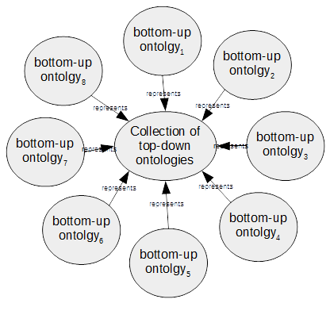

Figure 5 Star Organisation of a Project

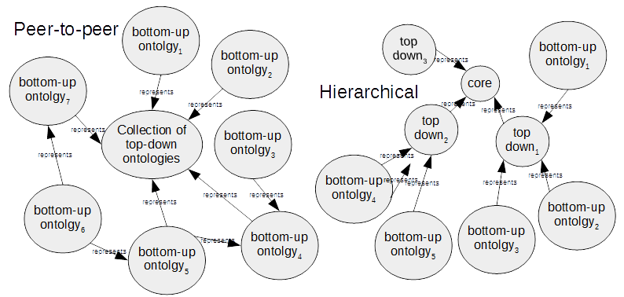

Figure 6 Project organisations

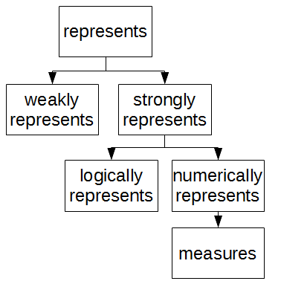

Figure 7 Represents hierarchy

This is one final, little complication and addition to the above. If we have as above, that the initiative stakeholder interview ontology, ***initiative*** represents some InitiativeOrganizerin the top-down ontology, then to represent this, all classes in the “initiative” ontology are subclassed to a class denoted InitiativeOntologyClass, and this class is said to represent InitiativeOrganizer.

This seems eminently reasonable, but does LackOfKnowledge which is also a subclass of InitiativeOntologyClass, a representation of InitiativeOrganizer? It is part, or a component of the total representation of InitiativeOrganizer, but not an obvious representation, say, as for example Person which is also a subclass of InitiativeOntologyClass would be considered a more relevant representation of InitiativeOrganizer. In order to distinguish between these two cases, then another refinement to represents is made: a global represents, γ-represents is introduced to indicate that a group of classes represents some concept in the top-down ontology, where σ–represents denoted a *specific*, one-to-one representation of something. So in the above cases we would have:

* InitiativeOntologyClass γ-represents InitiativeOrganizer, and
* LackOfKnowledge γ-represents InitiativeOrganizer

but:

* Person σ–represents InitiativeOrganizer.

Essential there is a global-represents in γ-represents and a specifically-represents using σ–represents. Needless to say all the specialisations of represents shown in Figure 7 are duplicated for both these new primitives.

All the above is to be found in the ontology which was denoted ***star*** and a complete listing of which may be found on GitHub at <https://github.com/DougSalt/GLAMURS/blob/master/ontologies/integration%20ontologies/star.owl>.

The last thing provided in the star ontology was similar to the metadata ontology as described in section 2.1, inasmuch as this ontology provided metadata scaffolding by which to construct the global ontology. For this purpose two additional classes and some addition object properties by way of organisational metadata were provided. The two additional classes provided a means of categorising a given class into a bottom-up or top-down category. By assigning any class in the eventual ontology into one of these classes, we could enforce the direction of the σ–represents and γ–represents primitives. That is, they necessarily always had domain in a bottom-up ontology and range in the top-down ontology. Moreover it meant that all classes in a given ontology could be subclassed to some structure ontological class, meaning that the γ–represents could then be applied to all classes in that ontology. For instance all members of the agent-based model TiPaC ontology were subclassed to TipacOntologyClass, which itself was a subclass of BottomUpOntologyClass. Thus could be was part of the valid domain for the γ–represents.

Additionally provision was made for the categorization of object properties, with domains originating in either TopDownOntologyClass or BottomUpOntologyClass subclass correspondingly belonging to either a top-down or bottom-up object property and made subproperties in the star ontology of either hasTopDownOntologicalProperty or hasBottomUpOntologicalProperty.

Corresponding provision was made for the categorization of data value properties, with domains originating in either TopDownOntologyClass or BottomUpOntologyClass subclass correspondingly belonging to either a top-down or bottom-up data value property and made subproperties in the star ontology of either hasTopDownOntologyDataProperty or hasBottomUpOntologyDataProperty.

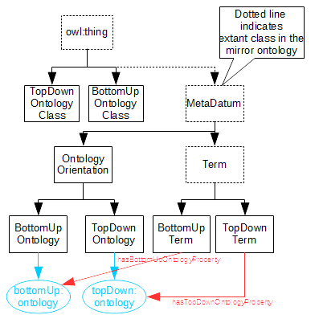

Figure 8 Extra integration metadata

Lastly for reasoning over the mirrored ontology, a last piece of metadata framework was provided. Allowance was made for the new metadata structures described above to be mirrored and consequently additional fields were added as metadata to provide this. Specifically the ontological orientation was added as individuals, i.e. whether a given class is part of a top-down or bottom-up ontology was included. This metadata has been added for the purposes and to the mirror ontology described in the next section, section 2.4. A summary of these new metadata classes, metadata object properties and metadata data value properties can be found in Figure 8.

Whether the class in question was bottom-up or top-down, and the consequent orientation of the instantiated individual, are all determined by the choice of project pattern. This is why they have been included in the ontology, which describes the “shape” of the project, as described in this section.

## Mirroring the ontology

The last part of the GLAMURS ontology supporting metadata framework is the mirroring of the whole ontology as individuals. The overall aim of the ontology has to be to extract new information about the project from modelling it as an ontology, and the primary facility of any ontology by which this is achieved is the ability to reason over that ontology. This is the one of the reasons that OWL 2 was selected as the means of specifying the project ontology. Not only is OWL 2 a W3C standard (Bock et al. 2008), and effectively the standard means of constructing ontologies for publishing to the Web, but OWL 2 has been implemented in order to reason. In particular OWL 2 implements description logic SROIQ(D) (Gruber and others 1993) (dependent upon which reasoning profile is adopted for OWL 2 (Golbreich 2009)). This means that providing the ontology meets certain restrictions then new inferences may be drawn using some form of a description logic (DL) reasoner, such as Pellet (Sirin et al. 2007), FACT++ (Tsarkov and Horrocks 2006), ELK (Kazakov, Krötzsch, and Simancik 2012), Hermit (Shearer, Motik, and Horrocks 2008), Ontop (Bagosi et al. 2014) , jcel (Mendez 2012) and Drools (Proctor et al. 2008). Such inference, if novel would represent new information about the GLAMURS project.

DL was developed based originally on Minski’s frame logic (Nardi, Brachman, and others 2003, 9), which is constructed from *concepts* and *roles*. Roles tie concepts together, and concepts type individuals. Although some inferences can be drawn about roles and concepts, such inference is necessarily limited to such things as hierarchies, domain and codomain restrictions (Sirin et al. 2007). It is these roles and concepts act on individuals that are of the most interest. From these roles, we then we can draw inferences about that individual if it of a certain type.

For us to make new inferences about the GLAMURS project, the ontology has to be constructed as a set of individuals, with roles or properties asserted against those individual and then reasoning may take place over the result and see what new inferences are drawn and how these might be useful. To briefly illustrate by paraphrasing a much used syllogism:

*All Humans are Mortal*

In ontological terms this might be represented by the TBox axiom:

$$∀m ϵ Human → ∃ n ∈ Dies: haveProperty(m,n)$$

representing the fact all instances of the type Human will have an object property an instance of the type Dies, which may, for instance have some data value property, such as date of death, or some such, linked by the axiom. So what about the individual Socrates, who is an instance of a Human? We know that the individual Socrates with have some instance of the class Dies, i.e. Socrates is indeed mortal: a new inference. Thus to make use of the axiomatic power of ontologies, then individuals are required.

In order to obtain the required individuals then it is necessary to firstly construct the axiomatic ontology of the project. This will primarily be a TBox ontology, in that we will try and construct an ontology that links high level concepts by relations. The concepts will be the ontological classes mentioned in section 1, the introduction, and the links will correspond to object properties, and lastly if these classes or concepts have any concrete measurable properties then these will become the data value properties both of which were introduced in the same section.

To achieve this mirroring of the entire GLAMURS ontology, then a new framework is required. This framework has been created as the additional ontology denoted the ***mirror*** ontology. This ontology is illustrated in Figure 9 and may be found on GitHub at <https://github.com/DougSalt/GLAMURS/blob/master/ontologies/mirror.owl>.

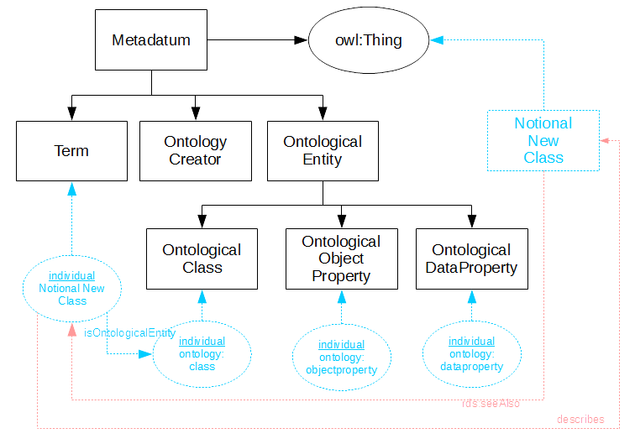

Figure 9 Metadata for a class

Figure 9 shows how a notional new class is created as a instance, individual:NotionalNewClass in the class Term and then the following role is asserted on that individual (using functional notation):

isOntologicalEntity(individual:NotionalNewClass ontology:class)

where individual:NotionalNewClass is the instantiation as an individual of the class NotionalNewClass, ontology:class is any kind of OWL 2 class represented as an individual and isOntologyEntity asserts that the first predicate argument is in a relationship with the second predicate argument. This asserts that NotionalNewClass is a class.

A couple of notes here. Firstly this is very similar to the instantiation of terminology that takes place in the metadata ontology in section 2.1, but opposite in direction. Indeed this is where the idea for the process originated in some degree, and moreover explains the slight difference in processing (in the code discussed below) between elements of the ontologies that make use of the metadata ontology and those that don’t.

Secondly is should be noted that assertions can likewise be made about object properties and data value properties, instantiated as instances of Term. This, in addition with the metadata determined by the ***star*** ontology described in 2.3, for example, the class Person from the ***initiative***, might have the following additional metadata asserted against it.

hasOntologicalProperty(initiative:Person topDown:ontology),

initative:Person being the corresponding entity in the ontology ***initiative***, and this asserts that the entity Person, in this case a class is from a top-down ontology, represented by topDown:ontology.

To create the mirror, a Perl script [create_terminology_ontology_wrapper.pl](https://github.com/DougSalt/GLAMURS/blob/master/src/create_terminology_ontology_wrapper.pl) was created. This processes the original ontology, creates an individual corresponding to each ontological entity of class, object or data value property and then links in both directions to the original ontological entity (making it easier to check, track and organise in subsequent ontology integration) and then indicates what kind of entity the class, object or data property is by asserting the role isOntologicalEntity on one of the three individual representing the types of ontological entities:

* ontology:class – representing OWL 2 classes;
* ontology:objectproperty – representing OWL 2 object properties, and
* ontology:dataproperty – representing OWL 2 data value properties.

The new ontology is denoted the mirror ontology and the prefix “mirror-“ is added to the ontology namespace and filename containing the ontology. This process is illustrated in **Figure 11**. Just to reiterate a note above, the processing in the Perl script above differs slightly for those ontologies which include the “metadata” ontologies (the ***expert*** and ***questionnaire*** ontologies, as these already have instantiated individuals to represent terminology.

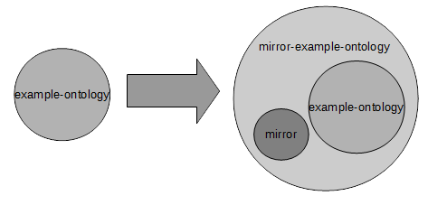

Figure 10 Mirroring an ontology

Note this process was carried out for every single ontology in the project, except the final GLAMURS ontology, which we have, for obvious reasons denoted the ***glamurs*** ontology. Consequently for every component ontology, except for the ntnu (environmental foot printing), there are always two ontologies. The first is the ontology representing that particular part of the project, for example ***tipac***, for the TiPaC agent based model ontology; or ***expert***, for the expert terms ontology; or ***top-down*** for the conglomeration of ontologies that represent the top-down view of the GLAMURS project. The ontologies would produce, in the same directory ***mirror-tipac***, ***mirror-expert*** and ***mirror-top-down*** respectively. The reason for the exception of the ntnu ontology is that the original ontology consists of two ontologies, ntnu and ntnu-abox, but other than this minor difference, the processing is identical for all ontologies.

# Developing the top-down ontologies

This section details the approach to creating the top-down definition of the GLAMURS project. Essentially the work was reduced to a series of ontologies, or functional units encompassed by a single ontology. These ontologies were then integrated together using an ontological vocabulary of our own devising.

Initially we took the original description of work ontology, and added the results from an on-line questionnaire, an analysis of the documentation for the project, and integrated these ontologies together using another structured ontology abstracting the common parts of some of these ontologies, and simultaneously structuring the final top-down ontology. We also began development on several other ontologies, which were not factored into the overall top-down ontology, due to incompletion.

The structure of this section is divided into the description of:

* the core, common-sense ontology, developed in the first milestone of this part of the project (Polhill and Craig 2014);
* the on-line questionnaire, used to elicit any definitions that researchers felt were important;
* the expert-terms vocabulary arising from the text-mining of the GLAMURS content management system;
* the high-usage, low-familiarity word-group ontology arising from the text-mining of the GLAMURS content management system;
* the high usage, low familiarity single words ontology from the text-mining of the GLAMURS content management system, and
* the glossary ontology containing the single words and word groups from the actual GLAMURS ontology that did actually show up as high usage and low familiarity from the text-mining of the GLAMURS content management system.

The descriptions of each of these ontologies is divided into an introduction outlining some of the history and reasoning behind the ontology; a description of the purpose of the ontology and links it has with the other ontologies; data used to develop the ontology; method by which the ontology was constructed; some results (typically in the form of a diagram showing all or part of the ontology); and any discussion points arising from this process. The final subsection details how the first three ontologies above were integrated using a common ontological skeleton, a small integration vocabulary and a very brief reiteration as to why that particular structural approach was selected, as this has already been discussed in the previous section.

## Core common-sense ontology

### Introduction

This ontology is denoted the ***core*** ontology in its filename, core.owl and namespace. In order to explain the ontology structure and in particular the origin of the ***core*** we explain a little history of the ontology development.

Initially an ontology was developed and published in the first milestone report (Polhill and Craig 2014), which appears as an appendix to Deliverable 2.1. This was based on a workshop in the first consortium meeting in January 2014. This first ontology was developed base on Shove’s Practice Theory (Shove 2012) and Latour’s Actor Network Theory (ANT) (Latour 2005). Feedback was obtained on this ontology in subsequent consortium meetings, particularly the Rome consortium meeting of October 2014 and the Trondheim consortium meeting of May 2015.

As a result of the Trondheim consortium meeting the ontology was modified by removing the overt structuring based on ANT, as this was proving to be awkward and unwieldy when trying to relate the ontology to concepts that project members could comprehend, especially with regards to massively overloading certain concepts, such as Actor. The led to the approach documented in this Deliverable, in which vocabularies are developed around a core ontology that closely reflected the everyday sense of the research question that GLAMURS was trying to answer: “How has GLAMURS provided a context in which policymakers, researchers, citizens and stakeholders come to know what it is we have to do to transform our ways of life and ways of thinking such that they are individually, socially, environmentally and economically sustainable?”

Thus it might be said that the construction of this ontology was the result of feedback on the first milestone report (Polhill and Craig 2014), and feedback from the Trondheim consortium meeting in May 2015, but briefly this is an ontological form of the description of work documentation, in conjunction with some small input from an early workshop was used create the common-sense core ontology of the project.

### Purpose and relationship with other ontologies

This is a component of the top-down ontology aggregation for the project and represents common-sense description of the GLAMURS project. This ontology, along with the on-line questionnaire ontology, ***questionnaire***, and the expert-terms ontology, ***expert*** ontology, after having been mirrored using the ***mirror*** ontology completes the components that make up the ***top-down*** ontology.

These relationships are illustrated Figure 2 and show the dependency on the ***mirror*** ontology and how the three ontologies ***questionnaire***, ***expert*** and ***core*** use this to create ***mirror-questionnaire***, ***mirror-expert*** and ***mirror-core*** respectively then combine to form the ***top-down*** ontology.

### Data used by the ontology

The ‘core’ ontology was just developed from one sentence in the description of work documents.

### Method of construction

Please consult the first milestone report (Polhill and Craig 2014) and the brief discussion of the history of this ontology in section 3.1.1.

### Results

This ontology is shown in Figure 11 and listed in on GitHub at <https://github.com/DougSalt/GLAMURS/blob/master/ontologies/top-down%20ontologies/original%20description%20of%20work%20ontology/core.owl>.

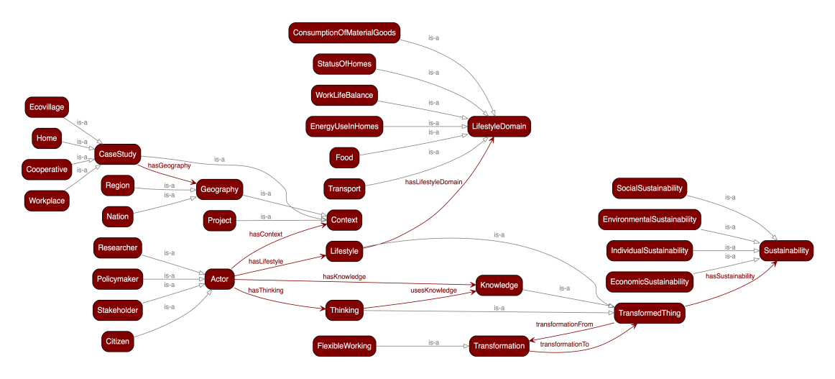

Figure 11 The common sense ontology class diagram

### Discussion points

This ontology is complete.

The aim of the ***core*** ontology was to provide a framework in which researchers could classify their research outputs, particularly anything document based. However, in the consortium meeting in Bath, October 2015 workshopping this new ontology to include the terms from the GLAMURS glossary (‘“Green Lifestyles, Alternative Models and Upscaling Regional Sustainability” Glossary’ 2015) proved surprisingly intractable. Even with a reduced number of “proof-of-concept” examples, the task of classifying these within the new ontology was not successful.

We realized as a result of the Bath meeting that a different and more dedicated approach was required. This approach resulted in the acquisition of a full-time researcher, dubbed as per (Sowa 1999), a knowledge engineer, who set about acquiring terminological definitions, using as their starting point the help-sheet form the Bath consortium ontology workshop. This worksheet formed the basis of the main instrument in acquiring definitions from the other researchers and is discussed in section 3.2.

However despite the above, this ontology is essentially the starting point for all the subsequent ontologies within this document.

## The on-line questionnaire ontology

### Introduction

This ontology is denoted the ***questionnaire*** ontology for both its filename, questionnaire.owl and namespace.

The online questionnaire was created as a result of discussing the ontology at the Bath consortium meeting, to allow researchers to specify and refine the ontology of the GLAMURS project in their own time and at their own pace, and without the need to learn specialist ontology language to do with the basic ontological ‘kinds’ (classes, attributes, relationships and processes). The ***core*** ontology described in section 3.1 proved somewhat unwieldy to use as evidenced by the difficulty in classification that occurred at the Bath consortium meeting in October 2015. In order to remedy this, several ontologies were developed. The first of these is detailed in this section and was to directly ask researchers which terminology they considered important, whether it was defined properly or even if it were defined at all. In order to do this we designed an on-line questionnaire by which researchers could voluntarily define such terminology in a manner closely aligned to required ontological concepts. This section examines the design of the questionnaire and the process by which the first set of responses to this questionnaire; denoted ‘unsolicited’ responses (because respondents were not asked to enter specific terms, but to contribute terms they thought important *ad hoc*) were processed into an ontology that we have denoted the ***questionnaire*** ontology (see GitHub <https://github.com/DougSalt/GLAMURS/blob/master/ontologies/top-down%20ontologies/on-line%20questionnaire%20ontology/questionnaire.owl> for a full listing of this ontology).

### Purpose and relationship with other ontologies

This ontology represents primary specialist vocabulary.

This is a component of the top-down ontology aggregation for the project and represents definitions provided by researchers to an on-line questionnaire, that researchers consider important to define. This ontology, along with the core common-sense ontology, ***core*** and the expert-terms ontology, ***expert***, after having been mirrored using the ***mirror*** ontology completes the components that make up the ***top-down*** ontology.

This ontology also incorporates the ***metadata*** ontology class framework and uses the vocabulary in the ***integration*** ontology.

These relationships are illustrated Figure 2 and show the dependency on the ***mirror*** ontology and how the three ontologies ***questionnaire***, ***expert*** and ***core*** use this to create ***mirror-questionnaire***, ***mirror-expert*** and ***mirror-core*** respectively then combine to form the ***top-down*** ontology.

### Data used by the ontology

Forty responses to an on-line questionnaire obtained in the period 26 April 2016 – 15 July 2016.

### Method of construction

This approach involved gathering terms via the on-line questionnaire, by invite only (although accessible publicly). The questionnaire was designed to elicit specifically OWL 2 ontological specifications [1]. A textual representation of the entire questionnaire can be found in appendix 1. A simplified block diagram of the questionnaire is also shown in Figure 12. In summary, the respondent is initially confronted by a screen requesting name and email information. This was done in order to identify where the response had originated, and in particular to help identify the institution of the participant, giving some further indication as to their area of interest and expertise. By completing the registration the respondent was emailed a link to the survey along with a uniquely identifying URL cookie. Having followed this link the respondent was asked to specify the term they were interested in defining. They were also asked to specify what their area of expertise or discipline was and if this related to the term under consideration. They were also asked if they agreed with the definition of the term if it was extant in the glossary already. If not, then they were given the opportunity to define that term for themselves.

As explained in the Introduction there are 4 primary ontological entities:

* class;
* data value;
* object property, and
* individual.

This are the ontological entities we are trying to elicit by use of the questionnaire discussed in this section. Along with these four primary ontological entities each can have other attributes associated with it. These attributes are listed in Table 5.

In addition to these primary entities we introduced a fifth entity: the process. As discussed elsewhere, such processes may be defined as composite of the original OWL 2 ontological primitives listed above, but for concepts of environmental sustainability it was argued in (Polhill and Craig 2014), that the process should be considered an ontological primitive in any project investigation of sustainability, as transformation to such sustainability, must perforce be time-dependent, and consequently a process. Processes are therefore important in a project covering transitions to sustainable lifestyles and the green economy. OWL 2 ontologies have been used to describe such things as the means by which artefacts come to exist (provenance – see [3] and [4]). Processes are therefore viewed as a special kind of class, which is assumed to be part of the vocabulary for that particular domain of discourse.

A series of informal questions were then posed to establish the provenance of the term. These established whether the term represented measurement or some property of an item (a data value in OWL 2); if this term represented a specific instance of something (an individual in OWL 2); whether this term could be used to type or classify objects into some form of taxonomy (a class in OWL 2); if this term could be used to link objects (a relationship, or object property in OWL 2 terms), or finally, if the term represented some time-dependent process (as mentioned above, a special kind of class, but not a primitive in OWL 2). For instance, to try and prompt the user to recognize the term as an OWL 2 data value, then questions were posed as to whether the term could be represented numerically, or if it had units.

Upon completion of this informal part of the questionnaire, the respondent was queried more formally as to the nature of the term under examination. The respondent had a choice of more prompted, formal definition or terminating the questionnaire at that point.

Table 5 shows the division of definition of the questionnaire at this point and the supporting required specifications used in order to complete the definition of a given term. It should be noted that very few of this values were mandatory for completion of the questionnaire, as it was felt that any definition information would be useful, rather than none.

Table 5 OWL 2 entity attributes

|  |  |
| --- | --- |
| **Entity** | **Attributes** |
| Class | Name, related classes and the relation to the those classes, such as superclass, subclass, equivalent to, or something else. |
| Individual | Name |
| Data Value | Name and kind of property. If numeric then minimum, maximum values and units of measurement. If text then possible values. Also to which class the property applied |
| Object Property | Name, and which classes this relationship linked. |
| Process | Name, previous processes and classes affected by the process (given that a process is always a type of class) |

Given the relatively low number of unsolicited responses to the questionnaire, and informal requests for feedback to the questionnaire from the project members, it is evident that the design of the questionnaire was not particularly suited to eliciting the required information from the given audience; the nature of the specialist nature of OWL 2 terminology tended to confuse respondents, or even deter them from even attempting the questionnaire. Although we tried to mitigate this with the informal section of the questionnaire (see Figure 12) by asking questions that tried to get the respondent thinking in the correct manner, this helped, but not as much as we would have wished. Indeed the most complete responses were for specifications of processes, which are not themselves recognized OWL 2 primitives. The reason for the easy comprehension of the processes may be because it is part of everyday experience that one process may follow another and processes always have effects on some class of objects.

Figure 13 Questionnaire flowchart

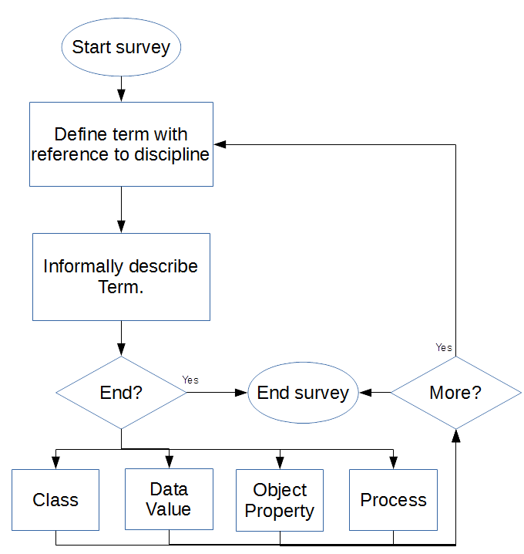

Figure 12 Simplified questionnaire flowchart

The reason for the additional metadata, shown in the flowchart for the construction of all ontological entities in Figure 14 is partially for back-referencing when trying to determine the origin and definition of terminology. The additional metadata also allows the effective categorisation and identification of the ontological classes and properties when trying to link entities in the very complicated combined ontologies such as in the top-down ontology and when combining this ontology with the various bottom-up ontologies. Given that there were eventually 16,000 axioms then effective organisation was absolutely necessary in order to locate and classify links between the various ontological entities, and between the component ontologies. For this purpose, and in particular for linking the various ontological components of the top-down ontology, a top-down ontology with common features, denoted the metadata ontology was developed. For more details on the structure and purpose of this common structure for the creation of the components of the top-down ontology, please consult section 2.1.

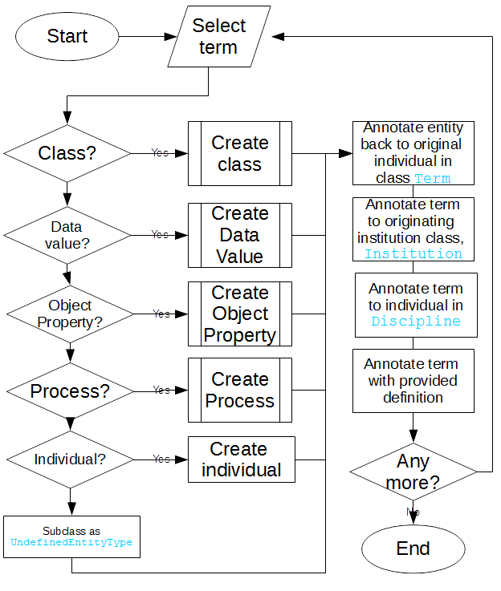

Figure 14 Overall Ontology Construction

The actual construction of the ontology based on the responses to the questionnaire was reasonably straightforward in that the each of the terms were created as individuals in a class Term. This allowed the establishment of provenance by linking each term instantiated as an individual in the ontology to the ontological entity that was created, corresponding to that term. This also linked the ontological entity with an annotation on that individual such as the textual definition for the term created by questionnaire respondents.

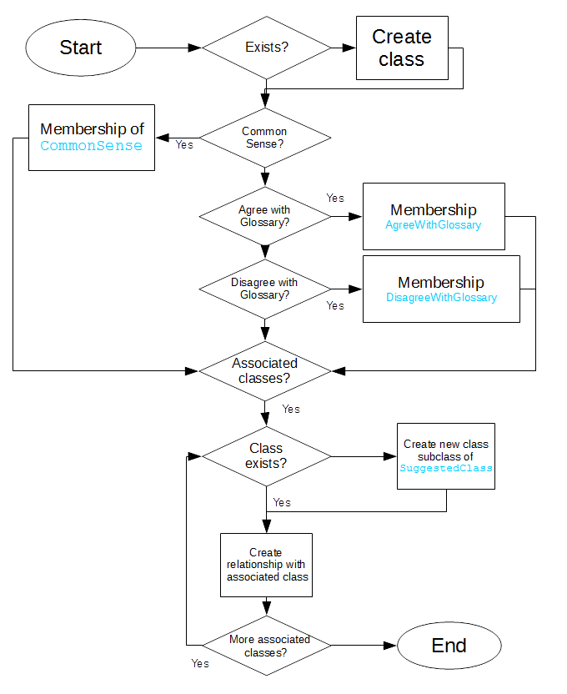

Figure 15 The class creation flowchart

Each individual of this class was then examined in terms of the results returned from the on-line questionnaire. This is shown in the flowchart Figure 14. If the term is just an individual then the individual is instantiated and the next term is examined. The create data value process is also very straightforward in that it creates a data type in hasSuggestedAtrribute and sets the domain of the attribute as the associated class if that class is provided. For the present it is assumed that the domain of such data types are sets of strings of basic data types already defined for OWL 2. For a list of such datatypes, please consult (Bock et al. 2008).

The processes of evaluation for the remaining entities were a little more involved and a brief explanation of each now follows with a corresponding flow-chart.

The class evaluation and creation process is shown in Figure 15, which will create a class if it does not exist and then link to any new classes specified in the questionnaire as being associated with this class and create these (if they do not already exist) and add these new classes to the SuggestedClass class, along with specifying the relationship to the new class derived from the terminology. Such a relationship might be as subclass, a superclass, equivalence or some other relationship, such as disjoint or disjoint union with. This part of the evaluation also classifies the new class as part of the glossary, either agreeing or disagreeing with the glossary, or has been determined to be common-sense (for more on the definition of common-sense, please see section 3.3).

For relationships, each relationship specified in the responses to the questionnaire was examined for domains and ranges, these necessarily being classes, and thus requiring definition if not already present. Again these were subclassed to SuggestedClass. These domains and ranges were then used to set the domains and ranges, in intersection for these relationships, one the relationship had been defined in hasSuggestedProperty.

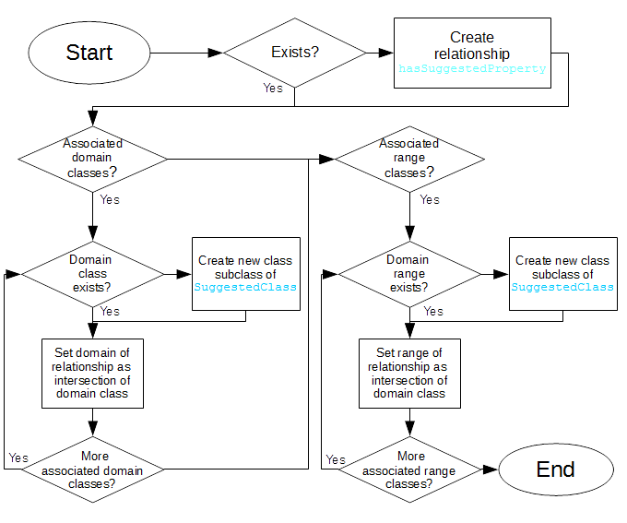

Figure 16 Relationship creation flowchart

Although OWL 2 does not insist that such ranges and domains are prescriptive, in that they serve no other purpose than acting as an advisory on what should be in the domain or codomain of such a relationship[1]; this being a reasonable consequence of the notion of the open-world assumption, an ontology may be assumed never to fully specified for every eventuality, they are however used in generating metadata relationships between terms representing such classes in the global GLAMURS ontology in section 5.

Lastly we have processes analysis and definition flowchart and this is shown in Figure 17, which in some ways is very similar to the diagram for the definition of relationships/object properties above. The structure is similar in that the definitions forces the cycling through each of the prerequisite processes and makes sure that these are defined, along with cycling through the affected classes and ensuring, as well that these are defined. The main difference between this and the previous definition flowchart is that the prerequisite processes are defined in the ontology as restrictions on the domain of the process under analysis. That is they must be in the domain of the requires primitive (a specialisation of the uses primitive)

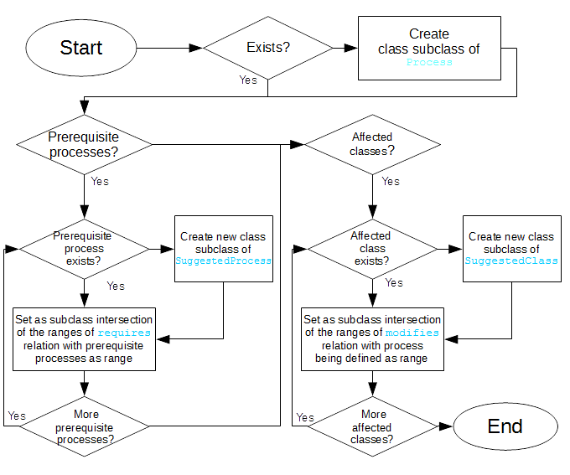

Figure 17 Process definition flowchart

Diagrammatically this restriction on the domain of these processes can be represented as shown in the diagram below.

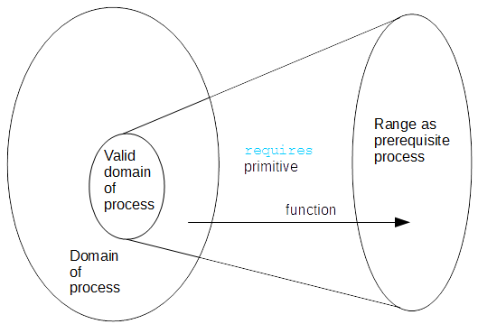

Figure 18 Process domain and range

So for example, if Process A is a prerequisite of Process B, then we make the restriction of exists some member a of Process A and there exists some member b of Process B such that a *requires* b;

or symbolically:

$$∃ a ∈dom({Process}_{A}), b ∈dom({Process}_{B)}:b=requires(a)$$

where $dom\left({Process}_{A}\right)$ is the domain for ${Process}_{A}$, as $dom\left({Process}_{B}\right)$ is the domain for ${Process}_{B}$.

The above is only strictly true if requires is functional, but the principle still applies in general to a non-functional requires primitive. A similar construction can be used to in conjunction with the primitive modifies to establish a domain that specifies those class that such a process affects, under modifies.

### Results

We had some 86 responses to the questionnaire, the responses being split into two groups. These we have denoted as unsolicited responses and solicited responses.

The unsolicited responses were those responses we obtained once members of the project group were informed that the questionnaire was ready. These were for definitions for terminology already in extant in the project glossary [2], and additionally terms that project members deemed sufficiently important enough for definition. The solicited responses were answers to requests to specific requests for definitions of terminology that was uncovered as part of the process to uncover expert terminology detailed in section 3.3.

The class diagram for this ontology is shown in Figure 19.

The online questionnaire ontology, ***questionnaire*** listing can be found on GitHub at <https://github.com/DougSalt/GLAMURS/blob/master/ontologies/top-down%20ontologies/on-line%20questionnaire%20ontology/questionnaire.owl>.

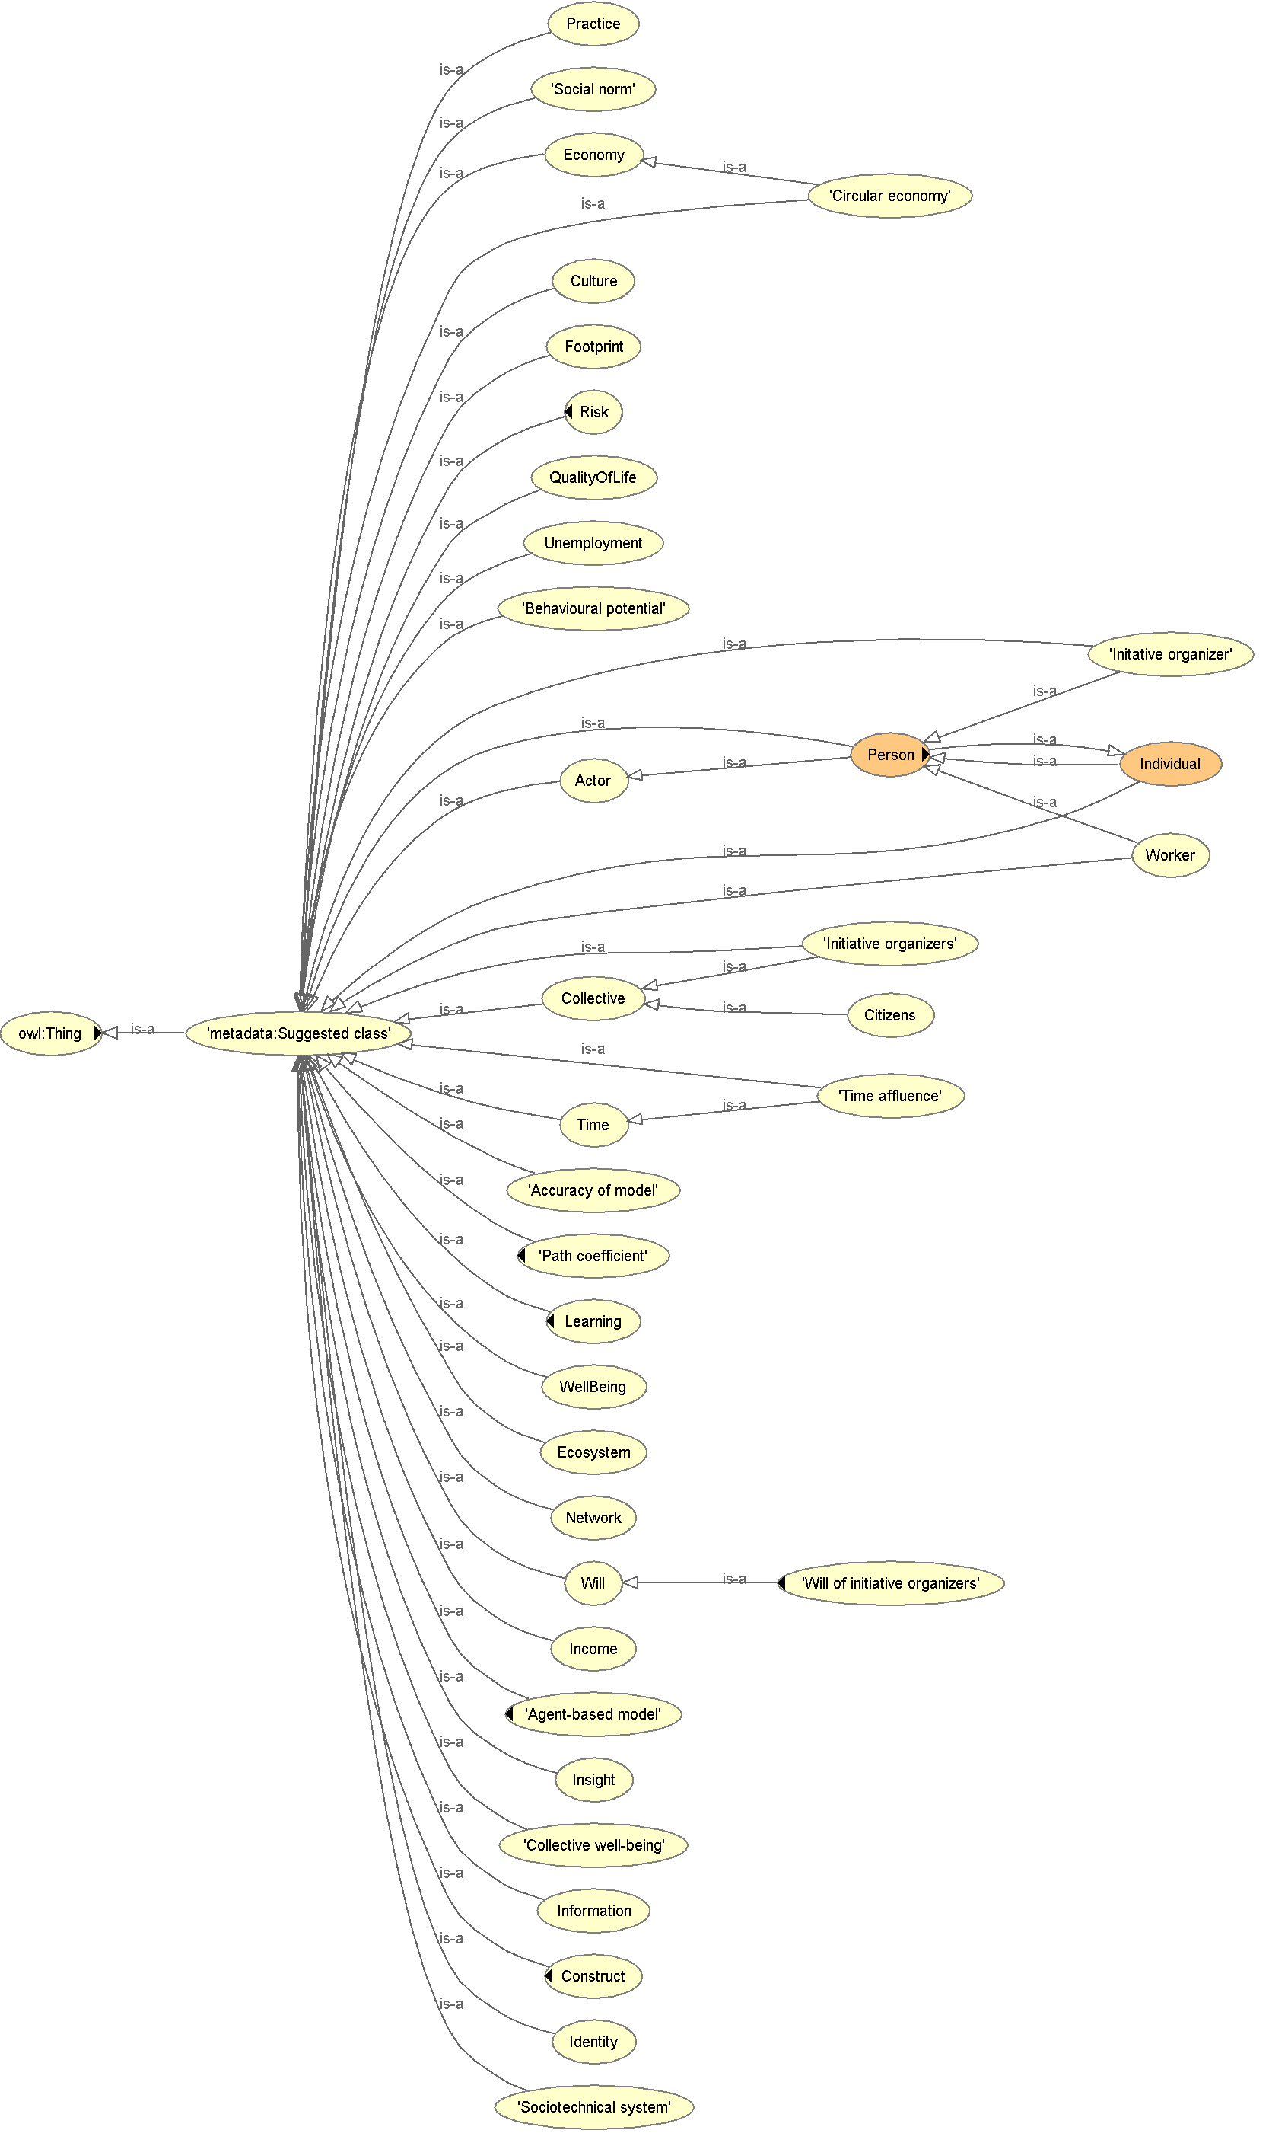

Figure 19 The *questionnaire* ontology class diagram

### Discussion points

This ontology is complete.

In this section we have developed a successful methodology for the gathering and collation of terms in a manner useful to knowledge engineers. Moreover we have also developed a qualitative comprehension methodology for converting the responses to the questionnaire into an OWL 2 ontology. This methodology is useful in that it is used elsewhere in construction of other components of the full top-down ontology. Although the responses were of a lower number than hoped, it was also noted that if the ontological concepts were explained to project members in a one-to-one situation or small group, then with such coaching it was apparent that project members definitely understood and easily grasped the concepts involved. This leads us to believe that in future a questionnaire to elicit ontological definitions must be carefully couched in non-technical language with clear examples and a clear explanation of the aims of the gathering of such definitions. In particular easier to understand concepts which are not strictly ontological primitives, such as “process” definition used above, in order to tease out the required information from project participants. This would also mean existing work such as that already done for provenance ontologies as in (Herre 2010) and process conceptualisation in (Moreau et al. 2011). Moreover we believe as well, given our personal experience, that not only would it increase the information relevant to project integration if each of the contributing members of the project were individually coached, or at least helped in small gatherings to understand the concepts in building the ontology for the project this would massively increase in enthusiasm and engagement with the whole project integration process.

## The expert-terms ontology

### Introduction

This ontology is denoted the ***expert*** ontology for both its filename, expert.owl and namespace.

The common-sense ***core*** ontology, detailed in section 3.1 was not comprehensive enough to describe the project from a top-down perspective, so rather than repeating the workshop approach to further broaden the top-down ontologies, we decided to try and enhance the ***core*** ontology using several other approaches. The first of these was to try obtain terminology *ad hoc* from project members by use of an online questionnaire. This approach has been detailed in the previous section, 3.2. We obtained just 40 definitions using this method, over a two month period commencing late April 2016, and clearly this was insufficient to produce the kind of detail we really wanted to obtain.

The ontology described in this section, and denoted the expert terms ontology was an attempt to elicit the actual working ontology of the project, rather than that defined in the initial description of work and formal specification of the project. This ontology is referred to throughout this document as the “expert” ontology That is this would be the vocabulary that was most used in the project between researchers, rather than the expected vocabulary that was initially defined in the GLAMURS glossary (‘“Green Lifestyles, Alternative Models and Upscaling Regional Sustainability” Glossary’ 2015).

### Purpose and relationship with other ontologies

This ontology represents primary specialist vocabulary.

This ontology was created from terminology mined from the GLAMURS documentation and assessed using text analysis techniques to have high usage within the GLAMURS project. Initially started as an experiment to test the correctness of the WordNet “familiarity” metric (see section 3.3.4), this uncovered specialist vocabulary that need definition.

This ontology, along with the core common-sense ontology, ***core*** and the on-line questionnaire ontology, ***questionnaire***, after having been mirrored using the ***mirror*** ontology completes the components that make up the ***top-down*** ontology.

This ontology also incorporates the ***metadata*** ontology class framework and uses the vocabulary in the ***integration*** ontology.

These relationships are illustrated Figure 2 and show the dependency on the ***mirror*** ontology and how the three ontologies ***questionnaire***, ***expert*** and ***core*** use this to create ***mirror-questionnaire***, ***mirror-expert*** and ***mirror-core*** respectively then combine to form the ***top-down*** ontology.

### Data used by the ontology

This was result of text mining the GLAMURS content management system (CMS): Alfresco, and solicitation for definition for these terms via the on-line questionnaire already discussed in section 3.2.

A copy of the CMS was taken on 23 March 2016 which yielded:

* 1569 documents;
* 698 readable documents (pdf, doc, docx);
* 7,081,384 single words and word-groups of 2 and 3.

### Method of construction

In order to uncover this vocabulary text-mining was performed on the GLAMURS documentation corpus residing in the Alfresco Content Management System (CMS). Initially the terminology with greatest frequency and that with greatest “familiarity” was selected. This was done in order to investigate the effectiveness of the toolset at our disposal, and to test out some ideas we had about the distribution of vocabulary, not least whether this measure of “familiarity” was actually a useful tool for terminology discovery.

The text mining was executed using a combination of Perl, Java and shell scripts. We analysed all PDF and Word documents in the repository, converted these to text files, semi-automatically eliminated older versions and duplicate documents, tokenised and sequenced the results into individual words and word groups and then counted the frequency of single words, and word groups of two and three, discarding those having a trivial frequency of occurrence (less than 5 instances).

We used WordNet (Miller 1995) to measure the “familiarity” of particular words and word groups. This familiarity is a count of how many *synsets* a word or word group is present in and thus generally correlates with frequency of usage in the English language. Synsets are collections of words that are semantically related to each other. For instance, “consumption” and “total usage” might be members of the same synset.

As an exercise in testing the effectiveness of the familiarity measure we selected the top 200 single words in terms of their frequency of occurrence in the text and their familiarity. Upon investigation of these 200 terms, all 200 single words were found to be “common-sense,” in that it was deemed unnecessary to elicit their meanings from other members of the project team, as their meaning was fairly self-evident. This was the expected result, as these words were “highly familiar” and thus it should come as no surprise that these are indeed “common-sense.” As a further test, we then plotted the frequency of each word used anywhere in any documentation against its familiarity (in grey), contrasting the selected 200 terms (in red) against single words from the GLAMURS glossary (in blue). The result was quite striking, and it is shown in Figure 20 in that words from the glossary had high frequency, but low familiarity (contained in the upright oval on the graph), which is as we would expect for technical terminology in the documentation of a project. It would seem reasonable to suggest that there is further undefined project specialist terminology in the same region of the graph. Moreover this also gave some indication of the actual glossary terms that were not really part of the ontology of the project. That is terminology that was initially defined as part of the project in the glossary (‘“Green Lifestyles, Alternative Models and Upscaling Regional Sustainability” Glossary’ 2015) seemed to be unused in the documentation resident in the CMS.

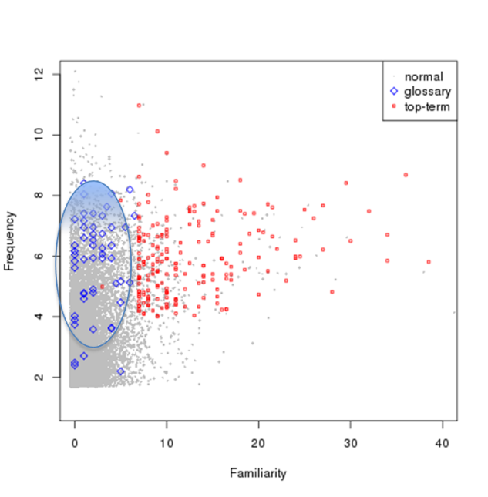

Figure 20 Single word frequency vs familiarity

In the case of word groups of 2 and 3 the result was not quite so clear cut. Again we determined the top two hundred word groups in use with the highest familiarity (summed over all words in the word group) and analysed the results. So for instance if a word group consists of some words in any order: $W= X_{1},{…, X}_{n}$ where $X_{i}$ is some word in the word group, and $2 ≤n≤3$, then if the individual familiarity of all the words in the word group, is denoted $familiarity\left(X\right)$, then we regard the total familiarity for a particular word group, $W_{F}$ as simply:

$W_{F}= \sum_{i=1}^{n}{(familiarity(X_{n}))}$

There is no theoretical justification for summing the familiarity in the word groups in this manner, and indeed we did try and take the mean, and the mode to see if this made any difference. The “sum” produced the best results, but this needs additional investigation.

This lead to rejecting all but 61 of the resultant words groups as possible terminology. Reason for rejection included ending in “the,” “a” or a verb.

Of these remaining terms a further 14 were eliminated being judged by Hutton GLAMURS team to be common sense, and thus not requiring definition. This was determined by randomly selecting 9 terms and providing these terms to two members of the Hutton GLAMURS team. If both agreed that the term was common-sense, then no further definition was sought for that term, and it was marked as common-sense. Another 8 terms were rejected for reasons of duplication or being subsets of other terminology.

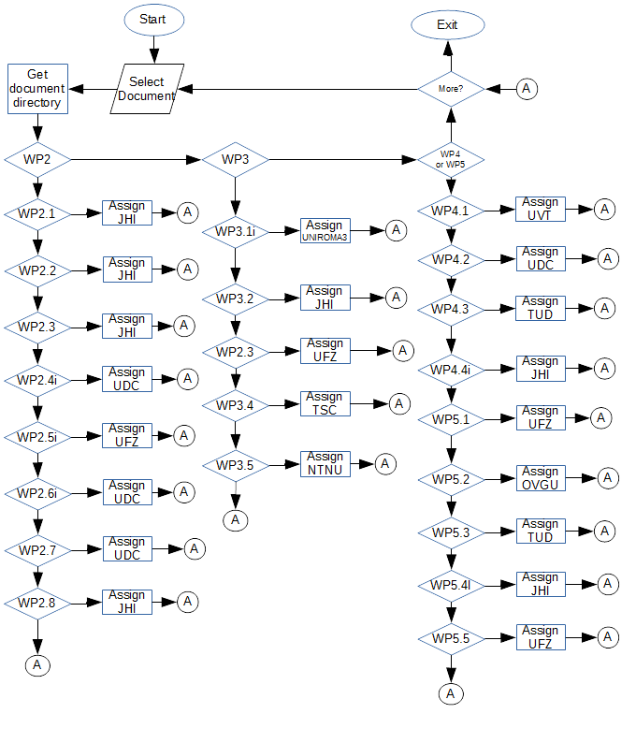

Figure 21 Document responsibility flowchart

The remaining 47 terms, denoted the expert vocabulary, were distributed to the GLAMURS project team. Members of the project team were asked to define these terms using the online questionnaire referred to in section 3.2 and detailed in textual form in appendix 1. Project members were selected on the basis on their institution of origin and which work package directory the term originated in. For instance if the word appeared in a document in work package 2 – project integration and knowledge coproduction – then any project member from The James Hutton Institute would be asked for a definition of that particular term. The process for this assignment is shown in Figure 21.

Although not clearly defined specialist vocabulary as in the sense of the oval in Figure 20, these word groups were in frequent use within the project, and by definition represented an ontology of some description and consequently must provide some contribution to the overall project ontology. Hence, even though these word groups were of high-familiarity (and thus possibly not specialist vocabulary) it was felt that definition of these word groups would make a considerable contribution to the top-down ontology.

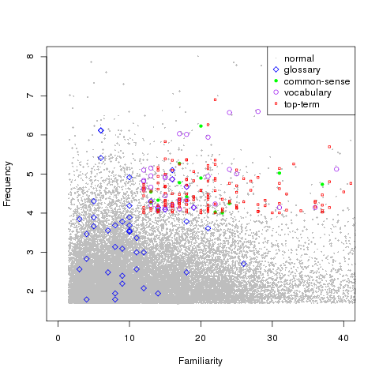

Figure 22 Word-group frequency vs familiarity

As in the case for single words the frequency of a word group occurrence was plotted against its additive familiarity, giving the graph shown in Figure 22. This graph differs from that for single words in that it includes two additional forms of high-lighting. The 47 new word groups in the expert terms from this text mining are highlighted (purple), and the common-sense terms obtained from the top 200 terms are also included (green). The distinction between terminology in this graph, Figure 22 is not so clear cut. The additive familiarity is not quite so useful as common words in uncommon combination do not necessarily imply high familiarity. However the upright oval selects terms of low familiarity and high frequency, capturing quite a few terms from the glossary, implying the glossary had reasonable success when applied to word groups. It may also be that choosing a different metric to determine the familiarity of a word combination (e.g. the minimum familiarity, or a mean, or a mode rather than the total familiarity) would produce a clearer separation of terminology and everyday language.

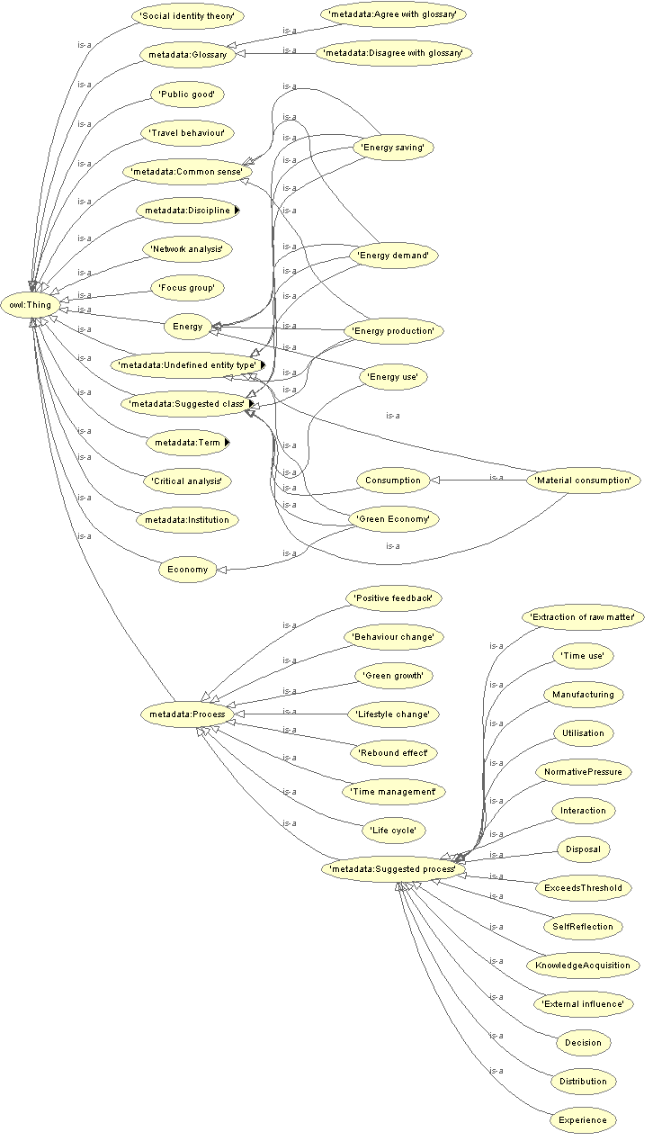

Figure 23 Class diagram for the *expert* ontology

The ontology was then constructed using exactly the same formalised qualitative approach outlined in by the flow-charts described in 3.2 and the flowcharts in Figure 14 - Figure 17.

### Results

46 of these terms and these were defined in the period 26th July 2016 – 31st December 2016.

The class diagram for this ontology, ***expert*** with key classes expanded is shown in Figure 23.

A full listing of the ontology can be found on GitHub at <https://github.com/DougSalt/GLAMURS/blob/master/ontologies/top-down%20ontologies/expert%20vocabulary%20ontology/expert.owl>.

### Discussion points

This ontology is complete.

From the graphs above, and in particular the graph in Figure 20 it is quite striking that some terms of the glossary for both single words and word groups have low frequency in both graphs. The conclusion that we draw from this is that such terms from the glossary and not really parts of the project ontology.

This is not so clear for word groups as shown in Figure 22, but the measure of familiarity we chose was somewhat arbitrary. We believe there is probably some corresponding measure to single word familiarity that would probably prove just as striking as that which we used for single words. We have tried summation, mean and mode and summation gave the best results. However there could other measures such as plain maximum or minimum familiarity or some more abstruse combination of the individual familiarities.

We also successfully re-employed the methodology to generate this ontology that was developed in order to create the ***questionnaire*** ontology (see section 3.2.4).

## High frequency word group terms ontology

### Introduction

This ontology is denoted the ***word-groups-frequency*** ontology for both its filename, word-groups-frequency.owl and namespace.

This was a direct response to the success and usefulness of the expert-terms, ***expert*** ontology. This and the following ontology represented the next stage in eliciting the more specialist vocabulary, from the project members. However, unlike the ***expert*** ontology, these word groups would have had high usage, but low Wordnet familiarity (see section 3.2.4) firmly placing them in the real glossary of the project, of true terminology for GLAMURS represented by the oval in Figure 22, which we believe expresses actual expert vocabulary in use by the project.

### Purpose and relationship with other ontologies

High-frequency word-groups with low-familiarity mined form the GLAMURS content-management system, Alfresco.

The aim was to include this ontology in the aggregation of ontologies that would have made up the top-down view of the project. Because this ontology was not completed then it takes no part in the final GLAMURS ontology.

The ontology includes the ***metadata*** and ***integration*** ontologies which are included in any top-down ontology as a matter of course for their development.

### Data used by the ontology

Text-mining the CMS on 23 March 2016 which yielded:

* 1569 documents;
* 698 readable documents (pdf, doc, docx);

Review of the 5000 word-groups from analysis of the CMS, semi-automated using Perl scripts of the results by two researchers to determine whether the word-group in question was one of the following:

* possibly project terminology - requiring definition;
* nonsense term – spelling error or invalid grammatically, or
* common-sense term - not requiring any definition.

Two researchers were used in order to more accurately if a term was truly one of the above. Categorisations of word-terms were only accepted if both researchers were in accord.

### Method of construction

Although incomplete the method of construction was to emulate that described in section 3.1.4.

### Results

The high-frequency word group ontology denoted the “word-group-frequency” ontology containing word groups of high-frequency and low-familiarity.

This is where we expected to find the word group terminology of the project, as per the explanation in section 3.3. As it stands this ontology contains 206 word-groups defined as individuals in the ***metadata*** class Term.

A full listing of the incomplete ontology may be found on GitHub at <https://github.com/DougSalt/GLAMURS/blob/master/ontologies/top-down%20ontologies/high%20frequency%20terms%20ontology/word-groups-frequency.owl>.

### Discussion points

There is not much to say here and no analysis was performed on the incomplete ontology, other than we would have expected at least some commonality between this ontology and the word groups from the ***glossary***, the ***expert*** and the ***questionnaire*** ontologies.

## The high frequency single word terms ontology

### Introduction

This ontology is denoted the ***single-words-frequency*** ontology for both its filename, single-words-frequency.owl and namespace.

This was a direct response to the success and usefulness of the expert-terms, ***expert*** ontology. This and the following ontology represented the next stage in eliciting the more specialist vocabulary, from the project members. However, unlike the ***expert*** ontology, these single-words would have had high usage, but low WordNet familiarity (see section 3.2.4) firmly placing them in the real glossary of the project, of true terminology for GLAMURS represented by the oval in Figure 20, which we believe expresses actual expert vocabulary in use by the project.

### Purpose and relationship with other ontologies

High-frequency single-words with low-familiarity mined form the GLAMURS content-management system, Alfresco.

The aim was to include this ontology in the aggregation of ontologies that would have made up the top-down view of the project. Because this ontology was not completed then it takes no part in the final GLAMURS ontology.

The ontology includes the ***metadata*** and ***integration*** ontologies which are included in any top-down ontology as a matter of course for their development.

### Data used by the ontology

Text-mining the CMS on 23 March 2016 which yielded:

* 1569 documents;
* 698 readable documents (pdf, doc, docx);

Review of the 5000 single-word from analysis of the CMS, semi-automated using Perl scripts of the results by two researchers to determine whether the single-word in question was one of the following:

* possibly project terminology - requiring definition;
* nonsense term – spelling error or invalid grammatically, or
* common-sense term - not requiring any definition.

Two researchers were used in order to more accurately if a term was truly one of the above. Categorisations of single-words were only accepted if both researchers were in accord.

### Method of construction

Although incomplete the method of construction was to emulate that described in section 3.1.4.

### Results

The high-frequency single-word ontology denoted the “single-words-frequency” ontology containing single words of high-frequency and low-familiarity.

This is where we expected to find the single-words terminology of the project, as per the explanation in section 3.3. As it stands this ontology contains 691 single words defined as individuals in the ***metadata*** class Term.

A full listing of the incomplete ontology, ***single-word-frequency*** may be found on GitHub at <https://github.com/DougSalt/GLAMURS/blob/master/ontologies/top-down%20ontologies/high%20frequency%20terms%20ontology/single-words-frequency.owl>.

### Discussion points

There is not much to say here and no analysis was performed on the incomplete ontology, other than we would have expected at least some commonality between this ontology and the single words from the ***glossary***, the ***expert*** and the ***questionnaire*** ontologies.

## The glossary ontology

### Introduction

This ontology is denoted the ***glossary*** ontology for both its filename, glossary.owl and namespace.

This ontology would include terms from the actual GLAMURS glossary (‘“Green Lifestyles, Alternative Models and Upscaling Regional Sustainability” Glossary’ 2015) that were found to be in use in the corpus of the GLAMURS documentation.

### Purpose and relationship with other ontologies

High-frequency single-words and word-groups with low-familiarity mined from the GLAMURS content-management system, Alfresco. n

The aim was to include this ontology in the aggregation of ontologies that would have made up the top-down view of the project. Because this ontology was not completed then it takes no part in the final GLAMURS ontology.

The ontology includes the ***metadata*** and ***integration*** ontologies which are included in any top-down ontology as a matter of course for their development.

### Data used by the ontology

Text-mining the CMS on 23 March 2016 which yielded:

* 1569 documents;
* 698 readable documents (pdf, doc, docx);

A list of single words and word groups were compiled from the actual GLAMURS glossary (‘“Green Lifestyles, Alternative Models and Upscaling Regional Sustainability” Glossary’ 2015) and these words were checked against the above mined documentation to see if they had reasonable frequency of usage and low familiarity.

### Method of construction

Although incomplete the method of construction was to emulate that described in section 3.1.4.

### Results

We would have expected to find all the terms of the glossary in the lists produced from section 3.6.3 and 3.6.4 but only found 41 of 61 single words in use by text analysis from the actual GLAMURS glossary (‘“Green Lifestyles, Alternative Models and Upscaling Regional Sustainability” Glossary’ 2015). Similarly with word groups only 23 of 116 word groups from the same glossary were found to be in common use.

A full listing of the incomplete ontology, ***glossary*** may be found on GitHub at <https://github.com/DougSalt/GLAMURS/blob/master/ontologies/top-down%20ontologies/glossary%20ontology/glossary.owl>.

### Discussion points

This ontology is incomplete.

Seemingly only 67% of single words from the actual GLAMURS glossary were used, and 20% of word groups were used from the same source. Even though this ontology was not completed, this provides empirical evidence that even with the best of intentions a project glossary will not always indicate the true ontology of a project.

## The top-down ontology

### Introduction

This ontology is denoted the ***top-down*** ontology for both its filename, top-down.owl and namespace.

This subsection explains the process by which the previous 3 ontologies, the common-sense core ontology, ***core***; the online questionnaire ontology, ***questionnaire***, and the expert-terms ontology, ***expert*** were integrated together into one top-down ontology, sufficiently comprehensive to represent a description of the GLAMURS project based on the stated aims of the project, taking into account the documentation of the project and the initial description and specification of the project.

### Purpose and relationship with other ontologies

This is the top-down view of the GLAMURS project. This is an integration of the common-sense core ontology of the project, ***core*** and the two expert terminology ontologies compiled with a top-down view in mind: the expert-terms ontology, ***expert***.

Its relationship is the aggregation of the ontologies shown in Table 6.

Table 6 Top-down ontology constitution

|  |  |  |
| --- | --- | --- |
| **Ontology name** | **Contains ontologies** | **§** |
| ***core*** |  | Section 3.1 |
| ***mirror-core*** | ***core, mirror*** |  |
| ***questionnaire*** | ***integration, metadata*** | Section 3.2 |
| ***mirror-questionnaire*** | ***questionnaire, integration, metadata*** |  |
| ***expert*** | ***integration, metadata*** | Section 3.3 |
| ***mirror-expert*** | ***mirror, integration, metadata, mirror*** |  |
| ***metadata*** | ***integration*** | Section 2.1 |
| ***integration*** |  | Section 2.2 |
| ***mirror*** |  | Section 2.4 |

### Data used by the ontology

This is an integration of the ontologies shown in Table 7.

Table 7 Top-down component ontology purposes

|  |  |  |
| --- | --- | --- |
| Ontology name | **Ontology purpose** | **See section.** |
| ***core*** | Common sense description of the GLAMURS project | Section 3.1 |
| ***mirror-core*** | Mirrored version of ***core*** | Section 2.4 |
| ***questionnaire*** | Contains the expert terminology with the highest usage and “familiarity.” | Section 3.2 |
| ***mirror-questionnaire*** | Mirrored version of ***questionnaire*** | Section 2.4 |
| ***expert*** | integration, metadata | Section 3.3 |
| ***mirror-expert*** | Mirrored version of ***expert*** | Section 2.4 |
| ***metadata*** | Contains development class framework for top-down ontology development | Section 2.1 |
| ***integration*** | This contains the integration vocabulary used to integrate the component ontologies in the top-down aggregation. | Section 2.2 |
| ***mirror*** | This is used to mirror ontologies for analysis. | Section 2.4 |

### Method of construction

In order to construct the ***top-down*** ontology a generalised vocabulary ontology was created with an integration vocabulary, ***integration***.Another generalised framework ontology was also created with a class structure, an object property structure and data value framework, the ***metadata*** ontology, in order to facilitate the ease of construction of the component ontologies of the top-down ontology, implied and constrained in some degree by the methodology for top-down ontology constructed detailed in 3.2 and the flowcharts in Figure 14 - Figure 17. These framework ontologies have already been discussed in sections 2.1 and 2.2.

Our aim in this section is to provide an explanation of the standard framework in which two of our three top-down ontologies were developed. Further, we suspect that this framework could be used to develop any top-down ontology in an inter-/trans-disciplinary project such as GLAMURS. In particular we provided an integration vocabulary, the ***integration*** ontology; a common framework about which to develop the top-down ontology, the ***metadata*** ontology and on which to hang the component ontological entities, including a metadata framework to keep track of the origins of each of these ontological components. This can be summarised in the diagram in Figure 24. That is the generalised integration vocabulary ontology is embedded in the generalised framework ontology, which in turn is embedded in two of the top-down ontologies developed in sections 3.1.6 and 3.3. This is achieved using ontological imports and namespaces.

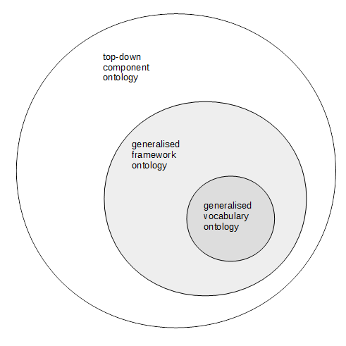

Figure 24 Top-down component ontology organisation

Given that we now have a class framework, detailed in section 2.1 that allowed the development of the components of the top-down ontologies and also that we have managed to develop and integration vocabulary as detailed in section 2.2 all that remains is to present the final structure of the top-down ontology, or common sense description of the project, ***core***; elicitation of glossary from project researchers, the ***questionnaire*** ontology, and an analysis of the available project documentation, the ***expert*** ontology. This ontology we have denoted as the ***top-down*** ontology. We would expect, given what has gone previously that this ontology should now be of the structure shown in Figure 25, where basic vocabulary from the *integration* ontology is any of the generalised integration vocabulary from the ontology discussed in section 2.1, such as, for example modifies. However this diagram does not show the actual structure of the final completed, top-down ontology. Figure 25 does not include an additional nested ontology namespace and corresponding import, which allows the creation of some additional metadata which eventually allows reasoning over the entire GLAMURS ontology to take place.

For the ontology components in this section the introduction of this new metadata namespace ontology does not modify the existing ontology components that much. The primary role of these new namespace ontologies is to allow for the creation of terms corresponding to the ontological entities for the target ontology or ontology component. As these terms already exist in the ***questionnaire*** and ***expert*** ontologies, the introduction of this additional metadata does not affect these component ontologies too much. However, for the ***core*** ontology and the bottom-up ontologies this represents a shift in how the ontologies are evaluated.

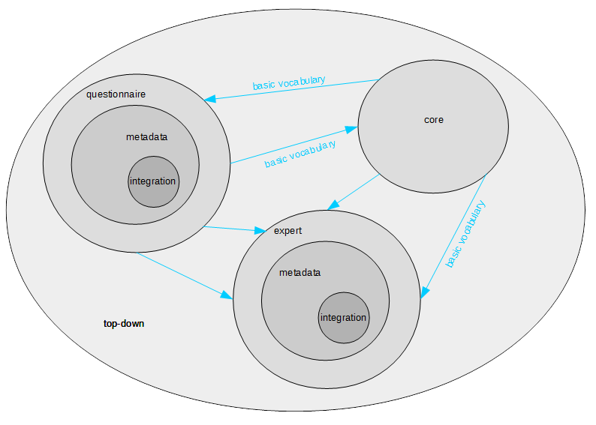

Figure 25 The expected structure of the top-down ontology

Although the new structures are metadata, these have had to be incorporated into the main structures of the ontologies, as no reasoner, as it stands, can reason over such metadata. Most of the ontologies in this document are TBox ontologies; being mostly collections of classes with relationships and datatypes defined on those classes. There are very few, if any individuals, except in the case of the ***expert*** and ***questionnaire*** where they have been metadata instantiations in the ***metadata*** for the metadata and the instantiation of the actual terms as individuals as part of the process of developing both these ontologies as detailed in sections 2.1 and 2.1. There are two other types of ontology, and these are the ABox and the knowledge base. An ABox ontology consists purely of assertions about individuals, whereas a knowledge base is a combination of an ABox and TBox ontologies. The new ***metadata*** namespace and import we have denoted, ***mirror***. Thus, in order to distinguish between the ontologies without this new ***metadata*** namespace and import, the new ontologies have been prefixed with “mirror-“ to stand for knowledge base. So, for instance the expert terms ontology component, ***expert*** is combined with this new metadata namespace, to form the new ontology ***mirror-expert***. Indeed this is the case for all bottom-up ontologies, top-down ontologies and top-down ontology components, if the name (including the IRI in the ontology) is of the form “mirror-“ suffixed by some name, then the ontology or ontology component denoted by the suffix has been processed to include this ***mirror*** namespace and ontology. So the picture in Figure 24 becomes slightly more complicated as illustrated in Figure 26.

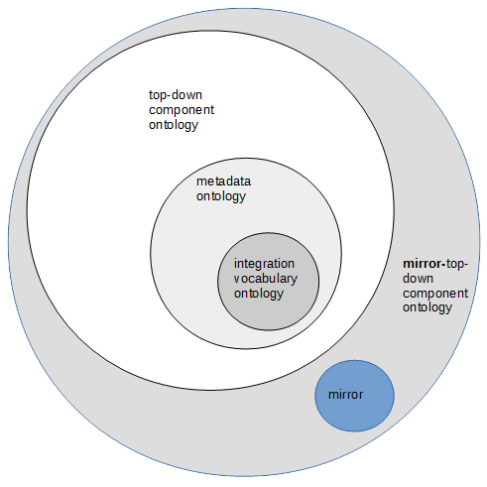

Figure 26 Mirror top-down component ontology organisation

So what processing of the extant ontology does the addition of this new ***mirror*** namespace and import add? As already mentioned this takes each of our standard ontological entities of class, data value, object property, individual or process converts them to an individual. This individual is subclassed to Term. An annotation is then created back to the original ontological entity using the relationship describes. There is an annotation (already present for the ***expert*** and ***questionnaire*** ontologies) using the standard OWL 2 rdfs:seeAlso from the ontological entity that the term defines to the actual instantiation of the term as an individual. This primitive, which as the name implies, means “see also.” Finally there is an actual relationship form the individual in the class Term to the type of ontological entity that this is. This is done as relationship assertions at individual level using the relationship isOntologicalEntity. These are instantiations as individuals representing an OWL 2 class, a data property or object property. These have been implemented as proper ontological relationships, as again, if implemented in OWL 2 annotations, then they cannot be reasoned over. Finally there is some metadata, indicating by similar relationship assertion for authorship of the ontology. This was just provided for information purposes and as yet is not actively used in any reasoning. Figure 9 shows the this new metadata class framework interacting with the new individuals for the creation of a class. For a more in-depth discussion of why this approach was taken then please consult section 2.

In addition to all the ontologies that make up the top-down ontology in aggregation being mirrored before being combined to form the ***top-down*** ontology, the ***top-down*** ontology itself is mirrored to reflect any new data found in the ontology. This ontology is denoted, ***mirror-top-down***.

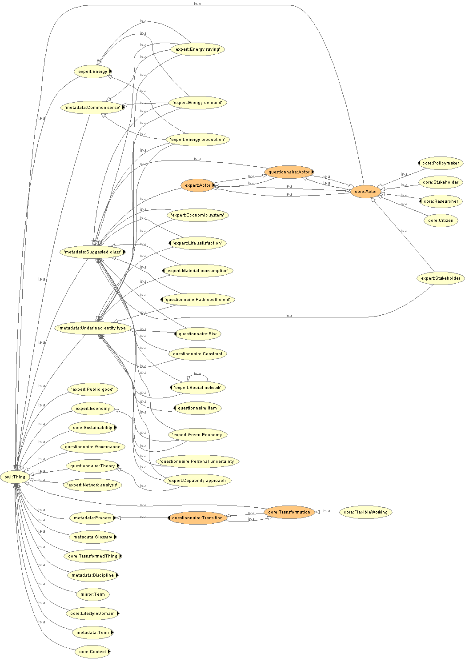

Figure 27 A selection of classes from the *top-down* ontology

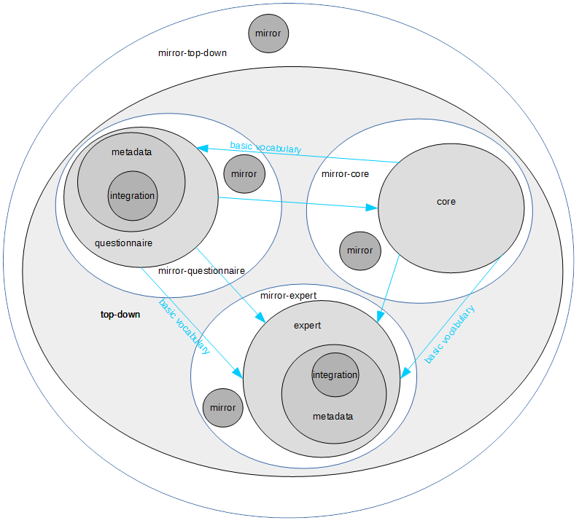

Figure 28 Final mirrored top-down ontology

### Results

Bearing the preceding discussion in mind, the diagram for the final top-down ontology is shown in Figure 28. The full listing for the top-down ontology can be found on GitHub at <https://github.com/DougSalt/GLAMURS/blob/master/ontologies/top-down%20ontologies/top-down.owl>, and the mirrored top-down ontology <https://github.com/DougSalt/GLAMURS/blob/master/ontologies/top-down%20ontologies/mirror-top-down.owl>.

Some of the classes available to the ***top-down*** ontology are shown in Figure 27.

From the point of view of integration, the creation of the axioms shown in Table 8 were required to complete this ontology.

### Discussion points

This ontology may be considered to be complete, although there are probably other connections between the three component ontologies: ***core***, ***questionnaire*** and ***expert*** ontologies that might be uncovered. Furthermore the original intention was to include the three additional ontologies, ***frequency-single-words***, ***frequency-word-groups***, and ***glossary***, so this also might be viewed as a form of incompletion.

No formal reasoning was undertaken on this ontology, but this may be worth investigation in its own right, as a conception of the project from a top-down point of view including both a common-sense view of project and an ontology actually gathered from the analysis of the project documentation.

Table 8 Top-down ontology axioms

|  |  |
| --- | --- |
| **Axiom type** | **Number of axioms** |
| EquivalentTo | 7 |
| SubClassOf | 36 |
| modifies | 4 |
| creates | 2 |
| uses | 5 |
| requires | 2 |
| hasPart | 3 |
| hasProperty | 1 |
| isModifiedBy | 13 |
| isUsedBy | 6 |
| partOf | 7 |

# The bottom-up ontologies

These ontologies represent the individual tasks within the project. We denote such ontologies as *bottom-up ontologies*. To create these ontologies we analysed documentation supplied to us from the institution responsible for that task or data. Such ontologies correspond to tasks from GLAMURS work packages WP4 – WP7. Generally coding schemes or schemata were used to create ontologies consisting purely of types, otherwise known as TBox. If actual data was present (suitably anonymised to protect privacy), then these were used to populate ABox ontologies, the resultant combination is usually referred to as *knowledge-base* in ontological engineering. The ABox may be thought of as the data in a database, correspondingly the TBox ontology may be thought of as the schemata for such a database, the combination of the data and schemata results in a useable database. The corresponding knowledge base in ontology engineering is the most useful, as this is the entity over which any formal reasoning might take place. For the purposes of this document all ontologies are TBox in nature, other than the environmental footprinting ontology, ***ntnu*** (see section 4.8), but are converted to a kind of knowledge base by mirroring with the ***mirror*** ontology (see section 2.4 and the next section).

Thus this section is structured as follows:

* An explanation of common features to the bottom-up ontologies.
* Regional questionnaire ontologies.
* Ontologies from the stakeholder interviews for the regional case-studies.
* The United Kingdom Household Longitudinal Study (UKHLS) ontologies.
* Ontologies from the TiPaC agent-based model.
* Ontologies from Tilburg University’s macro-economic model,
* Ontologies from Bath University’s micro-economic model.
* Ontologies from NTNU environmental footprinting data
* Ontologies from the backcasting.
* Ontologies from the social networking analysis of the regional case-studies.

## Common features to all bottom-up ontologies

All ontologies in this section are of the same structure, unless otherwise stated. This structure is shown in Figure 29. Generally an ontology in this section is developed using one of the methods explained below and then this resultant bottom-up ontology is nested within a “wrapper” ontology along with the metadata namespace and import. This ontology namespace and filename using contains the prefix “mirror-“. This is contains a representation of the particular bottom-up ontology as a collection of individuals, so they might be formally reasoned over, in the context of the developed knowledge base. To do this each ontological entity in the bottom-up ontology is converted to an individual.

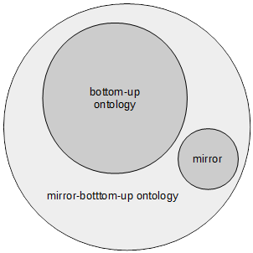

Figure 29 Bottom-up ontological structure

Along with ontological classes and properties being converted into individuals, pointers are included in the metadata both in the original ontological concept and in the resultant individual representation of the ontological entity, indicating the origin of the individual and what the individual is supposed to represent.

Finally a relationship is instantiated between the individual representing the ontological class or property to the kind of ontological entity that actual individual represents. It can be one of the following:

* class;
* data value, or
* object property.

These relationship are used to select against the correct kinds of entities when reasoning over the ontology represented as individuals in the metadata.

Rather than repeating these constructions across all bottom-up ontologies, these structures were abstracted into their own namespace, a valid ontology in its own right which we have denoted as the “mirror” ontology. The class structure of this ontology, and how it is used to create an individual for a class is illustrated in Figure 9. For a more detailed discussion of why this approach was taken and how it works then please consult section 2.3. Thus when any ontology is referenced below, then it can be assumed there is the original ontology and the wrapper ontology, name the same as the original ontology but with the prefix “mirror-“ which imports the original ontology and the ***mirror*** ontology used to provide the framework for mirroring ontologies.

## Ontologies from the GLAMURS regional questionnaires

### Introduction

These ontologies represent the regional surveys carried out in each of the case-study regions of the countries involved in the GLAMURS project. These countries were:

* Austria;
* Germany;
* Italy;
* Netherlands;
* Romania;
* Scotland, and
* Spain.

There are two sets of these ontologies. There will be unpopulated TBox ontology for the for the Scottish region, and an ontology for the remaining regions of Europe taking part in the project. The countries of these regions, being Austria, Germany, Italy, Netherlands Spain and Romania. These are different as the nature of the case studies in the rest of Europe was quite different from that in the Scotland case study.

These ontology name spaces are denoted:

* ***regional-sco*** – the regional survey TBox for Scotland, and
* ***regional-roe*** – the regional survey for the rest of the countries containing the case study regions, excluding Scotland.

The ontologies were then manipulated having all their ontological entities mirrored using the structure mentioned in section 4.1 to give an additional two ontologies, with namespaces:

* ***mirror-regional-sco***
* ***mirror-regional-roe***

The main Scottish regional survey ontology derived in section is denoted the ***regional-sco*** ontology for both its filename, regional-sco.owl and namespace. The mirroring of this ontology (see section 4.1) produces the ontology denoted ***mirror-regional-sco*** and the corresponding filename mirror-regional-sco.owl.

The main rest of Europe regional survey ontology derived in section is denoted the ***sna-regional*** ontology for both its filename, regional-roe.owl and namespace. The mirroring of this ontology (see section 4.1) produces the ontology denoted ***mirror-regional-roe*** and the corresponding filename mirror-regional-roe.owl.

### Purpose and relationship with other ontologies

There are two sets of ontologies which are the main ontologies and these are TBox and are encodings using the methodology of section 4.2.4 of the coding sheets for these regional surveys.

These ontologies, ***regional-sco***, and ***regional-roe*** are mirrored into the ontologies ***mirror-regional-sco*** and ***mirror­-regional-roe*** respectively, using the mirroring framework ontology ***mirror***, and these are included directly into the final GLAMURS ontology ***glamurs***.

This is illustrated in Figure 2.

### Data used by the ontology

The coding scheme for the regional surveys for the Scottish regional survey and the rest of Europe surveys were provided, by direct request from the directly involved researchers.

### Method of construction

Many of the tasks within this section have the responses constrained by coding schemes. Coding is a well-established means and practice of assigning quantitative values to usually qualitative domains in order that statistical analysis of the responses to a given questionnaire, or interviews may take place. That is a coding framework goes somewhere to standardising responses obtained from stakeholders, be they the general public or specific stakeholders. For instance in the bottom-up ontologies below, coding has been used in all the GLAMURS regional surveys, the GLAMURS case-study stakeholders interviews and the United Kingdom Household Longitudinal Study (UKHLS). These coding schemes are effectively ontological descriptions of the interviews or questionnaires, so it should come as no surprise that such coding can form the basis of a methodology to allow the creation of a TBox ontology, which can then be used as bottom-up ontology for that particular aspect of the project. Such a methodology is now described.

For coding schemes a data schemata is always given against the questions asked for either a questionnaire or interview. These questions and the allowable answers are used to construct the basis, or initial ontology, consisting purely of data value properties. For instance many questionnaires and interviews will ask “What is the sex of the respondent?” The allowable answers maybe “M” or “F”, or possibly “man” or “woman”, the important point being there is a constrained and definite range to the original response. When developing such a coding into an ontology, then the first step is to establish some kind of class representing an individual, for instance Person. This makes sense in that an interview or a questionnaire is a single individuals responses. Each of the questions is then used to create a data value property for the Person class. So in this case “What is sex of the respondent?” is added as a label or comment annotation to some data value object. The name of the data value property might be the question number “Q1”, if the question was the first question, or some meaningful values, for example “hasSex”. Indeed as these are data-value properties it can be quite handy to group such values using the subproperty facility for data values in order to keep track and group data value properties together to facilitate grouping of values for class identification later on. Moreover such subproperty grouping allows the assignment of the identical ranges to similarly answered questions. For example, a question might ask “How often do you recycle scale of 1 to 7, 1 being very rarely up to 7 being very often”, and another question asking “How often do you use public transport?” with a similar range. These could be grouped as subproperties of some property who range is the set 1-7.

The domain of the data value property is merely the set of allowable responses. OWL 2 allows a selection from a set of strings, free-form numeric and string values and other kinds of ranges. OWL 2 should be able to specify a range which will satisfy the demands of any coding scheme.

This process is repeated for all questions and question codomains for all elements of the coding, until the entire coding has been represented as data value properties. Now begins the identification of new classes and object properties. To do this involves particularly the identification of new classes. For new classes we are looking for externalities in the data value properties. This is why is useful to record the actual question as a label or comment annotation, so reference can be made to the original intention of the coding.

Generally a new class can be created if the externality in the question is measured by the range of the data value property, or referenced. Considering the former, then as an example of the first we might have the question “How much do you pay for your electricity bill?” which is an annotation to some data value property hasElectricityBillValue. The externality is the electricity bill, so the class ElectricityBill is created. Now the original data value property no longer applies to the Person, so the domain of hasElectricityBillValue is changed to ElectricityBill and a relation, or object property is formed between Person and ElectricityBill. As we want to maintain the link between a correctly specified instance of Person and the ElectricityBill value, we need to specify a domain for new relation that not only allows this, but also implies that relation for later reference.

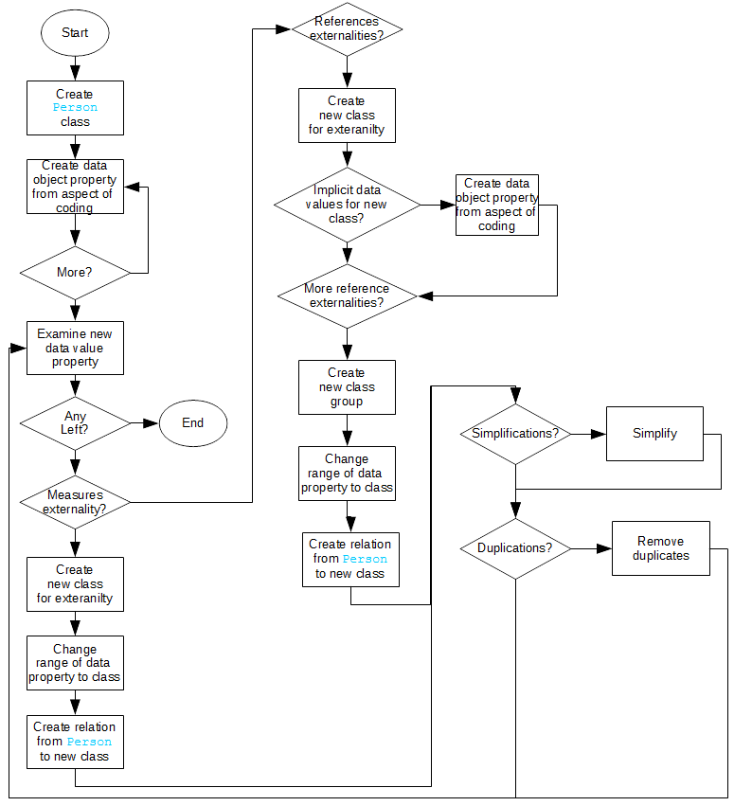

Figure 30 Creating an ontology from a coding

So for instance we might create the new relation hasElectricityValue with the domain Person and range ElectricityBill, and this would be sufficient to allow the creation of individuals that will model (in the mathematical sense of being logically equivalent) the above situation. Indeed OWL 2 will allow you to go further than this. Say we want to say that hasElectricityValue only points to an instance of ElectricityBill if and only if the instance of ElectricityBill has some valid value for the data value property. In this manner the link and conditions for linkage can be made more explicit.

So from this process we have uncovered a new class and linked that class to Person, but this is not the end the new class may have implicit data value properties, as for example, in this case, period for the bill, currency of the bill, and each of these can be added as data value properties and the same process applied to these. The degree of resolution is dependent upon the aims of the ontology and the choice of the ontology author. Moreover the new data value properties might reference externalities, the process for encoding for is explained next.

An example of a question which contains references to externality would be something like: “What kind of transport do you use to commute?” with restricted answers to “car”, “bus” or “train”. In this case the externalities are “car”, “bus” and “train”. This is then quite simple, classes for Bus, Car and Train are created, and are either subclassed to some existing class, or a class is created that logically groups such classes together, say, for instance in this case, a class called Transport. A relationship is then created from the Person class to Transport class, say usesTransport, with domain Person and range Transport. It might be argued here that all we need was the class Transport, and indeed this would be a perfectly valid approach, but the aim of the investigation here is to uncover as much terminology as possible. Due to the nature of the data we have been able to uncover then we have mostly TBox, i.e. unpopulated ontologies. Hence it the processing of these “empty” ontologies, in the sense they do not contain individuals that we hope to obtain trans-disciplinary vocabulary and insights. Thus whenever possible we try and specify as much TBox as possible. TBox includes class definitions, range and codomain specification for object and data value properties.

The last step is review. This is duplication removal and simplification. This means removing duplicate classes, being very careful to make sure that such classes are truly equivalent in the sense that every single individual of the class you are eliminating can potentially have any of the properties of the class into which you are merging the completed class. Simplification carries the same caveats, inasmuch as if a simplification is made then it must precisely equivalent in terms of the set axioms that underlie the ontology otherwise it is not a valid simplification.

Once this stage is completed the next new data value property is examined and this process is continued until all such data value properties have been reviewed and processed. This entire process is summarized in the flow chart in, for which checking for the pre-existence of any new class is assumed for the sake of simplicity.

### Results

A full list of all four ontologies can be found on GitHub at <https://github.com/DougSalt/GLAMURS/tree/master/ontologies/bottom-up%20ontologies/regional%20surveys>.

A list of the top-level classes for the ontology ***regional-roe*** are shown in Figure 31.

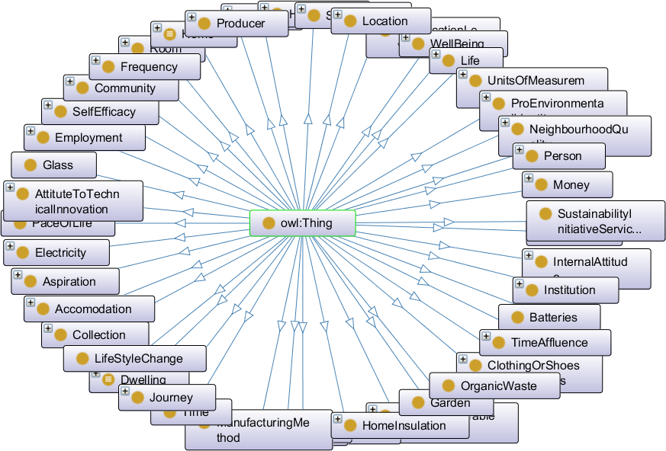

Figure 31 First level class diagram for the ontology *region-roe*

A selection of classes for the ontology ***regional-sco*** is shown in Figure 32.

### Discussion points

This ontology as a TBox is complete.

We have successfully developed a methodology which uses interview or survey coding schemes to develop an ontology. This could be partially automated.

In addition, these ontologies are unpopulated. However there is data to create an ABox version of these ontologies, which may also be amenable to automation. So from this point of view the ontology might be considered incomplete. The data for such population was available, but had yet to be sanitised inasmuch as personally identifier data had to be obscured. Such knowledge basis may produce novel inferences once complete.

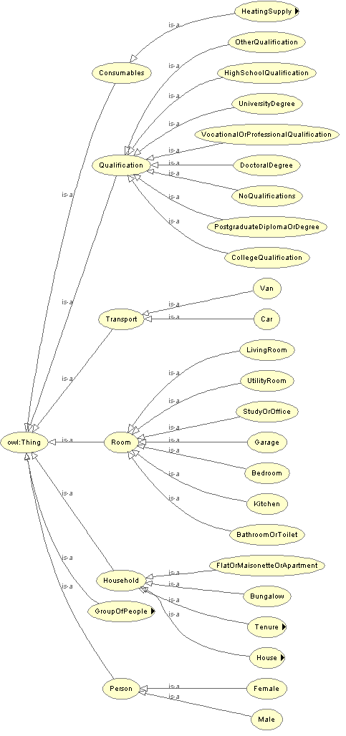

Figure 32 Key classes from the *regional-sco* ontology

## Ontologies from the GLAMURS regional case-study interviews

### Introduction

These ontologies are a representation of the interviews of the key stakeholders in the case-studies in seven regions of the countries involved in the GLAMURS project. These countries were:

* Austria;
* Germany;
* Italy;
* Netherlands;
* Romania;
* Scotland, and
* Spain.

The main ontology derived in section is denoted the ***initiative*** ontology for both its filename, initiative.owl and namespace. The mirroring of this ontology (see section 4.1) produces the ontology denoted ***mirror-initiative*** and the corresponding filename mirror-initiative.owl.

This ontology is denoted the ***top-down*** ontology for both its filename, top-down.owl and namespace.

### Purpose and relationship with other ontologies

The ***initiative*** is a TBox ontology which is an encoding of the coding for the regional case-study stakeholder interview

The ontology, ***initiative*** is mirrored into the ontology ***mirror-initiative***, using the mirroring framework ontology ***mirror***, and these are included directly into the final GLAMURS ontology ***glamurs***.

This is illustrated in Figure 2.

### Data used by the ontology

Coding schemes used for the interview were provided on direct request to the relevant researchers. No other data, such as raw responses was supplied.

### Method of construction

This re-used the construction outlined first in section 4.2.4.

### Results

A full listing of the two ontologies can be found on GitHub at <https://github.com/DougSalt/GLAMURS/tree/master/ontologies/bottom-up%20ontologies/initiative%20interviews>.

Some of the key classes from the ***initiative*** ontology are shown in Figure 33.

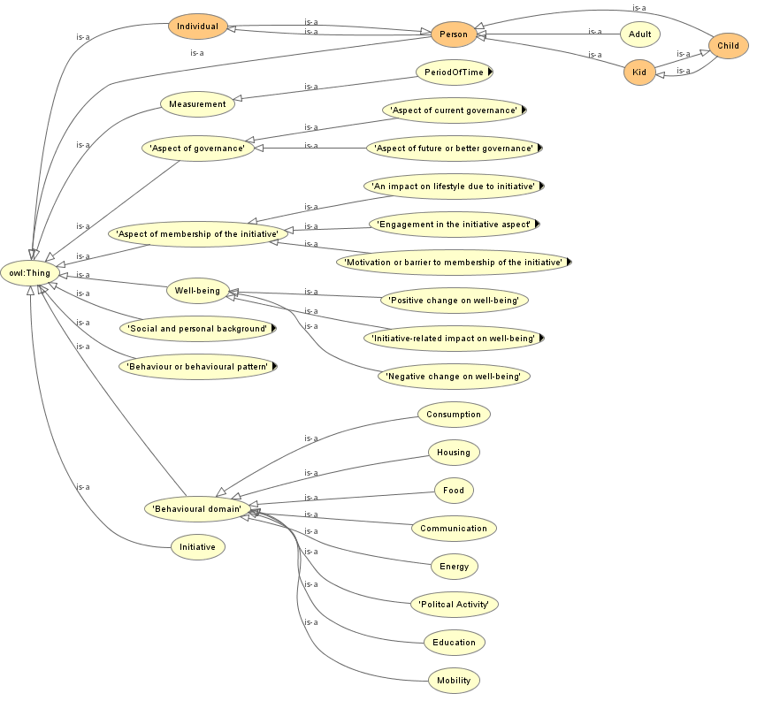

Figure 33 Key classes form the *initiative* ontology

### Discussion points

This ontology is complete.

This is a successful demonstration of the reuse of the methodology developed for creating TBox ontologies from interview and questionnaire codings, first explained in section 4.2.4,

The was no readily available source of actual instance data in this case in order to create an ABox ontology with which to populate the TBox ontology. Maybe some kind of standardised response forms which might form the basis of purely quantitative approach to interview might be developed in order to facilitate the construction, thence population of such ontologies, eventually allowing formal reasoning over such entities.

## Ontologies from the UKHLS

### Introduction

This is the UK household longitudinal study (UKHLS) and represents a collection of 25 years data for UK households, useful for environmental research, as many of the questions pertain to sustainable living or environmental awareness (Longhi 2013) (Lynn and others 2014). For example attitudes and habits with regard to household recycling and consumption. The data from this is being used by the JHI team to model pro-environmental behaviour as a function of perceived time-pressure.

The main ontology derived in section is denoted the ***ukhls*** ontology for both its filename, ukhls.owl and namespace. The mirroring of this ontology (see section 4.1) produces the ontology denoted ***mirror-ukhls*** and the corresponding filename mirror-ukhls.owl.

### Purpose and relationship with other ontologies

The ***ukhls*** ontology is a TBox representation of the coding scheme for the United Kingdom Household longitudinal study.

This ontology, ***ukhls*** is mirrored into the ontology ***mirror-ukhls***, using the mirroring framework ontology ***mirror***, and these are included directly into the final GLAMURS ontology ***glamurs***.

This is illustrated in Figure 2.

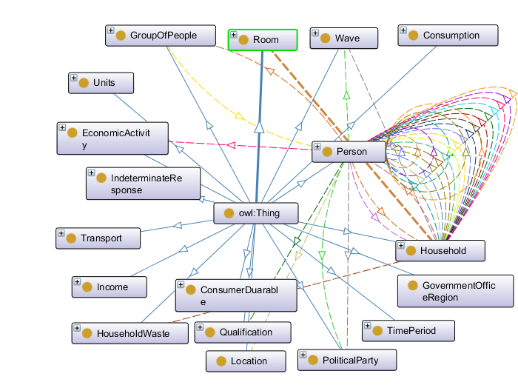

Figure 34 Top-level classes for the *ukhls* ontology

### Data used by the ontology

We were provided with the relevant coding scheme and actual responses by the relevant researchers in the form of spreadsheets.

This ontology did have responses provided to the researcher. This data consisted of two waves of the questionnaire, firstly with all the environmentally pertinent data for those two waves, and separately with the data used purely in the context of the Hutton investigations. This data was provided, but no use was made of it

### Method of construction

This re-used the construction outlined first in section 4.2.4.

### Results

The full listing for both the ontologies mentioned above may be found on GitHub at <https://github.com/DougSalt/GLAMURS/tree/master/ontologies/bottom-up%20ontologies/UKHLS>.

A diagram just showing the top-level classes for the ontology ***ukhls*** is shown in Figure 34.

### Discussion points

This TBox ontology is complete.

This is a successful demonstration of the reuse of the methodology developed for creating TBox ontologies from interview and questionnaire codings, first explained in section 4.2.4. Indeed this methodology was developed using this ontology.

This section of the UKHLS data that we processed is, apparently only a subsection of the data and coding scheme available, so there is substantial amounts of data.

This ontology required the most time for development as it was the first ontology to be developed.

An ABox for this ontology could be created from the supplied data, and thus a knowledge base for UKHLS could be developed, so in this sense the ontology is not quite complete. Such a knowledge base would represent an excellent opportunity to perform formal reasoning over such data and possibly draw new inferences, in its own right.

## Ontologies from the GLAMURS agent-based model

### Introduction

TiPaC is an agent-based model produced in Netlogo. This is a model of the traffic in for the city of Aberdeen and its immediate environment. This model was produced in order to test the impact of flexible working in Aberdeen.

The main ontology derived in section is denoted the ***tipac*** ontology for both its filename, tipac.owl and namespace. The mirroring of this ontology (see section 4.1) produces the ontology denoted ***mirror-tipac*** and the corresponding filename mirror-tipac.owl.

### Purpose and relationship with other ontologies

The ontology produced in this section is a TBox ontological representation of the TiPaC Netlogo model.

This ontology, ***tipac*** is mirrored into the ontology ***mirror-tipac***, using the mirroring framework ontology ***mirror***, and these are included directly into the final GLAMURS ontology ***glamurs***.

This is illustrated in Figure 2.

### Data used by the ontology

The NetLogo code was used to create the ontology.

### Method of construction

The ontology was produced automatically using software to convert the code used to create the model, Netlogo automatically into an ontology.

### Results

The full listing for both the ontologies mentioned above may be found on GitHub at <https://github.com/DougSalt/GLAMURS/tree/master/ontologies/bottom-up%20ontologies/models/agent-based%20models>.

The class diagram for this model is shown in Figure 35.

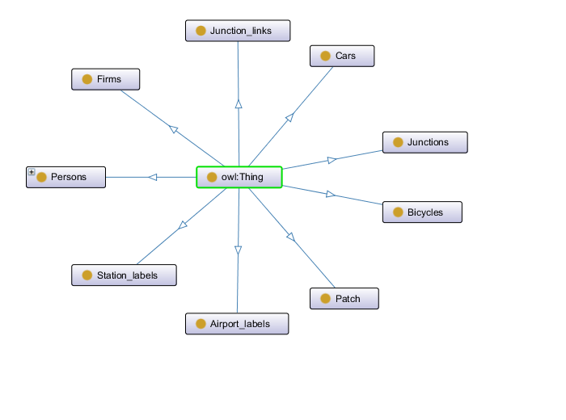

Figure 35 The *tipac* ontology class diagram

### Discussion points

This ontology is complete in that this is TBox only.

The model is rather sparse, in that object orientation, and in particular inheritance is dealt with differently in Netlogo (which in turn is based on Java) to how such inheritance is applied in OWL 2. This inhibits, to a certain extent the automatic translation from one to the other. This could be mitigated by either enforcing coding standards in Netlogo and automated code checking of some kind.

The automation of model production from Netlogo models may be extended.

## Ontologies from the GLAMURS micro-economic models

### Introduction

The section deals with Bath Universities micro-economic models. These were produced in order to model the effect of environmental rewards and punishments on individuals modelled as differential equations.

The main ontology derived in section is denoted the ***ubah*** ontology for both its filename, ubah.owl and namespace. The mirroring of this ontology (see section 4.1) produces the ontology denoted ***mirror-ubah*** and the corresponding filename mirror-ubah.owl.

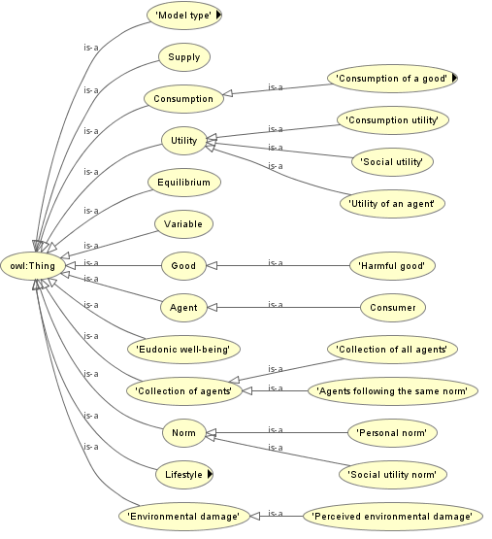

Figure 36 Key classes for the *ubah* ontology

### Purpose and relationship with other ontologies

The ***ubah*** ontology is TBox ontology only. The ontology will be derived from the model from the University of Bath team describing their mathematical economic micro models modelling consumer attitudes towards and environmental impact of notional consumer goods.

This ontology, ***ubah*** is mirrored into the ontology ***mirror-ubah***, using the mirroring framework ontology ***mirror***, and these are included directly into the final GLAMURS ontology ***glamurs***.

This is illustrated in Figure 2.

### Data used by the ontology

Presentation slides provided by the relevant researchers.

### Method of construction

Direct interpretation of the provided slides.

### Results

The listing for these two ontologies may be found on GitHub at <https://github.com/DougSalt/GLAMURS/tree/master/ontologies/bottom-up%20ontologies/models/micro-economic%20models>.

Key class for the ***ubah*** ontology are shown in Figure 36.

### Discussion points

This is a complete TBox ontology.

The ontology never received any feedback from the original researchers who specified the model. We believe this would have greatly enhanced the model given such feedback. Unfortunately there was insufficient time.

## Ontologies from the GLAMURS macro-economic models

### Introduction

The ontology is based on the macro-economic models created by the team from Tilburg University detailing their macro-economic modelling. This tries to model “degrowth” using classical economic models.

The main ontology derived in section is denoted the ***tsc*** ontology for both its filename, tsc.owl and namespace. The mirroring of this ontology (see section 4.1) produces the ontology denoted ***mirror-tsc*** and the corresponding filename mirror-tsc.owl.

### Purpose and relationship with other ontologies

This is a TBox ontology with no instance data available.

This ontology, ***tsc*** is mirrored into the ontology ***mirror-tsc***, using the mirroring framework ontology ***mirror***, and these are included directly into the final GLAMURS ontology ***glamurs***.

This is illustrated in Figure 2.

### Data used by the ontology

Presentation slides provided by the relevant researchers.

### Method of construction

Direct interpretation of the provided slides.

### Results

The listing for these two ontologies may be found on GitHub at <https://github.com/DougSalt/GLAMURS/tree/master/ontologies/bottom-up%20ontologies/models/macro-economic%20models>.

The class diagram for the ***tsc*** ontology is shown in Figure 37.

### Discussion points

This ontology is a complete TBox ontology based on the supplied documentation.

The ontology never received any feedback from the original researchers who specified the model. We believe this would have greatly enhanced the model given such feedback. Unfortunately no response was received to the requests for feedback.

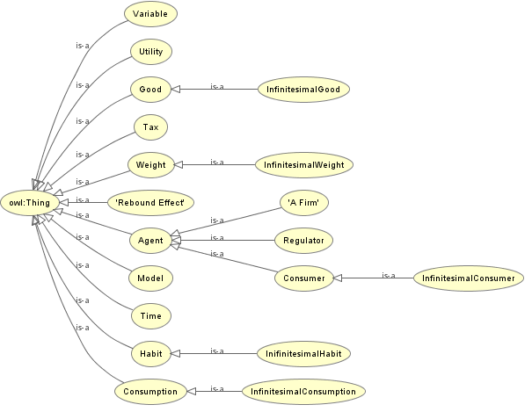

Figure 37 Class diagram for the *tsc* ontology

## Ontologies from the GLAMURS footprinting data

### Introduction

In this section ontologies were developed using data from NTNU. This data represents environmental and consumption statistics obtained from existing environmental meta-databases.

The main ontology derived in section is denoted the ***ntnu*** ontology for both its filename, ntnu.owl and namespace. The mirroring of this ontology (see section 4.1) produces the ontology denoted ***mirror-ntnu*** and the corresponding filename mirror-ntnu.owl.

### Purpose and relationship with other ontologies

The TBox ontology was produced initially, the ***ntnu*** ontology and then this was used to incorporate national footprinting data, producing the new ontology ***ntnu-abox***,

This ontology, ***ntnu-abox*** was mirrored into the ontology ***mirror-ntnu***, using the mirroring framework ontology ***mirror***, and these are included directly into the final GLAMURS ontology ***glamurs***.

This is illustrated in Figure 2.

### Data used by the ontology

Summary spreadsheets provided directly by the relevant researches.

This ontology is populated and is formed from a selection from the data from the EXOBIOS2 (Ivanova et al. 2016) (Wood et al. 2014) relevant to European countries and in particular that data from the 7 regions involved in the GLAMURS project.

### Method of construction

Creation of the TBox ontology from the headings of the spreadsheets.

Creation of the ABox ontology simultaneously using the TBox ontology to create a knowledge base containing the TBox and ABox values from the cells of the supplied spread sheets.

### Results

The three ontologies described in this section may be found on GitHub at <https://github.com/DougSalt/GLAMURS/tree/master/ontologies/bottom-up%20ontologies/environmental%20footprinting>.

Key classes are shown from the ***ntnu*** ontology in Figure 38

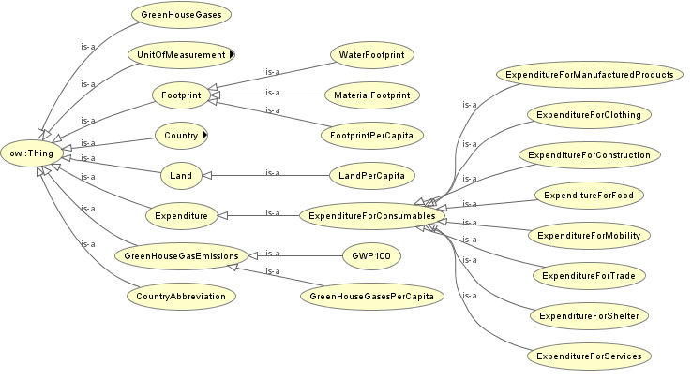

Figure 38 Key classes from the *ntnu* ontology

### Discussion points

This ontology is complete, and is the only ontology that actually is a knowledge base, containing both ABox and TBox.

The ontology is too small. There is a wealth of data that supports the summaries that were provided. It would be of interest to actually specify the original databases as ontologies, although a task of some magnitude.

## Ontologies from the GLAMURS regional backcasting

### Introduction

These ontologies were derived from the backcasting workshops undertaken in order to determine the circumstances under which conditions would be conducive to the proliferation of more instances of the examples of the regional case studies.

Only the Dutch case-study was analysed in this case due to the constraints of time.

The main ontology derived in section is denoted the ***backcasting*** ontology for both its filename, backcasting.owl and namespace. The mirroring of this ontology (see section 4.1) produces the ontology denoted ***mirror-backcasting*** and the corresponding filename mirror-backcasting.owl.

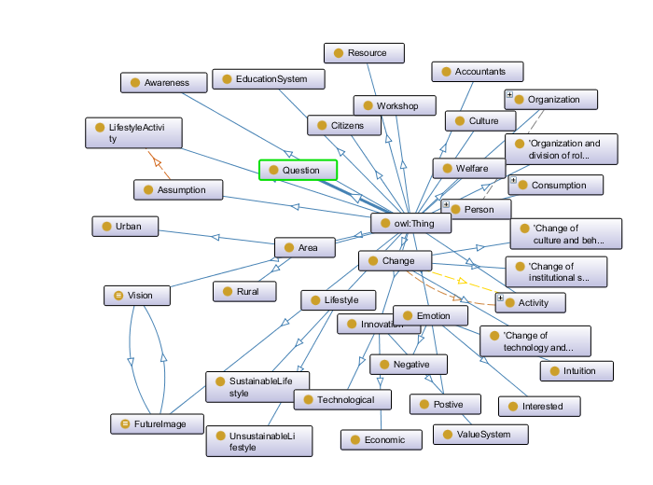

Figure 39 Key class from the *backcasting* ontology

### Purpose and relationship with other ontologies

This is the ontology created to model the backcasting sessions particular for the Dutch backcasting workshops in order to establish the right conditions for the proliferation of repair cafe movement.

This ontology was a TBOX representation of the documentation mentioned in the next section.

This ontology, ***backcasting*** is mirrored into the ontology ***mirror-backcasting***, using the mirroring framework ontology ***backcasting***, and these are included directly into the final GLAMURS ontology ***glamurs***.

This is illustrated in Figure 2.

### Data used by the ontology

WP5, Task 5.2 – Summary report of Second Backcasting Workshop (Pathway Development) in Dutch Case Study for GLAMURS

### Method of construction

Analysis and interpretation of the above document.

### Results

The two ontologies mentioned in this section can be found on GitHub at <https://github.com/DougSalt/GLAMURS/tree/master/ontologies/bottom-up%20ontologies/back-casting>.

A class diagram is shown in Figure 39.

### Discussion points

The ontology is a complete TBox ontology.

Only an ontology has been produced for the Dutch backcasting sessions. Ontologies need to developed for the remaining regional backcasting workshops.

## Ontologies from the GLAMURS regional social networking analyses

### Introduction

The ontologies in this section are ontological interpretations of the social network analyses performed on the key stakeholders, networks and agents in each of the regional case-studies.

There are two sets of ontologies in this section. The first covering the Scotland case-study region, and the other covering the remaining case study regions, denoted the rest of Europe, which include the case study regions from the countries of Austria, Germany, Italy, Netherlands Romania and Spain. These are different as the nature of the case studies in the rest of Europe was quite different from that in the Scotland case study.

Both main ontologies are TBox ontologies.

The main Scottish social networking analysis ontology derived in section is denoted the ***sna-sco*** ontology for both its filename, sna-sco.owl and namespace. The mirroring of this ontology (see section 4.1) produces the ontology denoted ***mirror-sna-sco*** and the corresponding filename mirror-sna-sco.owl.

The main rest of Europe social networking analysis ontology derived in section is denoted the ***sna-roe*** ontology for both its filename, sna-roe.owl and namespace. The mirroring of this ontology (see section 4.1) produces the ontology denoted ***mirror-sna-roe*** and the corresponding filename mirror-sna-roe.owl.

### Purpose and relationship with other ontologies

These ontologies, ***sna-sco***, and ***sna-roe*** are mirrored into the ontologies ***mirror-sna-sco*** and ***mirror­-sna-roe*** respectively, using the mirroring framework ontology ***mirror***, and these are included directly into the final GLAMURS ontology ***glamurs***.

This is illustrated in Figure 2.

### Data used by the ontology

The data for these ontologies was obtained from analysis of the WP5 D5.1 milestone report (Omann et al. 2015).

### Method of construction

Mostly by inspecting the diagrams of the networks and converting these to a corresponding ontology.

### Results

The full listing for the four ontologies found in this section may be found on GitHub here.

In addition the class diagram for the ***sna-roe*** ontology is shown in Figure 40.

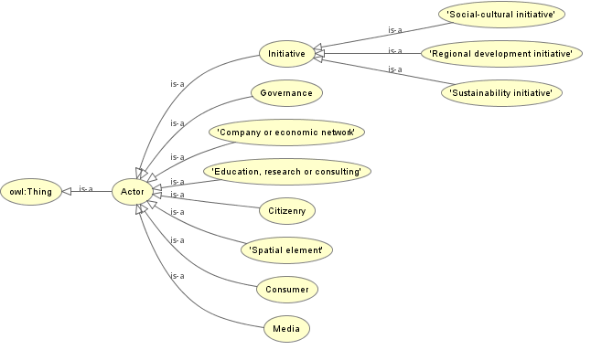

Figure 40 Class diagram for the *sna-roe* ontology

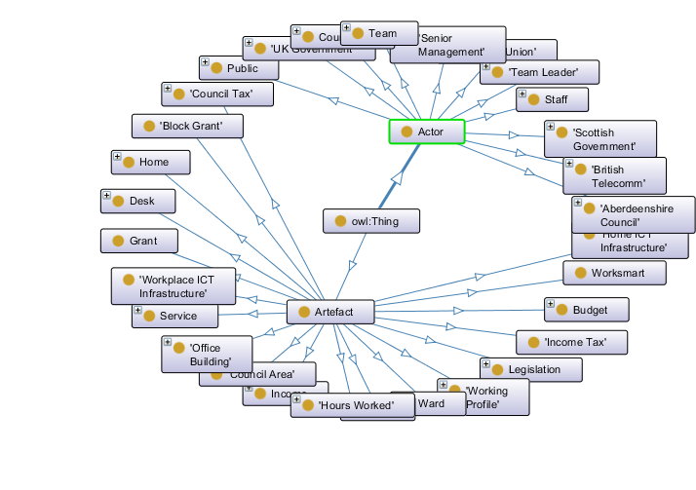

Figure 41 Key classes for the *sna-sco* ontology

Likewise the class diagram for the ontology ***sna-sco*** is shown in Figure 41.

### Discussion points

These TBox ontologies are complete.

These are TBox ontologies. There is no data for the ***sna-sco*** ontology, but there is lots of individuals for the ***sna-roe*** ontologies. These should be populated at some point in order to process social network ontologies that might be reasoned over.

# The GLAMURS ontology

## Introduction

This ontology is denoted the ***glamurs*** ontology and this is section describes the global ontology for the project. This ontology is a combination of the “top-down” ontology linked in a star network to each of the “bottom-up” ontologies. The linking was accomplished by joining individual classes using the vocabulary from the global integration ontology, ***star***, first mentioned in section 2.3. T

Although not meant to be in anyway particularly accurate, Figure 42 gives a simplified idea of how the global ontology was envisage. Upon implementation the final result was somewhat different and is represented by the simplified schematic in Figure 43.

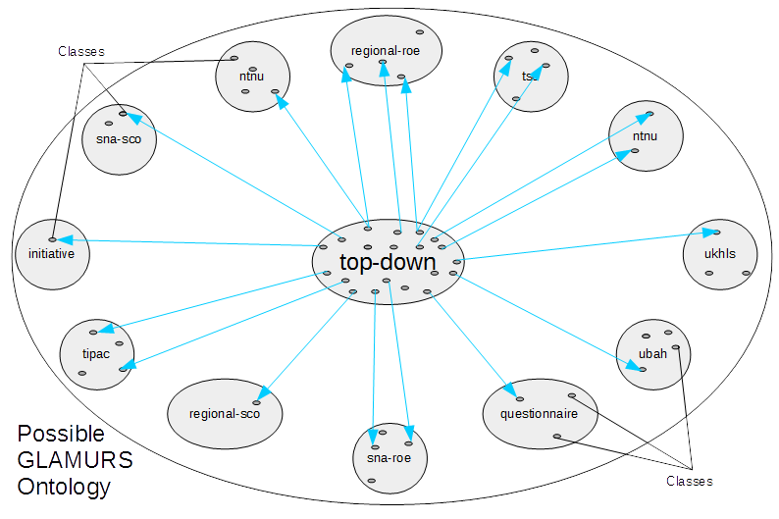

Figure 42 Possible GLAMURS ontology

## Purpose and relationship with other ontologies

This is the result: the ontology representing the entire GLAMURS project. This ontology will form the basis of any formal reasoning about the project.

## Data used by the ontology

This incorporates all the developed ontologies, and those ontologies in their mirror form (see LINK). Consequently this ontology incorporates the following ontologies:

* backcasting;
* ntnu;
* ntnu-abox;
* initiative;
* tipac;
* tsc;
* ubah;
* regional-roe;
* regional-sco;
* sna-roe;
* sna-sco;
* ukhls;
* expert;
* questionnaire;
* core;
* top-down;
* metadata;
* mirror;
* integration;
* mirror-backcasting;
* mirror-ntnu;
* mirror-initiative;
* mirror-tipac;
* mirror-tsc;
* mirror-ubah;
* mirror-regional-roe;
* mirror-regional-sco;
* mirror-sna-roe;
* mirror-sna-sco;
* mirror-ukhls;
* mirror-expert;
* mirror-questionnaire;
* mirror-core, and
* mirror-top-down.

Thus this ontology links directly or indirectly to every other ontology in the repository (except those that are incomplete), as shown by the ontology map in Figure 2.

## Method of construction

This ontology is constructed using a Perl script [create_glamurs_ontology.pl](https://github.com/DougSalt/GLAMURS/blob/master/src/create_glamurs_ontology.pl) as this automates a large part of manually assembling the process and can also introduce automation in linking concepts in the mirroring ontology explained in 2.4.

For the man page for this script then see appendix 3, however the important parameters for this script are shown in Table 9.

Table 9 create_glamurs_ontology.pl parameters

|  |  |
| --- | --- |
| **Parameter Name** | **Purpose** |
| --library | This is any ontology that will only be used as a component in the resultant ontology. No These are processed in order of the parameters |
| --ontology-name | The output ontology name space |
| --process-files | These ontologies are specially processed to get obtain the links between domain and ranges for the σ–represents and γ–represents, to link the individuals in the mirrored ontology explained in section 2.4 |

There are also positional parameters which include the ontologies that are imported and have their name spaces included.

Essentially how this program works is that it takes the positional parameters, reads these ontologies and works out their name and namespace. These are included in the global ontology. Each of libraries is then read and included verbatim into the glossary. This approach allows a component development and separation of functional units of parts of the top-down ontology. The parts used in the construction of the GLAMURS ontology and their purpose are listed in table link.

Table 10 - Libraries for the final GLAMURS ontology

|  |  |
| --- | --- |
| **Library name** | **Library purpose** |
| gamma_represent_types.owl | These are γ–represents, or group representations as discussed in section 2.4. These are all the general representations, generally between mutually exclusive groups of entities, and there sub-entities. |
| misc.owl | In the case of the GLAMURS ontology these are miscellaneous class creation and class subclassing used to clarify some links in the top-down ontology. |
| rules.owl | These are SWRL rules which help in reasoning over the ontology. For more discussion then please section 6.1. |
| sigma_represents.owl | These are σ–represents, or specific representations as discussed in section 2.4. These are specific representation asserted between ontological entities such as classes, object properties and data values, when, and only when these concepts are instantiated as individuals. |
| sigma_represents_types | These are σ–represents, or specific representations as discussed in section 2.4. These are specific representations, but at the level of the TBox definition. Unlike sigma_represents.owl above, these roles are processed to give relationships between the corresponding instance, generated for the ontological processes. This is done by using the domain and ranges for the are σ–represents. These can be processed to instantiated links between individual terms. |

Finally any file included as a --process-files parameter is read. This currently has to specify only σ–represents roles and these are processed to produce links between the corresponding instantiations of the classes in the mirrored ontology, discussed in section 2.4.

## Results

Rather than show the whole ontology we show a schematic of the ontology, as in illustrated in Figure 43.

The statistics for the resultant ontology are as follows:

|  |  |
| --- | --- |
| Axiom | 37433 |
| Logical axiom count | 22288 |
| Declaration count | 6335 |
| Object property count | 1312 |
| Data property count | 1030 |
| Individual count | 3542 |
| DL Expressivity | SROIQ(D) |

The final GLAMURS ontology, ***glamurs*** may be found on GitHub at <https://github.com/DougSalt/GLAMURS/blob/master/ontologies/glamurs.owl>.

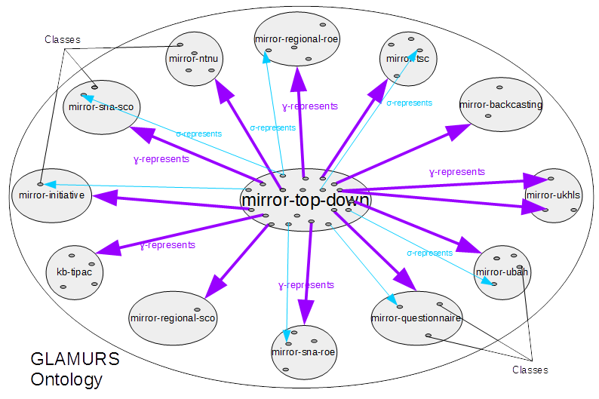

Figure 43 GLAMURS ontology

### Discussion points

Although ontologies are generally thought of as diagrammatic in nature, any ontology is actually defined by a series of axioms. These are statements that define domains, codomains, relationships, existence conditions. By counting the number of axioms a relationship, class, or individual is involved in, then we have an immediate measure of how important a concept, individual or relationship is with respect to the rest of the ontology. This will provide reflection on the whole project, in that we can compare the relative importance of a given entity to the original aims of the project. The original project being represented by the enhanced “top-down” ontology.

Moreover not only will the resultant ontology be able to be reasoned over with logical inference software such as FACT++ or Pellet, the final ontology may also be susceptible to other forms of analysis such as forming simple perspectives such as those suggested in (Kumazawa et al. 2009), in order to uncover connections between concepts of which we were previously unaware.

Finally we will make provision to publish the ontology in order that it might be of use, or at least serve as an example to other sustainability projects.

The resultant project ontology also has the potential to yield many project metrics, but unfortunately we are not in position to obtain these, as so far we only have a sample set of this project only.

# Discussion and Conclusions

This section includes a discussion about the utility of the project ontology, now that it has been created successfully, with an illustration of some simple reasoning that might be performed against this resultant ontology, and some useful metrics that also might be derived from the ontology.

We also draw conclusions about the work that has actually been performed, and the lessons and future work that might arise from what we have observed in the process of creating the global, project ontology for GLAMURS.

## Discussion

The approach taken in this study is somewhat orthogonal to the rest the project in that it encompasses the approach of a knowledge engineer with little involvement in the project until the latter stages. Thus this approach represents a rather analytic and reductionist approach to the various components of the project with somewhat lessened regard for the meaning of each of the components of the project. This is a direct consequence of the late involvement of one of the engineers, and represents the best comprehension of the project given the reduced time for such comprehension. However balanced against this is the intrinsic nature of such sustainability projects inasmuch as it is the nature of such projects to be necessarily trans-disciplinary and ipso facto, are initially a disjoint union of disciplines involved in the project. Thus it might be argued that the such an approach approximates a reasonable model of the project in terms of ontological integration.

Although not comprehensive and as detailed as we should like we provide some brief ideas of how the ontology of the entire project might be exploited in order to uncover new knowledge about the project and in addition also suggest some other ways that such an ontology may be utilized in terms of better project management.

The structure of this section is as follows.

* The possibility of reasoning over the resultant, global, project ontology for GLAMURS and some examples thereof, along with suggestions as to how we might extend such reasoning.
* A brief discussion, which is effectively a reiteration of the points made in section 2.3, but repeated here to emphasize its importance.
* Finally a similarly brief discussion about possible metrics that might also be extracted from the project ontology.

### Reasoning

One of the stated aims in this document (section 2.3) was to produce an ontology of the ontology in terms of individuals over which it would be possible to use formal reasoning and consequently obtain new inferences about ontological concepts that had been represented as those individuals. This is presuming, of course that the translation to those individuals is functional in nature, and moreover injective and surjective. This remains to be proved on the transformation of the ontology to individuals (mirroring) used to represent the ontology in the approach undertaken in this project. However if we assume this is the case, and the two are functionally equivalent, then there are new tools available which can extend the reasoning available in OWL 2 ontologies: in particular Semantic Web Rule XML (SWRL). SWRL is a representation of Horn-like rules, this being a fragment of first order logic, which is decidable, although when applied to OWL 2 ontologies it almost certainly is not decidable (Horrocks et al. 2004).

The following shows an example SWRL rule which can be applied to the GLAMURS global ontology, ***glamurs***.

TopDownTerm(?:t), hasOntologicalOrientation(?:t, topDown:ontology), BottomUpTerm(?:b1), hasOntologicalOrientation(?:b1, bottomUp:ontology), sigmaRepresents(?:b1, ?:t), BottomUpTerm(?:b2), hasOntologicalOrientation(?:b2, bottomUp:ontology), sigmaRepresents(?:b2, ?:t) -> isSemanticallyRelatedTo(?:b1, ?:b2)

which simplified means:

**if *b1* and *b2* represent *t*,**

**then *b1* is semantically related to b2;**

where **b1**, **b2** are both bottom-up terms and **t** is a top-down term.

Diagrammatically this might look like the following show in Figure 44.

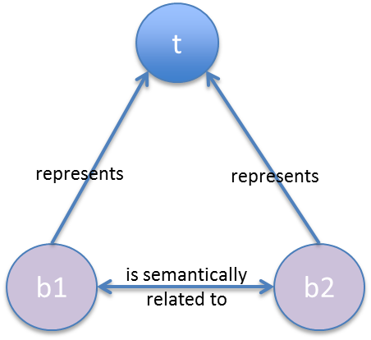

Figure 44 SWRL Rule in which ‘is semantically related to’ is inferred from assertions that b1 and b2 ‘represents’ t.

So what has occurred here is the uncovering using the specification of rules, some form of relation which is has certain existential constraints. In this case we have asserted semantic relatedness, but this might be some other property. The key is that reasoning has been utilised in order to coordinate those constraints between disparate concepts in order to obtain novel relations, which if the correct constraints are sufficiently reflect the reality they represent, then they may well tell us something novel about the real world.

Obviously this kind of reasoning and how it might be applied needs careful, future investigation in order to discover whether it indeed does have utility beyond just contrivance. But in order to convince the reader we present some examples of how the rule above has been used to extract correspondences between terminology from differing domains of application. That is, what we hope the examples below show is the possibility that his kind of approach might be used to tease out links between terminology between differing disciplines. Or more concisely, the ontology is doing what the semantic web was designed to do, which is represent meaning.

The three examples now follow. The prefix before the colon in all that follow is the *namespace* – this denotes the ontology form which the class originated. A map of these ontologies may be found in Figure 2 and listed in Table 1.

#### Example 1

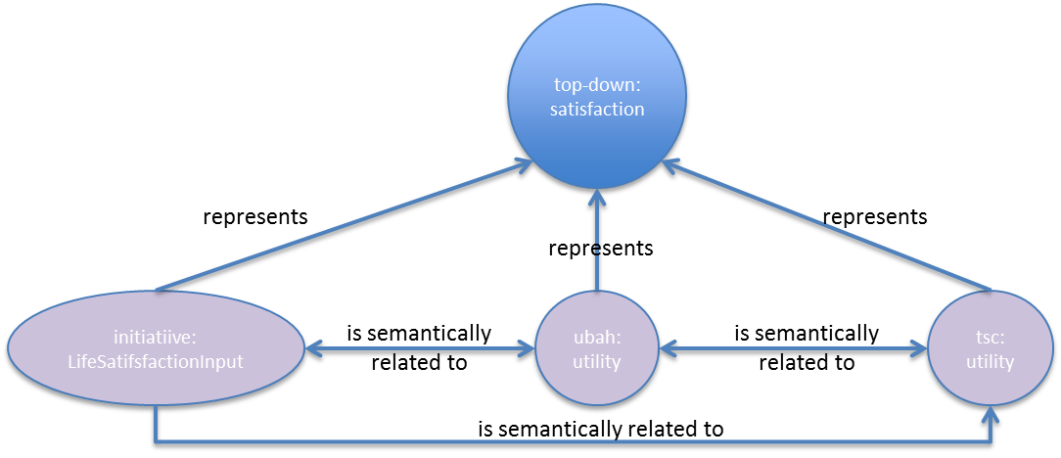

initiative:LifeSatisfactionImpact is semantically linked to tsc:utility as is initiative:LifeSatisfactionImpact is semantically linked to ubah:utility and tsc:utility is semantically linked to ubah:utility via: top-down:Satisfaction.

So this tells us that “Life satisfaction” and “Utility” are related to “Satisfaction”.

#### Example 2

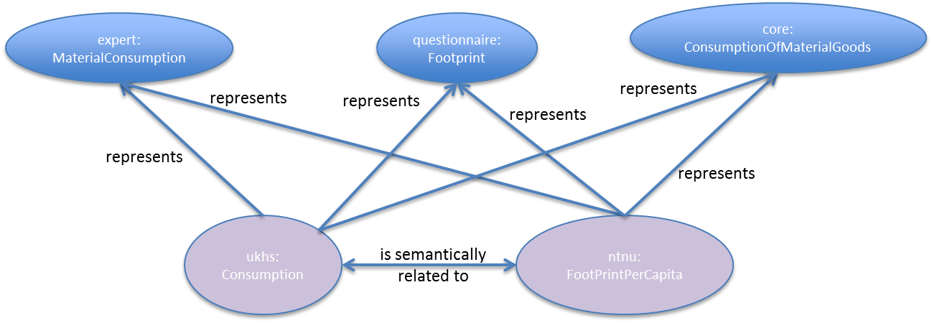

ukhls:consumption is semantically linked to ntnu:FootPrintPerCapita via: expert:MaterialConsumption, core:ConsumptionOfMaterialGoods and questionnaire:Footprint.

So this tells us that “Material consumption”, “Consumption”, “Footprint per capita”, “Footprint” and “Consumption of material goods” are in some way related.

#### Example 3

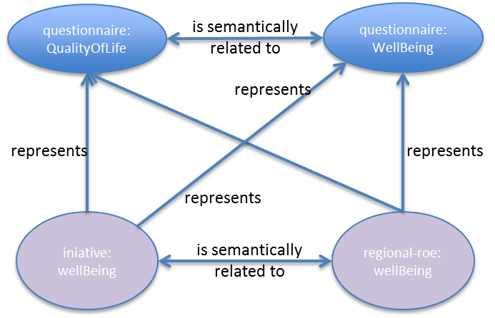

questionnaire:QualityOfLife is semantically linked to questionnaire:WellBeing via initiative:WellBeing is semantically linked to regional-roe:WellBeing

So this tells us that “Well Being” and “Quality of life” are related terms.

#### Other reasoning.

In addition to the above we suspect strongly that there is more logical implications to each element of the integration vocabulary and especially the *represents* primitive initially discussed in section 2.3. We have already uncovered the difference between what we have denoted the global, or *σ–represents* and the specifically represents, modelled by *γ–represents*. However, we believe there is more. For instance we would like to posit some of the following.

That ‘represents’ is an asymmetric annotation relation between entities in the model structure ontology and entities in the domain ontology. If *X* represents *Y*, then:

* *X* is necessarily something in the model and necessarily not something in the real world. That is, *X* can be mapped exclusively to entities in the computer program.
* *Y* is necessarily not something in the model and necessarily something in the real world. That is, *Y* can be mapped exclusively to concepts in natural language that refer to real-world entities.
* *X* and *Y* may therefore and provably not be the same type of entity.

Or possibly if *X* represents *Y* and *X* represents *Z*, then *Y* and *Z* must be the same type of entity. Further:

* If *Y* and *Z* are classes, *Y* and *Z* must not be disjoint.
* If *Y* and *Z* are object properties, their domains and ranges must not be disjoint.
* If *Y* and *Z* are data properties, their domains must not be disjoint.
* If *Y* and *Z* are individuals, then their classes must not be disjoint.

And maybe if the inverse of ‘represents’ is ‘represented-by’, if *Z* represented-by *X*, and Z represented-by *Y* then *X* and *Y* must be the same type of entity. Further:

* If *X* and *Y* are classes, *X* and *Y* must not be disjoint.
* If *X* and *Y* are object properties, their domains and ranges must not be disjoint.
* If *X* and *Y* are data properties, their domains must not be disjoint.
* If *X* and *Y* are individuals, then their classes must not be disjoint.

We have even more speculations based along these lines, predicated on how we believe the primitive *represents* minimally behaves and what logical constraints it places on the classes to which it relates. These need careful examination and also some critical evaluation. However, we believe that this kind of approach represents a novel method by which to integrate ontologies, or, more interestingly interoperate ontologies. Interoperability occurs when we can establish commonality between different ontologies. Interoperability between ontologies has been somewhat intractable historically (Kalfoglou and Schorlemmer 2003), and indeed may have stalled their widespread adoption and development. Such interoperability is very much the aim of the original design of the semantic web, of which OWL 2 is an important component of (Berners-Lee et al. 2001).

Moreover this approach is certainly not comprehensive, even with respect to what we have used in this approach. In particular, we also introduced specialisation of the relations *represents* in section 2.3; so the question becomes how do these affect any logical constraints we might determine that *represents* implies.

Lastly this is not the only integration vocabulary we uncovered. One of the surprising discoveries of this investigation is that the vocabulary to usefully integrated a set of ontologies can be reasonably small. In our case, and reducing our set of connectives to its smallest instance, then we could complete ontology integration with four just words of vocabulary:

* represents
* modifies;
* uses, and
* hasProperty.

Why so few? Is there something significant in this, or have we merely uncovered a truism? If this is not self-evident, then do the connecting primitives, other than *represents* have possible logical implications for ontological interoperability, rather similar in manner to that we suspect of the connective *represents*?

### Project shapes

We stated very early on that we have made a deliberate selection on the shape of the project, and this was reflected by the choice of integration model as explained in section 2.3, but we did not make clear is that such a choice was not quite so evident upon embarkation of the development of the ontology. But to restate what was said in section 2.3 what we did by separating out the *represents* connective and enforcing its solo role in connecting the top-down ontologies with the bottom-up ones was insisting that the overall project ontology shape must be a star. Although obvious in retrospect this was not the only interpretation of how the project was organized, and indeed we have had some debate as to whether the shape of the project should truly be represented as a star. This need not necessarily the be the case indeed, there are several other options available as illustrated earlier in Figure 6. Some of us believed that actually the project should be of the hierarchical organisation, with the ***core*** ontology connecting only to other top-down specialist vocabulary ontologies, which in turn linked to the various bottom-up ontologies.

Moreover these diagrams only look at the linking primitive, *represents*. The set of integration vocabulary contains quite a few terms, and there are a huge number of combinations if this set were partitioned into top-down integration vocabularies and bottom-down vocabularies and applied to the patterns in Figure 5 and Figure 6.

What this emphasises is that perception of the project organisation, rather like the definition of any ontology may be ultimately subjective. However, this project is definitely not a peer-to-peer shapes as also illustrated in Figure 6, so we have some objective evaluation of the real project shape, i.e. the project is either star-shaped or hierarchical.

Based on this small amount of evidence, we suspect that investigation of such project shapes might prove a fruitful area of research, particularly in the field of project management.

On a personal note although such subjectivity may be viewed by some as a weakness in the ontological approach, but we believe it may in fact be a strength. Evidence such as the above demonstrates that using such tools then it is possible to measure explicitly such subjectivity using the ontological approach described throughout this document.

### Project metrics

There appear to be many project metrics that can be extracted from the global ontology. Some of these are purely internal, and some of them rely of having more than one instance of a project ontology for comparison purposes. That is these would be most useful when other ontologies produced from other projects might be used for the purpose of project comparison and evaluation. These metrics have yet to be effectively investigated and tested, but from logic would dictate that with suitable refinement they might actively promote good project management, reflection and management.

Below we provide a list of some internal metrics that might, upon investigation prove to be useful.

|  |  |
| --- | --- |
| **Metric** | **Purpose** |
| Number of links into a class | Could be used to determine the relevance of a particular concept to a given project, in comparison with this property for other classes in the project. |
| Number of links into class by edge count | This would be like the former but the number of classes connected to that class with edge count, less or the same. Thus the previous example is a specialised version of this metric with edge count set to 1. This might be used in the same manner as the former in order to gauge the importance of a given concept within a project., relative to other classes. Both of these could be used to recognise important concepts at a glance if the process produced diagrams |
| Number of concepts in top-down ontology vs number of concepts in the bottom-down ontology | This would give some idea as a ratio of the balance of the project in terms of definition from a top-down point of view vs the bottom-up implementation of the project |
| Number of edges between classes or individuals | This might provide a measure of relatedness |
| Number of paths between individuals and classes. | This might provide a level of relatedness and complexity of the relations between these concepts. |

If there were more such ontologies describing projects with a similar amount of detail and similar process of construction as the one detailed herein, then there might be many metrics might be extracted for the purposes of comparison. For instance when in comparison the number of ontological concepts, or axioms defined might provide some means of comparison between suitably constructed project ontologies. Likewise the metric suggested above, where some form of ratio is constructed between the number of concepts in the top-down ontologies vs the number of the bottom-up ontologies, could be used as a means of distinguishing the success of a given project against a project which was known to be successful, already has such a ratio associated with it, and similarly organised into a top-down/bottom-up approach. Moreover there are many metrics measure complexity of directed graphs such as like tree-width and path-width, just some of those mentioned in (Rabinovich and Forschungsgebiet 2008).

Likewise there are graph matching methodologies that might provide a means of producing useful metrics such as similarity-flooding (Melnik, Garcia-Molina, and Rahm 2002) and tree-searching (Conte et al. 2004), then there are a vast number of possible approaches to independent project metrics.

It would appear that once we have a suitably constructed graph of a given project then there are rather a lot of project metrics that might be applied.

## Conclusions

Although this represents a large amount of work the potential uses for such project integration, via ontological componentization looks eminently feasible. We believe that we have shown that is entirely possible and useful to take a strictly formal approach to project integration using formal ontological representation.

In addition we have introduced the concept of mirroring the ontology, which we believe is novel, in order to reason over a given ontology. This approach has several problems in its current form. Firstly it is not comprehensive. The conversion from OWL 2 entities, such as classes, object and data value properties needs to be mathematically verified as valid. Secondly the approach taken here and coded into the Perl script that performed the mirroring is missing converting linkages between instances, by way of domain and range restrictions on the converted object properties and data values. This needs to be added.

We have also evolved several methodologies for creating ontologies from specific formats. Most notably from interview or questionnaire coding schemes and, in addition, but separately from vocabulary lists, using these in conjunction with an on-line questionnaire to elicit definitions from the relevant domain experts. We believe these methodologies could be codified into useful approaches, possibly with automation that could be used in other such trans-disciplinary projects.

One particularly interesting consequence of this work has been the discovery that small formal languages can be used to relate differing vocabularies to each other. We have found in this case that the set of relevant assertions required can be achieved with a surprisingly small vocabulary. Moreover these small vocabularies represent project integration languages with quite strong semantics already established by the underling semantics of OWL 2. This indicates that it is probable that specialist, well-behaved languages can be constructed specifically for the purposes of project integration.

In addition to the above, we have been able to detect that various terms are semantically related to each other on the basis of assertions made about integration. We have therefore generated new knowledge on the formal representation of semantic interoperability among ontologies. We have also developed a method for structuring knowledge by relating specialist terminology to common-sense terms. We believe we have also been able to show that specialist vocabulary can be automatically detected by looking for high-frequency, low-familiarity (using WordNet) terms.

Moreover we have conceived a methodology by which parts of the project may be compartmentalised as ontologies in their own right. This ontologies can be considered in isolation as describing particular activities within the project. These separate ontologies and then combined using the OWL 2 facilities of namespaces and structural import. Many treatments of ontology engineering in the literature usually adopt a single ontology approach to problem-domains. The approach we have detailed herein shows the validity of dividing ontological engineering of large projects into manageable portions.

Last, but not least we have manage to produce many OWL 2 ontologies representing common-sense and specialist vocabularies, and various data collected or used by the various components of the project. In total 35 ontologies were produced and published.

## Lessons learned and possibilities for future work

More investigation is definitely required on the notion of “familiarity” (WordNet) and its use in detecting project vocabulary. As mentioned before this approach clearly (in an almost startling manner) worked when applied to single words. This was represented by the oval in Figure 20, showing where in fact we probably should find project glossary. That is these should be words of high usage, but low “familiarity.” However, when applied to word groups the familiarity measure we selected (summation of single word familiarity) was clearly not as effective as when used on single words. This is almost certainly something to do with word groups being less probable in occurrence than single words, but this needs investigating and the remedy may be as simple as just extracting the minimum or maximum familiarity of a group of words, in a word group. It is interesting to note that WordNet is a formal ontology in its own right, demonstrating amply the utility of such formal ontologies.

Three of the ontologies in this document are not complete. Or, more specifically the TBox version of those ontologies were incomplete. These need completing. In addition most of the ontologies produced were TBox only, but there is data available to create ABox of the same ontologies and by combining these we might knowledge bases that can be formally reasoned over. This would represent a kind of logical datamining on the project data, and might reveal surprising inferences.

This work made various efforts to engage the project team in the construction of OWL 2 ontologies. One of the main lessons learned is just how hard it is for specialists in ontological languages to explain to non-specialists the basic assertions that these languages allow, and to differentiate between classes, relationships, data values and processes. In the end, we addressed this by asking questions in the vocabulary questionnaire on Lime Survey, though even this approach still needs work to make it less daunting for people to complete. These experiences serve only to emphasize the assertion of (Sowa 1999, 452) that knowledge engineering (converting natural language into formal logic) is a specialism, and there is a need for a dedicated knowledge engineer to construct the ontology. No matter how hard we tried, there were no short cuts that got round of having a full-time researcher dedicated to knowledge engineering.

The construction of the ontologies was included in the integration work package because it took a literal, technical interpretation of the term “integration”. It was intended as an exercise that would run throughout the project that all the team would engage with. It can be seen in the minutes from the Delft consortium meeting where the health check was discussed (see an appendix in Deliverable 2.1) that there was a call for something like this to be done to enable modellers and field researchers to talk to each other. One of the problems with committing ourselves to OWL 2 ontologies was the difficulties of visualizing the ontologies and in articulating the benefits that would accrue from reasoning over the formalization. In part, this is because such benefits could not be realized until the ontologies were finished, with the consequence that individuals had to engage with a rather technical exercise that would not be delivering benefits to their careers in terms of research outputs. (Bearing in mind especially that in some disciplines, only certain journals are ‘recognized’ as being legitimate destinations for published research for the purposes of career advancement.). However we did note much enthusiasm when researchers were engaged in small numbers with immediate feed-back from the knowledge engineers; for instance interacting in small group or one-to-one environments with these same engineers. We believe this again relates to the perceived upfront effort required in order to comprehend this particular type of ontology. This is not entirely surprising given that OWL 2 formalizations are a technical combination of cutting-edge computational techniques mixed in with considerable metaphysics.

Another lesson learned was that this specialist work needed to be done throughout the project, rather than, as has been the case here, concentrated effort being applied in the final year. (Though this is not to say that there was no activity on the ontology in the first two years – which arguably were spent learning how to do this.) The main point, however, is that scientific integration requires dedicated staff time to achieve successfully; a matter about which we were naïve when applying for funds, through not recognizing the degree of specialist skills and associated time costs required.

The ICT tools to facilitate integration in inter- and transdisciplinary projects are still lacking. In particular, there are major issues with metadata, which are well recognized in on-line content management systems and virtual research environments, that users hate completing metadata (Doctorow 2001). Ideally as much metadata as possible would be collected automatically. Naivety about file formats among non-specialists using their preferred tools for creating content means that extracting vocabulary automatically, for example, can be hampered by not being able to access the writing without proprietary software. (Indeed, owners of proprietary file formats often do not provide the tools that are needed.) Use of open and standard content formats (such as HTML, Open Document, or Markdown) should be strongly encouraged as part of facilitating automated services for metadata collection and text mining for terminology. As well as needing knowledge engineering to support scientific integration, inter- and transdisciplinary project team members in specialist domains do also need to recognize that they will have to devote time to this effort themselves. Reviewers of proposals claiming to do inter- and transdisciplinary work should be suspicious if insufficient budget is allowed for these supporting activities.

In addition to the above software standards, there is insufficient ontological visualisation software. No software seems to be able to deal with domain and range restrictions, object properties and data values. Most can draw class diagrams and this seems to be the limit of their ability. In addition there seems very little in the way of visualisation of complex ontologies with many classes. This last point is especially true when trying to visualise large numbers of individuals.

The ontologies can be used to develop various metrics reflecting on the project. These metrics require further exploration. Some of these possible metrics are suggested in section 6.1.3. For example, we can look at the relative frequency with which terms in the common-sense vocabulary have been applied in the project, which will highlight where less work has been done.

The development of a formal language for integration: the available OWL 2 axioms are insufficient to capture some of the important meanings that allow us to relate terms. It does appear, from the work herein that such a formal language probably is not that large.

There are potential future projects (were suitable funding available) to develop the tools needed to support scientific integration in other inter- and transdisciplinary research.

# References

Bagosi, Timea, Diego Calvanese, Josef Hardi, Sarah Komla-Ebri, Davide Lanti, Martin Rezk, Mariano Rodríguez-Muro, Mindaugas Slusnys, and Guohui Xiao. 2014. ‘The Ontop Framework for Ontology Based Data Access’. In *The Semantic Web and Web Science*, edited by Dongyan Zhao, Jianfeng Du, Haofen Wang, Peng Wang, Donghong Ji, and Jeff Z. Pan, 67–77. Communications in Computer and Information Science. Springer Berlin Heidelberg. doi:10.1007/978-3-662-45495-4_6.

Berners-Lee, Tim, James Hendler, Ora Lassila, and others. 2001. ‘The Semantic Web’. *Scientific American* 284 (5): 28–37.

Bock, Conrad, Achille Fokoue, Peter Haase, Rinke Hoekstra, Ian Horrocks, Alan Ruttenberg, Uli Sattler, and Mike Smith. 2008. ‘OWL 2 Web Ontology Language:Structural Specification and Functional-Style Syntax’. December. https://www.w3.org/TR/2008/WD-owl2-syntax-20081202/.

Borst, Pim. 1997. ‘Construction of Engineering Ontologies for Knowledge Sharing and Reuse’. Enschede: Centre for Telematics and Information Technology.

Bossel, Hartmut. 2013. *Modeling and Simulation*. Springer-Verlag.

Brand, Ralf, and Andrew Karvonen. 2007. ‘The Ecosystem of Expertise: Complementary Knowledges for Sustainable Development’. *Sustainability: Science, Practice, & Policy* 3 (1). http://search.proquest.com/openview/50b31f4f5c33074d72e057b736f43d8c/1?pq-origsite=gscholar.

Buttigieg, Pier Luigi, Norman Morrison, Barry Smith, Christopher J. Mungall, and Suzanna E. Lewis. 2013. ‘The Environment Ontology: Contextualising Biological and Biomedical Entities’. *Journal of Biomedical Semantics* 4 (1): 1.

Conte, D., P. Foggia, C. Sansone, and M. Vento. 2004. ‘Thirty Years of Graph Matching in Pattern Recognition’. *International Journal of Pattern Recognition and Artificial Intelligence* 18 (03): 265–98. doi:10.1142/S0218001404003228.

Doctorow, Cory. 2001. ‘Metacrap: Putting the Torch to Seven Straw-Men of the Meta-Utopia’. *Retrieved June* 10: 2003.

Fensel, D., F. van Harmelen, I. Horrocks, D.L. McGuinness, and P.F. Patel-Schneider. 2001. ‘OIL: An Ontology Infrastructure for the Semantic Web’. *IEEE Intelligent Systems* 16 (2): 38–45. doi:10.1109/5254.920598.

Giovannini, Antonio, Alexis Aubry, Hervé Panetto, Michele Dassisti, and Hind El Haouzi. 2012. ‘Ontology-Based System for Supporting Manufacturing Sustainability’. *Annual Reviews in Control* 36 (2): 309–17. doi:10.1016/j.arcontrol.2012.09.012.

Golbreich, Christine, ed. 2009. ‘OWL 2 Web Ontology Language New Features and Rationale’, October. http://www.w3.org/2009/pdf/NOTE-owl2-manchester-syntax-20091027.pdf.

‘“Green Lifestyles, Alternative Models and Upscaling Regional Sustainability” Glossary’. 2015. https://documenta.udc.es/share/page/site/glamurs/document-details?nodeRef=workspace://SpacesStore/753c5c78-9fcb-45eb-8024-fe1212dfc8fc.

Gruber, Thomas R., and others. 1993. ‘A Translation Approach to Portable Ontology Specifications’. *Knowledge Acquisition* 5 (2): 199–220.

Herre, Heinrich. 2010. ‘General Formal Ontology (GFO): A Foundational Ontology for Conceptual Modelling’. In *Theory and Applications of Ontology: Computer Applications*, edited by Roberto Poli, Michael Healy, and Achilles Kameas, 297–345. Springer Netherlands. doi:10.1007/978-90-481-8847-5_14.

Horrocks, Ian. 2005. ‘OWL: A Description Logic Based Ontology Language’. In *Logic Programming*, edited by Maurizio Gabbrielli and Gopal Gupta, 1–4. Lecture Notes in Computer Science 3668. Springer Berlin Heidelberg. doi:10.1007/11562931_1.

Horrocks, Ian, Peter F. Patel-Schneider, Harold Boley, Said Tabet, Benjamin Grosof, Mike Dean, and others. 2004. ‘SWRL: A Semantic Web Rule Language Combining OWL and RuleML’. *W3C Member Submission* 21: 79.

Ivanova, Diana, Konstantin Stadler, Kjartan Steen-Olsen, Richard Wood, Gibran Vita, Arnold Tukker, and Edgar G. Hertwich. 2016. ‘Environmental Impact Assessment of Household Consumption: Environmental Impact Assessment of Household Consumption’. *Journal of Industrial Ecology* 20 (3): 526–36. doi:10.1111/jiec.12371.

Kalfoglou, Yannis, and Marco Schorlemmer. 2003. ‘Ontology Mapping: The State of the Art’. *The Knowledge Engineering Review* 18 (01): 1–31.

Kazakov, Yevgeny, Markus Krötzsch, and Frantisek Simancik. 2012. ‘ELK Reasoner: Architecture and Evaluation.’ In *ORE*. https://www.uni-ulm.de/fileadmin/website_uni_ulm/iui.inst.090/Publikationen/2012/KazKroSim12ELK_ORE.pdf.

Kumazawa, Terukazu, Osamu Saito, Kouji Kozaki, Takanori Matsui, and Riichiro Mizoguchi. 2009. ‘Toward Knowledge Structuring of Sustainability Science Based on Ontology Engineering’. *Sustainability Science* 4 (1): 99–116. doi:10.1007/s11625-008-0063-z.

Latour, Bruno. 2005. *Reassembling the Social: An Introduction to Actor-Network-Theory*. Clarendon Lectures in Management Studies. Oxford ; New York: Oxford University Press.

Longhi, Simonetta. 2013. ‘Individual pro-Environmental Behaviour in the Household Context’. Institute for Social and Economic Research. https://iser.sx.ac.uk/research/publications/working-papers/iser/2013-21.pdf.

Lynn, Peter, and others. 2014. ‘Distinguishing Dimensions of pro-Environmental Behaviour’. *Institute for Social and Economic Research* 19: 1–19.

Melnik, Sergey, Hector Garcia-Molina, and Erhard Rahm. 2002. ‘Similarity Flooding: A Versatile Graph Matching Algorithm and Its Application to Schema Matching’. In *Data Engineering, 2002. Proceedings. 18th International Conference on*, 117–128. IEEE. http://ieeexplore.ieee.org/xpls/abs_all.jsp?arnumber=994702.

Mendez, Julian. 2012. ‘Jcel: A Modular Rule-Based Reasoner.’ In *ORE*. http://ceur-ws.org/Vol-858/ore2012_proceedings.pdf#page=130.

Miller, George A. 1995. ‘WordNet: A Lexical Database for English’. *Commun. ACM* 38 (11): 39–41. doi:10.1145/219717.219748.

Moreau, Luc, Ben Clifford, Juliana Freire, Joe Futrelle, Yolanda Gil, Paul Groth, Natalia Kwasnikowska, et al. 2011. ‘The Open Provenance Model Core Specification (v1.1)’. *Future Generation Computer Systems* 27 (6): 743–56. doi:10.1016/j.future.2010.07.005.

Nardi, Daniele, Ronald J. Brachman, and others. 2003. ‘An Introduction to Description Logics.’ In *Description Logic Handbook*, 1–40. http://vision.unipv.it/IA2/aa2004-2005/IntroductionToDescriptionLogics-01.pdf.

Omann, Ines, Mirijam Mock, Christine Polzin, and Felix Rauschmayer. 2015. ‘“Green Lifestyles Alternative Models and Up-Scaling Regional Sustainability” WORK PACKAGE 5: Case Studies in Su Stainable Lifestyles and Consumption Initiatives’.

Polhill, Gary, and Tony Craig. 2014. ‘“Green Lifestyles, Alternative Models and Upscaling Regional Sustainability” Work Package 2: Integration Milestone 2.1: Initial Ontology Report’. https://documenta.udc.es/share/page/site/glamurs/document-details?nodeRef=workspace://SpacesStore/73ee4515-fa90-4ca2-95d6-00fbd68d2a93.

Proctor, Mark, Michael Neale, Peter Lin, and Michael Frandsen. 2008. ‘Drools Documentation’. *JBoss* 5 (05): 2008.

Rabinovich, Roman, and Lehr-und Forschungsgebiet. 2008. ‘Complexity Measures of Directed Graphs’. Citeseer. http://citeseerx.ist.psu.edu/viewdoc/download?doi=10.1.1.161.6109&rep=rep1&type=pdf.

Raskin, Robert G., and Michael J. Pan. 2005. ‘Knowledge Representation in the Semantic Web for Earth and Environmental Terminology (SWEET)’. *Computers & Geosciences* 31 (9): 1119–25. doi:10.1016/j.cageo.2004.12.004.

Salt, Doug, and Junkang Feng. 2012. ‘Using Logic Programming to Represent Information Content Inclusion Relations’. *International Journal of Information Technology and Computer Science* 4 (1): 50–63. doi:10.5815/ijitcs.2012.01.07.

Shearer, Rob, Boris Motik, and Ian Horrocks. 2008. ‘HermiT: A Highly-Efficient OWL Reasoner.’ In *OWLED*, 432:91. http://www.cs.ox.ac.uk/boris.motik/pubs/smh08HermiT.pdf.

Shove, Elizabeth. 2012. *The Dynamics of Social Practice: Everyday Life and How It Changes*. Los Angeles: SAGE Publications Ltd.

Sirin, Evren, Bijan Parsia, Bernardo Cuenca Grau, Aditya Kalyanpur, and Yarden Katz. 2007. ‘Pellet: A Practical OWL-DL Reasoner’. *Web Semantics: Science, Services and Agents on the World Wide Web* 5 (2): 51–53. doi:10.1016/j.websem.2007.03.004.

Sowa, John. 1999. *Knowledge Representation: Logical, Philosophical, and Computational Foundations*. Course Technology. http://www.jfsowa.com/krbook/.

Tsarkov, Dmitry, and Ian Horrocks. 2006. ‘FaCT++ Description Logic Reasoner: System Description’. In *Automated Reasoning*, edited by Ulrich Furbach and Natarajan Shankar, 292–97. Lecture Notes in Computer Science. Springer Berlin Heidelberg. doi:10.1007/11814771_26.

Wood, Richard, Konstantin Stadler, Tatyana Bulavskaya, Stephan Lutter, Stefan Giljum, Arjan de Koning, Jeroen Kuenen, et al. 2014. ‘Global Sustainability Accounting—Developing EXIOBASE for Multi-Regional Footprint Analysis’. *Sustainability* 7 (1): 138–63. doi:10.3390/su7010138.

# Appendices

# Textual specification of the on-line questionnaire

## GLAMURS Terminology Definition

This is a questionnaire designed to elicit information from the various users in the sub-projects of GLAMURS with relation to all the terms in the [GLAMURS glossary](https://documenta.udc.es/share/s/vy6CLlg7R4mb0CqKr3d_Wg). This information will be mined in order to define an ontology (in the sense of a computer science ontology) defined in OWL.

This is a questionnaire intended to help with accurately representing the terms in the [GLAMURS glossary](https://documenta.udc.es/share/s/vy6CLlg7R4mb0CqKr3d_Wg) in terms of a computer science ontology. That is, this questionnaire will help greatly in the creation of a knowledge representation of the [GLAMURS glossary](https://documenta.udc.es/share/s/vy6CLlg7R4mb0CqKr3d_Wg) in a computer readable form which can be easily shared and should facilitate information sharing and comprehension between the diverse members of the GLAMURS project, and also to those external to the project, by going some way to establish an agreed and common terminology.

The structure of the survey is simple. The respondent will enter a term which they wish to explicate. This need not necessary be in the [GLAMURS glossary](https://documenta.udc.es/share/s/vy6CLlg7R4mb0CqKr3d_Wg), but might be required to understand an existing term in the glossary. The survey-taker will first be offered the chance to define the term, if they disagree with the definition in the Glossary.

If the questionnaire participant agrees with the term, then the questionnaire finishes, making the exercise to do the term extremely rapid if the [GLAMURS glossary](https://documenta.udc.es/share/s/vy6CLlg7R4mb0CqKr3d_Wg) definition is already correct.

If the correspondent does not agree with the definition of the term, then the questionnaire will then ask some informal questions about the term. The initial questions are framed in a way which will give the authors of the questionnaire some insight into how the term should be modelled in terms of OWL.

The questionnaire then determines if the participant believes they can classify the term into one of the four types of ontological objects, these being:

* a class;
* an individual of that class;
* an attribute used to describe a member of such a class, or
* a relationship between classes or individuals belonging to those classes.

This stage is optional and should be undertaken with reference to the ["Ontology modelling helpsheet."](https://documenta.udc.es/share/page/site/glamurs/document-details?nodeRef=workspace://SpacesStore/c6994fa7-cfdd-4acf-97c1-d11bb95951b2)

The whole questionnaire just deals with the one term, but this does not limit the person answering the questions to just one term. Indeed we would greatly encourage the definition of as many terms as possible by as many people as possible. Thus the survey may be taken multiple times for multiple terms.

Obviously the more participants, defining the greatest number of terms will ultimately contribute to the accuracy of the ontology describing the [GLAMURS glossary](https://documenta.udc.es/share/s/vy6CLlg7R4mb0CqKr3d_Wg).

We are grateful than you can take time to participate and complete this questionnaire.

There are 156 questions in this survey

### Details of the Term Chosen

This short section allows you to state whether you agree with the existing definition, and then to define the term in question, along with relating the term to the relevant disciplines in which you are expert

#### 1 []Please enter the term in which you are interested in defining, or commenting upon. *

Please write your answer here:

This term could be in the [GLAMURS glossary](https://documenta.udc.es/share/s/vy6CLlg7R4mb0CqKr3d_Wg), or it might be a new term that you feel should be in the ontology. Examples from the [glossary](https://documenta.udc.es/share/s/vy6CLlg7R4mb0CqKr3d_Wg) might be terms like "ecovillage," "hedonic well-being," "optimism bias," etc. New terms that might be introduced might be something like "calorie," "psychology," "currency," etc.

#### 2 []Please enter the discipline or a list of disciplines in which you have expertise.

Please write your answer(s) here:

* Discipline #1

* Discipline #2

* Discipline #3

* Discipline #4

* Discipline #5

This may be anything, but examples might be sociology, psychology, computing, economics, etc.

#### 3 []Is the term "{term}" already in the [GLAMURS glossary](https://documenta.udc.es/share/s/vy6CLlg7R4mb0CqKr3d_Wg)? *

**Only answer this question if the following conditions are met:**  
! is_empty([term](http://surveys.hutton.ac.uk/index.php/admin/survey/sa/view/surveyid/559132/gid/607/qid/11889))

Please choose only one of the following:

*  Yes
*  No

#### 4 []Do you agree with the definition of the term, "{term}" in the [GLAMURS glossary](https://documenta.udc.es/share/s/vy6CLlg7R4mb0CqKr3d_Wg)? *

**Only answer this question if the following conditions are met:**  
! is_empty([term](http://surveys.hutton.ac.uk/index.php/admin/survey/sa/view/surveyid/559132/gid/607/qid/11889)) && [inGlossary.NAOK](http://surveys.hutton.ac.uk/index.php/admin/survey/sa/view/surveyid/559132/gid/607/qid/12151) == "Y"

Please choose only one of the following:

*  Yes
*  No

#### 5 []Please enter a definition for this term, if it differs from that in the glossary.

Please write your answer here:

#### 6 []Can you please enter the disciplines for which the term you are considering has relevance.

**Only answer this question if the following conditions are met:**  
count([discipline_1](http://surveys.hutton.ac.uk/index.php/admin/survey/sa/view/surveyid/559132/gid/607/qid/11890), [discipline_2](http://surveys.hutton.ac.uk/index.php/admin/survey/sa/view/surveyid/559132/gid/607/qid/11890), [discipline_3](http://surveys.hutton.ac.uk/index.php/admin/survey/sa/view/surveyid/559132/gid/607/qid/11890), [discipline_4](http://surveys.hutton.ac.uk/index.php/admin/survey/sa/view/surveyid/559132/gid/607/qid/11890), [discipline_5](http://surveys.hutton.ac.uk/index.php/admin/survey/sa/view/surveyid/559132/gid/607/qid/11890)) > 0

Please choose the appropriate response for each item:

Only answer this question for the items you selected in question discipline ('Please enter the discipline or a list of disciplines in which you have expertise.')

Only answer this question for the items you did not select in question discipline ('Please enter the discipline or a list of disciplines in which you have expertise.')

|  | Yes | Uncertain | No |
| --- | --- | --- | --- |
| {discipline_1} |  |  |  |
| {discipline_2} |  |  |  |
| {discipline_3} |  |  |  |
| {discipline_4} |  |  |  |
| {discipline_5} |  |  |  |

### Thinking About the Term

This section will allow an evaluation of the term, using everyday language but related semantically to the language required to embed the term in the final ontology.

#### 7 []Is the term, "{term}" something that might be represented as a number?

Please choose only one of the following:

*  Yes
*  No

For instance carbon-dioxide emissions of country or region in metric-tonnes.

#### 8 []Does the term "{term}" count something?

Please choose only one of the following:

*  Yes
*  No

For instance, regional population counts the number of people in that region.

#### 9 []Is the term, "{term}" something you can measure?

Please choose only one of the following:

*  Yes
*  No

The "term" must have some property that is quantifiable, for instance water-footprint which might be expressed as the number of cubic metres of water.

#### 10 []Does the term, "{term}" have units in which it is measured?

Please choose only one of the following:

*  Yes
*  No

Something might theoretically be "measurable," such as efficiency or quality, but in practice there are no universally recognised units of measurement for such concepts.

#### 11 []Please enter the units of measurement, if applicable.

Only answer this if you have answered “Yes” to questions 7, 8 and 9.

Please write your answer here:

For example an average human should consume approximately 2 litres of water per day, where litres is the unit of measure in this case.

#### 12 []Could the term, "{term}" be used in telling one individual apart from another individual?

Please choose only one of the following:

*  Yes
*  No

For instance a the term cow identifies an animal distinct from a sheep which is also an animal.

#### 13 []Could you use this term, "{term}" to identify specific examples of something?

Please choose only one of the following:

*  Yes
*  No

For example family-members identify a subclass of inidividuals that are also human.

#### 14 []Could the term, "{term}" be used as a collective name for some set of individuals?

Please choose only one of the following:

*  Yes
*  No

For instance a "flock of sheep" is a collective name for a number of sheep.

#### 15 []Do examples of the term, "{term}" have features that allow you to tell the examples apart?

Please choose only one of the following:

*  Yes
*  No

For instance a "house" may have many features that would allow to be distinguished from another house, such as energy consumption, number of rooms, number of windows, method of heating, method of cooling, etc.

#### 16 []Is the term, "{term}" something that names a link between pairs of things?

Please choose only one of the following:

*  Yes
*  No

For instance Alex is a citizen of the EU, where "is a citizen" expresses the link between Alex and the EU.

#### 17 []If the term "{term}" is used to link things together, is the simple existence of the connection, described by the term, "{term}" that is most important about the use of this term?

Please choose only one of the following:

*  Yes
*  No

By way of example, then if Alex is the daughter of Billy, then it the link "is the daughter of" describes a particular and specific link between Alex and Billy.

#### 18 []Is the term, "{term}" a specific thing, or a particular example of something?

Please choose only one of the following:

*  Yes
*  No

For example "wild emmer" identifies a particular species of wheat.

#### 19 []Is the term, "{term}" used to name something unique?

Please choose only one of the following:

*  Yes
*  No

For instance a grid reference might be used to uniquely determine a location, or a social security number to uniquely identify some individual.

#### 20 []How would you describe the term in question? *

Please choose only one of the following:

*  Class
*  Attribute
*  Relationship
*  Individual
*  Process
*  Terminate the questionnaire

This is identifying the term in terms more specific to terminology of computerised ontologies. This means the term might be in one of the five categories.

* **Class**: Does the term have instances/members that you could theoretically identify? Do those members have attributes?
* **Attribute**: Is something that would be represented by a basic datatype (e.g. a number or a label)? Does it have units? Could you measure it?
* **Relationship**: Is it something that could link two classes together? (i.e. does it describe a tie things might have with each other? Would/could we describe it using the language of mathematical relationships (symmetry, reflexivity, transitivity, ...)?
* **Individual**: Is it a specific thing? (e.g. a particular person, region or initiative)?
* **Process**: Is this something that describes the way things change, and could this occur over a period of time?

So examples of classes might be: humans; countries; academic discipline; social group; gender, etc.

Examples of attributes might be: age; height; gender, or nationality.

Whereas examples of relationships might be "is a member of", "has nationality", "belongs to", or "is-a", where Alex is a farmer expresses a relationship between the class farmer and the individual Alex.

The last example also embodies an example of an individual, that is Alex is an individual but belongs to the class of farmers.

Examples of processes might be aging, depletion, growth, etc.

If the term "{term}" does not fit into any of these categories, or if you are not comfortable with using such definitions then you may terminate the questionnaire at this point: your help is still appreciated.

### Defining a Class

You have decided the term that you have chosen to define is a **class**. We will now undertake to try and use questions to determine the nature and properties of such a class. From the modelling ontology helpsheet, then a class may be identified by asking the following questions.

1. The term will have instances/members that you could theoretically identify. Do those members, in turn, have attributes?
2. Which other classes is this class a superclass, or subclass of? Does it need a different kind of relationship to link it to another class?
3. Are they other terms that are classes that are definitely not members of this class.
4. Is it equivalent to other classes, or some other combination of classes, say in union or intersection?
5. Is it equivalent to some other class but restricted in some way, for instance say the class children might be defined as all members of the class humans with age <= 16?

#### 21 []Can you briefly supply the reasons why you decided that "{term}" might be a class.

**Only answer this question if the following conditions are met:**  
[type.NAOK](http://surveys.hutton.ac.uk/index.php/admin/survey/sa/view/surveyid/559132/gid/609/qid/11903) == "class"

Please write your answer here:

#### 22 []Are there other terms to which this class is related? Could you provide a list of such terms to which this class is related, where a class must be a term already existent in the GLAMURS glossary?

Please write your answer(s) here:

* Class Name #1

* Class Name #2

* Class Name #3

* Class Name #4

* Class Name #5

For instance humans are in the class primates, and primates are part of the class of mammals which in turn are part of the class animals, so the class of humans is related to all these classes, as is the class primates.

#### 23 []How is "{term}" related to class "{otherClasses_oc1}"? Please select one of the following:

**Only answer this question if the following conditions are met:**  
! is_empty([otherClasses_oc1](http://surveys.hutton.ac.uk/index.php/admin/survey/sa/view/surveyid/559132/gid/610/qid/11904))

Please select at most one answer

Please choose all that apply:

*  "{term}" is **different from** "{otherClasses_oc1}"
*  "{term}" is a **superclass** of "{otherClasses_oc1}"
*  "{term}" is a **subclass** of "{otherClasses_oc1}"
*  "{term}" is **equivalent** to "{otherClasses_oc1}"
* Other:

* Is different from - means that there is no commonality between the classes. If something is of one class, then it definitely isn't in the other class. For example oranges are different from apples. No individual apple may ever be denoted as an orange (well not sensibly anyway), and vice versa is also the case. For example above then the class of animals is completely different from the class of minerals.
* is a superclass of - means that a member of the last term is always a member of the first term. The first term may be thought of as belonging to the 2nd term. For example mammals are a superclass of humans as all individual humans are also mammals. In the example used at the start of this section, then animals are a superclass of mammals, primates and humans, whereas mammals are a superclass of primates and humans.
* Is a subclass of - means that a member of the first term is a member of the 2nd term, but not vice versa. So for example equilateral triangles are a subclass of triangles. So to continue the example humans are a subclass of primates, mammals and animals, as is mammals a subclass of animals.
* Is equivalent to - means precisely that. That is all member of the first are members of the 2nd term, and the opposite is true. For example a dozen objects is always equivalent to twelve objects. Thus for example the class humans is equivalent to the class *Homo sapiens sapiens*.
* For other relationship we will assume "{term}" → "{otherClasses_oc1}" that is the relation operates in the direction from "{term}" on "{otherClasses_oc1}." So for instance humans → sheep, where → represents the relation "raise."

#### 24 []How is "{term}" related to class "{otherClasses_oc2}"? Please select one of the following:

**Only answer this question if the following conditions are met:**  
! is_empty([otherClasses_oc2](http://surveys.hutton.ac.uk/index.php/admin/survey/sa/view/surveyid/559132/gid/610/qid/11904))

Please select at most one answer

Please choose all that apply:

*  "{term}" is **different from** "{otherClasses_oc2}"
*  "{term}" is a **superclass** of "{otherClasses_oc2}"
*  "{term}" is a **subclass** of "{otherClasses_oc2}"
*  "{term}" is **equivalent** to "{otherClasses_oc2}"
* Other:

* Is different from - means that there is no commonality between the classes. If something is of one class, then it definitely isn't in the other class. For example oranges are different from apples. No individual apple may ever be denoted as an orange (well not sensibly anyway), and vice versa is also the case. For example above then the class of animals is completely different from the class of minerals.
* is a superclass of - means that a member of the last term is always a member of the first term. The first term may be thought of as belonging to the 2nd term. For example mammals are a superclass of humans as all individual humans are also mammals. In the example used at the start of this section, then animals are a superclass of mammals, primates and humans, whereas mammals are a superclass of primates and humans.
* Is a subclass of - means that a member of the first term is a member of the 2nd term, but not vice versa. So for example equilateral triangles are a subclass of triangles. So to continue the example humans are a subclass of primates, mammals and animals, as is mammals a subclass of animals.
* Is equivalent to - means precisely that. That is all member of the first are members of the 2nd term, and the opposite is true. For example a dozen objects is always equivalent to twelve objects. Thus for example the class humans is equivalent to the class *Homo sapiens sapiens*.
* For other relationship we will assume "{term}" → "{otherClasses_oc2}" that is the relation operates in the direction from "{term}" on "{otherClasses_oc2}." So for instance humans → sheep, where → represents the relation "raise."

#### 25 []How is "{term}" related to class "{otherClasses_oc3}"? Please select one of the following:

**Only answer this question if the following conditions are met:**  
! is_empty([otherClasses_oc3](http://surveys.hutton.ac.uk/index.php/admin/survey/sa/view/surveyid/559132/gid/610/qid/11904))

Please select at most one answer

Please choose all that apply:

*  "{term}" is **different from** "{otherClasses_oc3}"
*  "{term}" is a **superclass** of "{otherClasses_oc3}"
*  "{term}" is a **subclass** of "{otherClasses_oc3}"
*  "{term}" is **equivalent** to "{otherClasses_oc3}"
* Other:

* Is different from - means that there is no commonality between the classes. If something is of one class, then it definitely isn't in the other class. For example oranges are different from apples. No individual apple may ever be denoted as an orange (well not sensibly anyway), and vice versa is also the case. For example above then the class of animals is completely different from the class of minerals.
* is a superclass of - means that a member of the last term is always a member of the first term. The first term may be thought of as belonging to the 2nd term. For example mammals are a superclass of humans as all individual humans are also mammals. In the example used at the start of this section, then animals are a superclass of mammals, primates and humans, whereas mammals are a superclass of primates and humans.
* Is a subclass of - means that a member of the first term is a member of the 2nd term, but not vice versa. So for example equilateral triangles are a subclass of triangles. So to continue the example humans are a subclass of primates, mammals and animals, as is mammals a subclass of animals.
* Is equivalent to - means precisely that. That is all member of the first are members of the 2nd term, and the opposite is true. For example a dozen objects is always equivalent to twelve objects. Thus for example the class humans is equivalent to the class *Homo sapiens sapiens*.
* For other relationship we will assume "{term}" → "{otherClasses_oc3}" that is the relation operates in the direction from "{term}" on "{otherClasses_oc3}." So for instance humans → sheep, where → represents the relation "raise."

#### 26 []How is "{term}" related to class "{otherClasses_oc4}"? Please select one of the following:

**Only answer this question if the following conditions are met:**  
! is_empty([otherClasses_oc4](http://surveys.hutton.ac.uk/index.php/admin/survey/sa/view/surveyid/559132/gid/610/qid/11904))

Please select at most one answer

Please choose all that apply:

*  "{term}" is **different from** "{otherClasses_oc4}"
*  "{term}" is a **superclass** of "{otherClasses_oc4}"
*  "{term}" is a **subclass** of "{otherClasses_oc4}"
*  "{term}" is **equivalent** to "{otherClasses_oc4}"
* Other:

* Is different from - means that there is no commonality between the classes. If something is of one class, then it definitely isn't in the other class. For example oranges are different from apples. No individual apple may ever be denoted as an orange (well not sensibly anyway), and vice versa is also the case. For example above then the class of animals is completely different from the class of minerals.
* is a superclass of - means that a member of the last term is always a member of the first term. The first term may be thought of as belonging to the 2nd term. For example mammals are a superclass of humans as all individual humans are also mammals. In the example used at the start of this section, then animals are a superclass of mammals, primates and humans, whereas mammals are a superclass of primates and humans.
* Is a subclass of - means that a member of the first term is a member of the 2nd term, but not vice versa. So for example equilateral triangles are a subclass of triangles. So to continue the example humans are a subclass of primates, mammals and animals, as is mammals a subclass of animals.
* Is equivalent to - means precisely that. That is all member of the first are members of the 2nd term, and the opposite is true. For example a dozen objects is always equivalent to twelve objects. Thus for example the class humans is equivalent to the class *Homo sapiens sapiens*.
* For other relationship we will assume "{term}" → "{otherClasses_oc4}" that is the relation operates in the direction from "{term}" on "{otherClasses_oc4}." So for instance humans → sheep, where → represents the relation "raise."

#### 27 []How is "{term}" related to class "{otherClasses_oc5}"? Please select one of the following:

**Only answer this question if the following conditions are met:**  
! is_empty([otherClasses_oc5](http://surveys.hutton.ac.uk/index.php/admin/survey/sa/view/surveyid/559132/gid/610/qid/11904))

Please select at most one answer

Please choose all that apply:

*  "{term}" is **different from** "{otherClasses_oc5}"
*  "{term}" is a **superclass** of "{otherClasses_oc5}"
*  "{term}" is a **subclass** of "{otherClasses_oc5}"
*  "{term}" is **equivalent** to "{otherClasses_oc5}"
* Other:

* Is different from - means that there is no commonality between the classes. If something is of one class, then it definitely isn't in the other class. For example oranges are different from apples. No individual apple may ever be denoted as an orange (well not sensibly anyway), and vice versa is also the case. For example above then the class of animals is completely different from the class of minerals.
* is a superclass of - means that a member of the last term is always a member of the first term. The first term may be thought of as belonging to the 2nd term. For example mammals are a superclass of humans as all individual humans are also mammals. In the example used at the start of this section, then animals are a superclass of mammals, primates and humans, whereas mammals are a superclass of primates and humans.
* Is a subclass of - means that a member of the first term is a member of the 2nd term, but not vice versa. So for example equilateral triangles are a subclass of triangles. So to continue the example humans are a subclass of primates, mammals and animals, as is mammals a subclass of animals.
* Is equivalent to - means precisely that. That is all member of the first are members of the 2nd term, and the opposite is true. For example a dozen objects is always equivalent to twelve objects. Thus for example the class humans is equivalent to the class *Homo sapiens sapiens*.
* For other relationship we will assume "{term}" → "{otherClasses_oc5}" that is the relation operates in the direction from "{term}" on "{otherClasses_oc5}." So for instance humans → sheep, where → represents the relation "raise."

### Defining an Attribute

You have decided the term that you have chosen to define is an attribute. We will now undertake to try and use questions to determine the nature and properties of this attribute.

#### 28 []Which class (other term), is "{term}" an attribute of? *

Please write your answer here:

For instance nationality is an attribute of humans. Note an attribute may be for more than one class. For instance weight may be an attribute of the classes humans and impacts on the environment. In the former it might be how much somebody masses where in the latter it might be a probability. To remove this ambiguity if an attribute is applicable to several classes, then they should be defined for each of those classes.

#### 29 []Does the attribute "{term}" count something?

Please choose only one of the following:

*  Yes
*  No

For instance an attribute such as population counts the number of people.

#### 30 []Is this attribute numeric?

**Only answer this question if the following conditions are met:**  
[attributeCountable.NAOK](http://surveys.hutton.ac.uk/index.php/admin/survey/sa/view/surveyid/559132/gid/611/qid/12212) == "Y"

Please choose only one of the following:

*  Yes
*  No

For instance carbon-dioxide emissions of country or region in metric-tonnes.

#### 31 []Is this attribute always an integer? That is, is it either a negative or positive whole number? *

**Only answer this question if the following conditions are met:**  
(([attributeNumeric.NAOK](http://surveys.hutton.ac.uk/index.php/admin/survey/sa/view/surveyid/559132/gid/611/qid/12056) == "Y"))

Please choose only one of the following:

*  Yes
*  No

Examples of integers are -99, -7, -3, 0, 1, 5, 9 and 27.

#### 32 []Is this number a real number.

**Only answer this question if the following conditions are met:**  
(([attributeInteger.NAOK](http://surveys.hutton.ac.uk/index.php/admin/survey/sa/view/surveyid/559132/gid/611/qid/12057) == "N"))

Please choose only one of the following:

*  Yes
*  No

By real we mean can this number take any value, for example 2.934269, or -29.632?

#### 33 []Does this attribute take a minimum value? *

**Only answer this question if the following conditions are met:**  
[attributeNumeric.NAOK](http://surveys.hutton.ac.uk/index.php/admin/survey/sa/view/surveyid/559132/gid/611/qid/12056) == "Y"

Please choose only one of the following:

*  Yes
*  No

#### 34 []Please enter the minimum value.

**Only answer this question if the following conditions are met:**  
[attributeHasMin.NAOK](http://surveys.hutton.ac.uk/index.php/admin/survey/sa/view/surveyid/559132/gid/611/qid/12060) == "Y"

Only numbers may be entered in this field.

This must be an integer if you have specified it as an integer. Otherwise it can be any number.

Please write your answer here:



#### 35 []Does this attribute have a maximum value? *

**Only answer this question if the following conditions are met:**  
(([attributeNumeric.NAOK](http://surveys.hutton.ac.uk/index.php/admin/survey/sa/view/surveyid/559132/gid/611/qid/12056) == "Y"))

Please choose only one of the following:

*  Yes
*  No

#### 36 []Please enter the maxium value.

**Only answer this question if the following conditions are met:**  
[attributeHasMax.NAOK](http://surveys.hutton.ac.uk/index.php/admin/survey/sa/view/surveyid/559132/gid/611/qid/12059) == "Y"

Only numbers may be entered in this field.

This must be more than the minimum value if it exists. Additionally it must be an integer if it the attribute has been defined as an integer previously.

Please write your answer here:



#### 37 []Does the attribute values consist of words? *

**Only answer this question if the following conditions are met:**  
[attributeCountable.NAOK](http://surveys.hutton.ac.uk/index.php/admin/survey/sa/view/surveyid/559132/gid/611/qid/12212) == "N"

Please choose only one of the following:

*  Yes
*  No

For example the class humans may have attribute hair colour which might be black, blonde, brunette, etc.

#### 38 []If the values of the attributes may be words, then can these words be listed?

**Only answer this question if the following conditions are met:**  
(([attributeText.NAOK](http://surveys.hutton.ac.uk/index.php/admin/survey/sa/view/surveyid/559132/gid/611/qid/12063) == "Y"))

Please choose only one of the following:

*  Yes
*  No

This is asking if there is a maximum number of values that such an attribute may take. For instance an attribute taking values that consist of possible combinations of the alpahbet is not limited. Or for that matter an argument that takes say year of birth. This may not be effectively be listed, as it is limited by the current year. Limited examples of an attribute are the week day on which you were born which will on take 7 values.

#### 39 []Could you please supply some values for the text.

**Only answer this question if the following conditions are met:**  
(([attributeLimitedText.NAOK](http://surveys.hutton.ac.uk/index.php/admin/survey/sa/view/surveyid/559132/gid/611/qid/12064) == "Y"))

Please write your answer here:

You may supply these in whatever format best suits you: comma delimited, space delimited, new line are all acceptable.

An example of this might be for the class of humans with attribute "weekday born," which would be one of the following values: Monday, Tuesday, Wednesday, etc.

### Defining a Relationship

You have decided the term that you have chosen to define is a relationship between classes or instances of such classes. We will now undertake to try and use questions to determine the nature and properties of such a relationship.

#### 40 []Which originating class for this relationship, if any; where a class must be a term already existent in the GLAMURS glossary?

Please write your answer(s) here:

* Source class #1

* Source class #2

* Source class #3

* Source class #4

* Source class #5

For instance, say we have the relationship "All girls have mothers", then "have" is the relationship, girls is the source classification.

#### 41 []Which is the target class for this relationship, if any; where a class must be a term already existent in the GLAMURS glossary?

**Only answer this question if the following conditions are met:**  
((count([relSourceClass_1](http://surveys.hutton.ac.uk/index.php/admin/survey/sa/view/surveyid/559132/gid/612/qid/11906), [relSourceClass_2](http://surveys.hutton.ac.uk/index.php/admin/survey/sa/view/surveyid/559132/gid/612/qid/11906), [relSourceClass_3](http://surveys.hutton.ac.uk/index.php/admin/survey/sa/view/surveyid/559132/gid/612/qid/11906), [relSourceClass_4](http://surveys.hutton.ac.uk/index.php/admin/survey/sa/view/surveyid/559132/gid/612/qid/11906), [relSourceClass_5](http://surveys.hutton.ac.uk/index.php/admin/survey/sa/view/surveyid/559132/gid/612/qid/11906)) > 0))

Please write your answer(s) here:

* Target class #1

* Target class #2

* Target class #3

* Target class #4

* Target class #5

For instance, say we have the relationship "All boys have fathers", then "have" is the relationship, fathers is the target classification.

#### 42 []Is this relationship, "{term}" functional?

**Only answer this question if the following conditions are met:**  
((count([relSourceClass_1](http://surveys.hutton.ac.uk/index.php/admin/survey/sa/view/surveyid/559132/gid/612/qid/11906), [relSourceClass_2](http://surveys.hutton.ac.uk/index.php/admin/survey/sa/view/surveyid/559132/gid/612/qid/11906), [relSourceClass_3](http://surveys.hutton.ac.uk/index.php/admin/survey/sa/view/surveyid/559132/gid/612/qid/11906), [relSourceClass_4](http://surveys.hutton.ac.uk/index.php/admin/survey/sa/view/surveyid/559132/gid/612/qid/11906), [relSourceClass_5](http://surveys.hutton.ac.uk/index.php/admin/survey/sa/view/surveyid/559132/gid/612/qid/11906)) > 0 && count([relTargetClass_1](http://surveys.hutton.ac.uk/index.php/admin/survey/sa/view/surveyid/559132/gid/612/qid/12066), [relTargetClass_2](http://surveys.hutton.ac.uk/index.php/admin/survey/sa/view/surveyid/559132/gid/612/qid/12066), [relTargetClass_3](http://surveys.hutton.ac.uk/index.php/admin/survey/sa/view/surveyid/559132/gid/612/qid/12066), [relTargetClass_4](http://surveys.hutton.ac.uk/index.php/admin/survey/sa/view/surveyid/559132/gid/612/qid/12066), [relTargetClass_5](http://surveys.hutton.ac.uk/index.php/admin/survey/sa/view/surveyid/559132/gid/612/qid/12066)) > 0))

Please choose only one of the following:

*  Yes
*  No

This is when any member of class A may have at most one member of class B linked by the relationship "{term}". For example a single individual of the classification dogs has at most one corresponding member of the classification breeds of dogs.

#### 43 []Is the relationship, "{term}" transitive?

**Only answer this question if the following conditions are met:**  
((count([relSourceClass_1](http://surveys.hutton.ac.uk/index.php/admin/survey/sa/view/surveyid/559132/gid/612/qid/11906), [relSourceClass_2](http://surveys.hutton.ac.uk/index.php/admin/survey/sa/view/surveyid/559132/gid/612/qid/11906), [relSourceClass_3](http://surveys.hutton.ac.uk/index.php/admin/survey/sa/view/surveyid/559132/gid/612/qid/11906), [relSourceClass_4](http://surveys.hutton.ac.uk/index.php/admin/survey/sa/view/surveyid/559132/gid/612/qid/11906), [relSourceClass_5](http://surveys.hutton.ac.uk/index.php/admin/survey/sa/view/surveyid/559132/gid/612/qid/11906)) > 0 && count([relTargetClass_1](http://surveys.hutton.ac.uk/index.php/admin/survey/sa/view/surveyid/559132/gid/612/qid/12066), [relTargetClass_2](http://surveys.hutton.ac.uk/index.php/admin/survey/sa/view/surveyid/559132/gid/612/qid/12066), [relTargetClass_3](http://surveys.hutton.ac.uk/index.php/admin/survey/sa/view/surveyid/559132/gid/612/qid/12066), [relTargetClass_4](http://surveys.hutton.ac.uk/index.php/admin/survey/sa/view/surveyid/559132/gid/612/qid/12066), [relTargetClass_5](http://surveys.hutton.ac.uk/index.php/admin/survey/sa/view/surveyid/559132/gid/612/qid/12066)) > 0))

Please choose only one of the following:

*  Yes
*  No

This is when there is a relationship between 3 differing classes A, B and C, then if A → B represents the relationship between A and B, B → C represent this relationship between classes B and C, then the relationship A → C may be inferred if this particular relationship is transitive.

For example if the set of numbers 1, 2, 3 are a subset of the numbers 1, 2, 3, 4 and the numbers are a subset of the first 10 integers then the numbers 1, 2 and 3 are also a subset of the first 10 integers; thus the subset relationship is transitive.

#### 44 []Is this relationship, "{term}" symmetric?

**Only answer this question if the following conditions are met:**  
[relAsymmetric.NAOK](http://surveys.hutton.ac.uk/index.php/admin/survey/sa/view/surveyid/559132/gid/612/qid/12082) != "Y" && ! ([relAsymmetric.NAOK](http://surveys.hutton.ac.uk/index.php/admin/survey/sa/view/surveyid/559132/gid/612/qid/12082) == "Y" && [relTransitive.NAOK](http://surveys.hutton.ac.uk/index.php/admin/survey/sa/view/surveyid/559132/gid/612/qid/12080) == "Y") && ! ([relIrreflexive.NAOK](http://surveys.hutton.ac.uk/index.php/admin/survey/sa/view/surveyid/559132/gid/612/qid/12084) == "Y" && [relTransitive.NAOK](http://surveys.hutton.ac.uk/index.php/admin/survey/sa/view/surveyid/559132/gid/612/qid/12080) == "Y") && ((count([relSourceClass_1](http://surveys.hutton.ac.uk/index.php/admin/survey/sa/view/surveyid/559132/gid/612/qid/11906), [relSourceClass_2](http://surveys.hutton.ac.uk/index.php/admin/survey/sa/view/surveyid/559132/gid/612/qid/11906), [relSourceClass_3](http://surveys.hutton.ac.uk/index.php/admin/survey/sa/view/surveyid/559132/gid/612/qid/11906), [relSourceClass_4](http://surveys.hutton.ac.uk/index.php/admin/survey/sa/view/surveyid/559132/gid/612/qid/11906), [relSourceClass_5](http://surveys.hutton.ac.uk/index.php/admin/survey/sa/view/surveyid/559132/gid/612/qid/11906)) > 0 && count([relTargetClass_1](http://surveys.hutton.ac.uk/index.php/admin/survey/sa/view/surveyid/559132/gid/612/qid/12066), [relTargetClass_2](http://surveys.hutton.ac.uk/index.php/admin/survey/sa/view/surveyid/559132/gid/612/qid/12066), [relTargetClass_3](http://surveys.hutton.ac.uk/index.php/admin/survey/sa/view/surveyid/559132/gid/612/qid/12066), [relTargetClass_4](http://surveys.hutton.ac.uk/index.php/admin/survey/sa/view/surveyid/559132/gid/612/qid/12066), [relTargetClass_5](http://surveys.hutton.ac.uk/index.php/admin/survey/sa/view/surveyid/559132/gid/612/qid/12066)) > 0))

Please choose only one of the following:

*  Yes
*  No

This is when the members of class A have an relationship, {term} with class B and if the relationship is symmetric then all members of class A have the same relationship with member of class B.

For example all people are human implies all people belong to the genus homo-sapiens, as all people belonging to the classification homo-sapiens, implies that all people are also humans.

#### 45 []Is the relationship "{term}" an asymmetric relationship?

**Only answer this question if the following conditions are met:**  
[relSymmetric.NAOK](http://surveys.hutton.ac.uk/index.php/admin/survey/sa/view/surveyid/559132/gid/612/qid/12081) != "Y" && ! ([relIrreflexive.NAOK](http://surveys.hutton.ac.uk/index.php/admin/survey/sa/view/surveyid/559132/gid/612/qid/12084) == "Y" && [relTransitive.NAOK](http://surveys.hutton.ac.uk/index.php/admin/survey/sa/view/surveyid/559132/gid/612/qid/12080) == "Y") && ((count([relSourceClass_1](http://surveys.hutton.ac.uk/index.php/admin/survey/sa/view/surveyid/559132/gid/612/qid/11906), [relSourceClass_2](http://surveys.hutton.ac.uk/index.php/admin/survey/sa/view/surveyid/559132/gid/612/qid/11906), [relSourceClass_3](http://surveys.hutton.ac.uk/index.php/admin/survey/sa/view/surveyid/559132/gid/612/qid/11906), [relSourceClass_4](http://surveys.hutton.ac.uk/index.php/admin/survey/sa/view/surveyid/559132/gid/612/qid/11906), [relSourceClass_5](http://surveys.hutton.ac.uk/index.php/admin/survey/sa/view/surveyid/559132/gid/612/qid/11906)) > 0 && count([relTargetClass_1](http://surveys.hutton.ac.uk/index.php/admin/survey/sa/view/surveyid/559132/gid/612/qid/12066), [relTargetClass_2](http://surveys.hutton.ac.uk/index.php/admin/survey/sa/view/surveyid/559132/gid/612/qid/12066), [relTargetClass_3](http://surveys.hutton.ac.uk/index.php/admin/survey/sa/view/surveyid/559132/gid/612/qid/12066), [relTargetClass_4](http://surveys.hutton.ac.uk/index.php/admin/survey/sa/view/surveyid/559132/gid/612/qid/12066), [relTargetClass_5](http://surveys.hutton.ac.uk/index.php/admin/survey/sa/view/surveyid/559132/gid/612/qid/12066)) > 0))

Please choose only one of the following:

*  Yes
*  No

That is we have members of class A and class B then if a member of A has a relationship "{term}" with B, then the opposite may not be true.

For example all humans are members of the primates, but not all primates may be considered as humans. The relation is being a member of/considered as.

#### 46 []Is the relationship, "{term}" reflexive?

**Only answer this question if the following conditions are met:**  
[relIrreflexive.NAOK](http://surveys.hutton.ac.uk/index.php/admin/survey/sa/view/surveyid/559132/gid/612/qid/12084) != "Y" && ! ([relAsymmetric.NAOK](http://surveys.hutton.ac.uk/index.php/admin/survey/sa/view/surveyid/559132/gid/612/qid/12082) == "Y" && [relTransitive.NAOK](http://surveys.hutton.ac.uk/index.php/admin/survey/sa/view/surveyid/559132/gid/612/qid/12080) == "Y") && ! ([relIrreflexive.NAOK](http://surveys.hutton.ac.uk/index.php/admin/survey/sa/view/surveyid/559132/gid/612/qid/12084) == "Y" && [relTransitive.NAOK](http://surveys.hutton.ac.uk/index.php/admin/survey/sa/view/surveyid/559132/gid/612/qid/12080) == "Y") && ((count([relSourceClass_1](http://surveys.hutton.ac.uk/index.php/admin/survey/sa/view/surveyid/559132/gid/612/qid/11906), [relSourceClass_2](http://surveys.hutton.ac.uk/index.php/admin/survey/sa/view/surveyid/559132/gid/612/qid/11906), [relSourceClass_3](http://surveys.hutton.ac.uk/index.php/admin/survey/sa/view/surveyid/559132/gid/612/qid/11906), [relSourceClass_4](http://surveys.hutton.ac.uk/index.php/admin/survey/sa/view/surveyid/559132/gid/612/qid/11906), [relSourceClass_5](http://surveys.hutton.ac.uk/index.php/admin/survey/sa/view/surveyid/559132/gid/612/qid/11906)) > 0 && count([relTargetClass_1](http://surveys.hutton.ac.uk/index.php/admin/survey/sa/view/surveyid/559132/gid/612/qid/12066), [relTargetClass_2](http://surveys.hutton.ac.uk/index.php/admin/survey/sa/view/surveyid/559132/gid/612/qid/12066), [relTargetClass_3](http://surveys.hutton.ac.uk/index.php/admin/survey/sa/view/surveyid/559132/gid/612/qid/12066), [relTargetClass_4](http://surveys.hutton.ac.uk/index.php/admin/survey/sa/view/surveyid/559132/gid/612/qid/12066), [relTargetClass_5](http://surveys.hutton.ac.uk/index.php/admin/survey/sa/view/surveyid/559132/gid/612/qid/12066)) > 0))

Please choose only one of the following:

*  Yes
*  No

This type of relation allows the class to have this relationship with itself.

For example the relationship "loves" may be reflexive in that Alex may love Billy, but it perfectly reasonable for Alex to love themselves. That is Alex loves Alex as well Alex loves Billy.

#### 47 []Is the relationship, "{term}" irreflexive?

**Only answer this question if the following conditions are met:**  
[relReflexive.NAOK](http://surveys.hutton.ac.uk/index.php/admin/survey/sa/view/surveyid/559132/gid/612/qid/12083) != "Y" && ! ([relAsymmetric.NAOK](http://surveys.hutton.ac.uk/index.php/admin/survey/sa/view/surveyid/559132/gid/612/qid/12082) == "Y" && [relTransitive.NAOK](http://surveys.hutton.ac.uk/index.php/admin/survey/sa/view/surveyid/559132/gid/612/qid/12080) == "Y") && ((count([relSourceClass_1](http://surveys.hutton.ac.uk/index.php/admin/survey/sa/view/surveyid/559132/gid/612/qid/11906), [relSourceClass_2](http://surveys.hutton.ac.uk/index.php/admin/survey/sa/view/surveyid/559132/gid/612/qid/11906), [relSourceClass_3](http://surveys.hutton.ac.uk/index.php/admin/survey/sa/view/surveyid/559132/gid/612/qid/11906), [relSourceClass_4](http://surveys.hutton.ac.uk/index.php/admin/survey/sa/view/surveyid/559132/gid/612/qid/11906), [relSourceClass_5](http://surveys.hutton.ac.uk/index.php/admin/survey/sa/view/surveyid/559132/gid/612/qid/11906)) > 0 && count([relTargetClass_1](http://surveys.hutton.ac.uk/index.php/admin/survey/sa/view/surveyid/559132/gid/612/qid/12066), [relTargetClass_2](http://surveys.hutton.ac.uk/index.php/admin/survey/sa/view/surveyid/559132/gid/612/qid/12066), [relTargetClass_3](http://surveys.hutton.ac.uk/index.php/admin/survey/sa/view/surveyid/559132/gid/612/qid/12066), [relTargetClass_4](http://surveys.hutton.ac.uk/index.php/admin/survey/sa/view/surveyid/559132/gid/612/qid/12066), [relTargetClass_5](http://surveys.hutton.ac.uk/index.php/admin/survey/sa/view/surveyid/559132/gid/612/qid/12066)) > 0))

Please choose only one of the following:

*  Yes
*  No

This is the type of relationship where the relation can be to itself.

For example Andrew is the father of Brian, then "father of" is an irreflexive relationship, as Andrew may not be the father of himself.

### Defining an Individual

You have decided the term that you have chosen to define is an individual, that is usually something definite, a singular thing that may be grouped together to form a named group of such individuals (in ontological parlance: a class). We will now undertake to try and use questions to determine the nature and properties of this individual.

#### 48 []Which classes does the individual, "{term}" belong to?

Please write your answer(s) here:

* Class Name #1

* Class Name #2

* Class Name #3

* Class Name #4

* Class Name #5

For example Jane might be an individual in the class humans, also of the class of primates, along with the classification in mammals, and also of the animal kingdom class.

#### 49 []If the class "{individualOf_1}" has attributes, what would these attributes be called?

**Only answer this question if the following conditions are met:**  
! is_empty([individualOf_1.NAOK](http://surveys.hutton.ac.uk/index.php/admin/survey/sa/view/surveyid/559132/gid/613/qid/11907))

Please write your answer(s) here:

* Attribute Name #1

* Attribute Name #2

* Attribute Name #3

* Attribute Name #4

* Attribute Name #5

For example, attributes of the class humans might be height, gender, age, calorific intake, wealth, hair colour, income, socio-economic class, etc.

#### 50 []Does the attribute "{individualAttriName1_1}" of class"{individualOf_1}" for individual "{term}" have a value?

**Only answer this question if the following conditions are met:**  
((regexMatch("/..*/", [individualAttriName1_1.NAOK](http://surveys.hutton.ac.uk/index.php/admin/survey/sa/view/surveyid/559132/gid/613/qid/11971))))

Please write your answer here:

For example an individual Arthur of the class humans may have attribute weight with a value 65kg. So 65kg would be supplied as the value here.

#### 51 []Does the attribute "{individualAttriName1_2}" of class"{individualOf_1}" for individual "{term}" have a value?

**Only answer this question if the following conditions are met:**  
((regexMatch("/..*/", [individualAttriName1_2.NAOK](http://surveys.hutton.ac.uk/index.php/admin/survey/sa/view/surveyid/559132/gid/613/qid/11971))))

Please write your answer here:

For example an individual Arthur of the class humans may have attribute weight with a value 65kg. So 65kg would be supplied as the value here.

#### 52 []Does the attribute "{individualAttriName1_3}" of class"{individualOf_1}" for individual "{term}" have a value?

**Only answer this question if the following conditions are met:**  
((regexMatch("/..*/", [individualAttriName1_3.NAOK](http://surveys.hutton.ac.uk/index.php/admin/survey/sa/view/surveyid/559132/gid/613/qid/11971))))

Please write your answer here:

For example an individual Arthur of the class humans may have attribute weight with a value 65kg. So 65kg would be supplied as the value here.

#### 53 []Does the attribute "{individualAttriName1_4}" of class"{individualOf_1}" for individual "{term}" have a value?

**Only answer this question if the following conditions are met:**  
((regexMatch("/..*/", [individualAttriName1_4.NAOK](http://surveys.hutton.ac.uk/index.php/admin/survey/sa/view/surveyid/559132/gid/613/qid/11971))))

Please write your answer here:

For example an individual Arthur of the class humans may have attribute weight with a value 65kg. So 65kg would be supplied as the value here.

#### 54 []Does the attribute "{individualAttriName1_5}" of class"{individualOf_1}" for individual "{term}" have a value?

**Only answer this question if the following conditions are met:**  
((regexMatch("/..*/", [individualAttriName1_5.NAOK](http://surveys.hutton.ac.uk/index.php/admin/survey/sa/view/surveyid/559132/gid/613/qid/11971))))

Please write your answer here:

For example an individual Arthur of the class humans may have attribute weight with a value 65kg. So 65kg would be supplied as the value here.

#### 55 []If the class "{individualOf_2}" has attributes, what would these attributes be called?

**Only answer this question if the following conditions are met:**  
((regexMatch("/..*/", [individualOf_2.NAOK](http://surveys.hutton.ac.uk/index.php/admin/survey/sa/view/surveyid/559132/gid/613/qid/11907))))

Please write your answer(s) here:

* Attribute name #1

* Attribute name #2

* Attribute name #3

* Attribute name #4

* Attribute name #5

For example, attributes of the class humans might be height, gender, age, calorific intake, wealth, hair colour, income, socio-economic class, etc.

#### 56 []Does the attribute "{individualAttriName2_1}" of class"{individualOf_2}" for individual "{term}" have a value?

**Only answer this question if the following conditions are met:**  
((regexMatch("/..*/", [individualAttriName2_1.NAOK](http://surveys.hutton.ac.uk/index.php/admin/survey/sa/view/surveyid/559132/gid/613/qid/11983))))

Please write your answer here:

For example an individual Arthur of the class humans may have attribute weight with a value 65kg. So 65kg would be supplied as the value here.

#### 57 []Does the attribute "{individualAttriName2_2}" of class"{individualOf_2}" for individual "{term}" have a value?

**Only answer this question if the following conditions are met:**  
((regexMatch("/..*/", [individualAttriName2_2.NAOK](http://surveys.hutton.ac.uk/index.php/admin/survey/sa/view/surveyid/559132/gid/613/qid/11983))))

Please write your answer here:

For example an individual Arthur of the class humans may have attribute weight with a value 65kg. So 65kg would be supplied as the value here.

#### 58 []Does the attribute "{individualAttriName2_3}" of class"{individualOf_2}" for individual "{term}" have a value?

**Only answer this question if the following conditions are met:**  
((regexMatch("/..*/", [individualAttriName2_3.NAOK](http://surveys.hutton.ac.uk/index.php/admin/survey/sa/view/surveyid/559132/gid/613/qid/11983))))

Please write your answer here:

For example an individual Arthur of the class humans may have attribute weight with a value 65kg. So 65kg would be supplied as the value here.

#### 59 []Does the attribute "{individualAttriName2_4}" of class"{individualOf_2}" for individual "{term}" have a value?

**Only answer this question if the following conditions are met:**  
((regexMatch("/..*/", [individualAttriName2_4.NAOK](http://surveys.hutton.ac.uk/index.php/admin/survey/sa/view/surveyid/559132/gid/613/qid/11983))))

Please write your answer here:

For example an individual Arthur of the class humans may have attribute weight with a value 65kg. So 65kg would be supplied as the value here.

#### 60 []Does the attribute "{individualAttriName2_5}" of class"{individualOf_2}" for individual "{term}" have a value?

**Only answer this question if the following conditions are met:**  
((regexMatch("/..*/", [individualAttriName2_5.NAOK](http://surveys.hutton.ac.uk/index.php/admin/survey/sa/view/surveyid/559132/gid/613/qid/11983))))

Please write your answer here:

For example an individual Arthur of the class humans may have attribute weight with a value 65kg. So 65kg would be supplied as the value here.

#### 61 []For example, attributes of the class humans might be height, gender, age, calorific intake, wealth, hair colour, income, socio-economic class, etc.

**Only answer this question if the following conditions are met:**  
((regexMatch("/..*/", [individualOf_3.NAOK](http://surveys.hutton.ac.uk/index.php/admin/survey/sa/view/surveyid/559132/gid/613/qid/11907))))

Please write your answer(s) here:

* Attribute name #1

* Attribute name #2

* Attribute name #3

* Attribute name #4

* Attribute name #5

For example, attribute of the class humans might be height, gender, age, hair colour, income, socio-economic class, etc.

#### 62 []Does the attribute "{individualAttriName3_1}" of class"{individualOf_3}" for individual "{term}" have a value?

**Only answer this question if the following conditions are met:**  
((regexMatch("/..*/", [individualAttriName3_1.NAOK](http://surveys.hutton.ac.uk/index.php/admin/survey/sa/view/surveyid/559132/gid/613/qid/11990))))

Please write your answer here:

For example an individual Arthur of the class humans may have attribute weight with a value 65kg. So 65kg would be supplied as the value here.

#### 63 []Does the attribute "{individualAttriName3_2}" of class"{individualOf_3}" for individual "{term}" have a value?

**Only answer this question if the following conditions are met:**  
((regexMatch("/..*/", [individualAttriName3_2.NAOK](http://surveys.hutton.ac.uk/index.php/admin/survey/sa/view/surveyid/559132/gid/613/qid/11990))))

Please write your answer here:

For example an individual Arthur of the class humans may have attribute weight with a value 65kg. So 65kg would be supplied as the value here.

#### 64 []Does the attribute "{individualAttriName3_3}" of class"{individualOf_3}" for individual "{term}" have a value?

**Only answer this question if the following conditions are met:**  
((regexMatch("/..*/", [individualAttriName3_3.NAOK](http://surveys.hutton.ac.uk/index.php/admin/survey/sa/view/surveyid/559132/gid/613/qid/11990))))

Please write your answer here:

For example an individual Arthur of the class humans may have attribute weight with a value 65kg. So 65kg would be supplied as the value here.

#### 65 []Does the attribute "{individualAttriName3_4}" of class"{individualOf_3}" for individual "{term}" have a value?

**Only answer this question if the following conditions are met:**  
((regexMatch("/..*/", [individualAttriName3_4.NAOK](http://surveys.hutton.ac.uk/index.php/admin/survey/sa/view/surveyid/559132/gid/613/qid/11990))))

Please write your answer here:

For example an individual Arthur of the class humans may have attribute weight with a value 65kg. So 65kg would be supplied as the value here.

#### 66 []Does the attribute "{individualAttriName3_5}" of class"{individualOf_3}" for individual "{term}" have a value?

**Only answer this question if the following conditions are met:**  
((regexMatch("/..*/", [individualAttriName3_5.NAOK](http://surveys.hutton.ac.uk/index.php/admin/survey/sa/view/surveyid/559132/gid/613/qid/11990))))

Please write your answer here:

For example an individual Arthur of the class humans may have attribute weight with a value 65kg. So 65kg would be supplied as the value here.

#### 67 []If the class "{individualOf_4}" has attributes, what would these attributes be called?

**Only answer this question if the following conditions are met:**  
((regexMatch("/..*/", [individualOf_4.NAOK](http://surveys.hutton.ac.uk/index.php/admin/survey/sa/view/surveyid/559132/gid/613/qid/11907))))

Please write your answer(s) here:

* Attribute name #1

* Attribute name #2

* Attribute name #3

* Attribute name #4

* Attribute name #5

For example, attributes of the class humans might be height, gender, age, calorific intake, wealth, hair colour, income, socio-economic class, etc.

#### 68 []Does the attribute "{individualAttriName4_1}" of class"{individualOf_4}" for individual "{term}" have a value?

**Only answer this question if the following conditions are met:**  
((regexMatch("/..*/", [individualAttriName4_1.NAOK](http://surveys.hutton.ac.uk/index.php/admin/survey/sa/view/surveyid/559132/gid/613/qid/11991))))

Please write your answer here:

For example an individual Arthur of the class humans may have attribute weight with a value 65kg. So 65kg would be supplied as the value here.

#### 69 []Does the attribute "{individualAttriName4_2}" of class"{individualOf_4}" for individual "{term}" have a value?

**Only answer this question if the following conditions are met:**  
((regexMatch("/..*/", [individualAttriName4_2.NAOK](http://surveys.hutton.ac.uk/index.php/admin/survey/sa/view/surveyid/559132/gid/613/qid/11991))))

Please write your answer here:

For example an individual Arthur of the class humans may have attribute weight with a value 65kg. So 65kg would be supplied as the value here.

#### 70 []Does the attribute "{individualAttriName4_2}" of class"{individualOf_4}" for individual "{term}" have a value?

**Only answer this question if the following conditions are met:**  
((regexMatch("/..*/", [individualAttriName4_3.NAOK](http://surveys.hutton.ac.uk/index.php/admin/survey/sa/view/surveyid/559132/gid/613/qid/11991))))

Please write your answer here:

For example an individual Arthur of the class humans may have attribute weight with a value 65kg. So 65kg would be supplied as the value here.

#### 71 []Does the attribute "{individualAttriName4_4}" of class"{individualOf_4}" for individual "{term}" have a value?

**Only answer this question if the following conditions are met:**  
((regexMatch("/..*/", [individualAttriName4_4.NAOK](http://surveys.hutton.ac.uk/index.php/admin/survey/sa/view/surveyid/559132/gid/613/qid/11991))))

Please write your answer here:

For example an individual Arthur of the class humans may have attribute weight with a value 65kg. So 65kg would be supplied as the value here.

#### 72 []Does the attribute "{individualAttriName4_5}" of class"{individualOf_4}" for individual "{term}" have a value?

**Only answer this question if the following conditions are met:**  
((regexMatch("/..*/", [individualAttriName4_5.NAOK](http://surveys.hutton.ac.uk/index.php/admin/survey/sa/view/surveyid/559132/gid/613/qid/11991))))

Please write your answer here:

For example an individual Arthur of the class humans may have attribute weight with a value 65kg. So 65kg would be supplied as the value here.

#### 73 []If the class "{individualOf_5}" has attributes, what would these attributes be called?

**Only answer this question if the following conditions are met:**  
((regexMatch("/..*/", [individualOf_5.NAOK](http://surveys.hutton.ac.uk/index.php/admin/survey/sa/view/surveyid/559132/gid/613/qid/11907))))

Please write your answer(s) here:

* Attribute name #1

* Attribute name #2

* Attribute name #3

* Attribute name #4

* Attribute name #5

For example, attributes of the class humans might be height, gender, age, calorific intake, wealth, hair colour, income, socio-economic class, etc.

#### 74 []Does the attribute "{individualAttriName5_1}" of class"{individualOf_5}" for individual "{term}" have a value?

**Only answer this question if the following conditions are met:**  
((regexMatch("/..*/", [individualAttriName5_1.NAOK](http://surveys.hutton.ac.uk/index.php/admin/survey/sa/view/surveyid/559132/gid/613/qid/11992))))

Please write your answer here:

For example an individual Arthur of the class humans may have attribute weight with a value 65kg. So 65kg would be supplied as the value here.

#### 75 []Does the attribute "{individualAttriName5_2}" of class"{individualOf_5}" for individual "{term}" have a value?

**Only answer this question if the following conditions are met:**  
((regexMatch("/..*/", [individualAttriName5_2.NAOK](http://surveys.hutton.ac.uk/index.php/admin/survey/sa/view/surveyid/559132/gid/613/qid/11992))))

Please write your answer here:

For example an individual Arthur of the class humans may have attribute weight with a value 65kg. So 65kg would be supplied as the value here.

#### 76 []

#### Does the attribute "{individualAttriName5_3}" of class"{individualOf_5}" for individual "{term}" have a value?

**Only answer this question if the following conditions are met:**  
((regexMatch("/..*/", [individualAttriName5_3.NAOK](http://surveys.hutton.ac.uk/index.php/admin/survey/sa/view/surveyid/559132/gid/613/qid/11992))))

Please write your answer here:

For example an individual Arthur of the class humans may have attribute weight with a value 65kg. So 65kg would be supplied as the value here.

#### 77 []Does the attribute "{individualAttriName5_4}" of class"{individualOf_5}" for individual "{term}" have a value?

**Only answer this question if the following conditions are met:**  
((regexMatch("/..*/", [individualAttriName5_4.NAOK](http://surveys.hutton.ac.uk/index.php/admin/survey/sa/view/surveyid/559132/gid/613/qid/11992))))

Please write your answer here:

For example an individual Arthur of the class humans may have attribute weight with a value 65kg. So 65kg would be supplied as the value here.

#### 78 []Does the attribute "{individualAttriName5_5}" of class"{individualOf_5}" for individual "{term}" have a value?

**Only answer this question if the following conditions are met:**  
((regexMatch("/..*/", [individualAttriName5_5.NAOK](http://surveys.hutton.ac.uk/index.php/admin/survey/sa/view/surveyid/559132/gid/613/qid/11992))))

Please write your answer here:

For example an individual Arthur of the class humans may have attribute weight with a value 65kg. So 65kg would be supplied as the value here.

### Defining a Process

You have decided the term that you have chosen to define is a **process**. We will now undertake to try and use questions to determine the nature and properties of the process, by asking the following questions.

* Is {term} something that describes the way things change?
* Is it meaningful to talk about {term} occurring over a period of time?

#### 79 []How long does the process "{term}" take?

Please write your answer here:

For instance, transition from an consumerist lifestyle to an sustainable lifestyle which may only take days for an individual but for a class of individuals it could take months or more likely, years.

#### 80 []How often does this process take place?

**Only answer this question if the following conditions are met:**  
[type.NAOK](http://surveys.hutton.ac.uk/index.php/admin/survey/sa/view/surveyid/559132/gid/609/qid/11903) == "proce"

Please write your answer here:

For instance the process of harvesting takes place annually.

#### 81 []What other processes cause this process, "{term}" to occur?

**Only answer this question if the following conditions are met:**  
[type.NAOK](http://surveys.hutton.ac.uk/index.php/admin/survey/sa/view/surveyid/559132/gid/609/qid/11903) == "proce"

Please write your answer(s) here:

* Process #1

* Process #2

* Process #3

* Process #4

* Process #5

For instance the raising of raw material prices may cause the implementation of recycling in a given region.

#### 82 []What other things does this process, "{term}" change and how?

**Only answer this question if the following conditions are met:**  
[type.NAOK](http://surveys.hutton.ac.uk/index.php/admin/survey/sa/view/surveyid/559132/gid/609/qid/11903) == "proce"

Each entry must be unique

|  | Class, Attribute, Relationship or Individual | How is this thing changed? |
| --- | --- | --- |
| Object #1 |  |  |
| Object #2 |  |  |
| Object #3 |  |  |
| Object #4 |  |  |
| Object #5 |  |  |
| Object #6 |  |  |
| Object #7 |  |  |
| Object #8 |  |  |
| Object #9 |  |  |
| Object #10 |  |  |

For instance the famine of drought affects the classes of farmers, crops and livestock.

A famine also changes the attributes of calorie-intake for the classes of farmers and animals.

A famine affects the relationship between farmers and markets.

Lastly individual farmers and farmers' family member as individuals are affected by famine.

### Summary

Shown below are all the answers to your questions. If you are happy with the survey then press "submit". If not then press "clear and reset".

#### 83 []The term you undertook to review was "{term}."

#### 84 []The disciplines in which you are expert are: {list(discipline_1,discipline_2,discipline_3,discipline_4, discipline_5)}.

#### 85 []You assert that the term "{term}" is not part of the [GLAMURS glossary](https://documenta.udc.es/share/s/vy6CLlg7R4mb0CqKr3d_Wg).

**Only answer this question if the following conditions are met:**  
[inGlossary.NAOK](http://surveys.hutton.ac.uk/index.php/admin/survey/sa/view/surveyid/559132/gid/607/qid/12151) == "N"

#### 86 []You {if(agree.NAOK == "N","did not agree","agreed")} with the current definition for this term in the GLAMURS glossary.

**Only answer this question if the following conditions are met:**  
[inGlossary.NAOK](http://surveys.hutton.ac.uk/index.php/admin/survey/sa/view/surveyid/559132/gid/607/qid/12151) == "Y"

#### 87 []You gave this definition of the "{term}": "{definition.NAOK}"

**Only answer this question if the following conditions are met:**  
! is_empty([definition](http://surveys.hutton.ac.uk/index.php/admin/survey/sa/view/surveyid/559132/gid/607/qid/11887))

#### 88 []You have supplied the following disciplines which are related to the term "{term}": {list(if(newDisciplines_1.NAOK=="Y",discipline_1,""),if(newDisciplines_2.NAOK=="Y",discipline_2,""),if(newDisciplines_3.NAOK=="Y",discipline_3,""),if(newDisciplines_4.NAOK=="Y",discipline_4,""),if(newDisciplines_5.NAOK=="Y",discipline_5,""))}.

**Only answer this question if the following conditions are met:**  
[newDisciplines_1.NAOK](http://surveys.hutton.ac.uk/index.php/admin/survey/sa/view/surveyid/559132/gid/607/qid/11891) == "Y" || [newDisciplines_2.NAOK](http://surveys.hutton.ac.uk/index.php/admin/survey/sa/view/surveyid/559132/gid/607/qid/11891) == "Y" || [newDisciplines_3.NAOK](http://surveys.hutton.ac.uk/index.php/admin/survey/sa/view/surveyid/559132/gid/607/qid/11891) == "Y" || [newDisciplines_4.NAOK](http://surveys.hutton.ac.uk/index.php/admin/survey/sa/view/surveyid/559132/gid/607/qid/11891) == "Y" || [newDisciplines_5.NAOK](http://surveys.hutton.ac.uk/index.php/admin/survey/sa/view/surveyid/559132/gid/607/qid/11891) == "Y"

#### 89 []You have asserted that the term "{term}" is {if((numeric.NAOK == "N"),"not","")} numeric.

**Only answer this question if the following conditions are met:**  
! is_empty([numeric](http://surveys.hutton.ac.uk/index.php/admin/survey/sa/view/surveyid/559132/gid/609/qid/11892))

#### 90 []You have asserted that the "{term}" may {if(countable.NAOK == "N", "not","")} be used to count something.

**Only answer this question if the following conditions are met:**  
! is_empty([countable](http://surveys.hutton.ac.uk/index.php/admin/survey/sa/view/surveyid/559132/gid/609/qid/12211))

#### 91 []You have asserted that the term "{term}" is something you {if ((measure.NAOK == "Y"),"can","cannot")} measure.

**Only answer this question if the following conditions are met:**  
! is_empty([measure](http://surveys.hutton.ac.uk/index.php/admin/survey/sa/view/surveyid/559132/gid/609/qid/11893))

#### 92 []This property, "{term}" does {if((areThereUnits.NAOK == "Y"), "","not")} have units.

**Only answer this question if the following conditions are met:**  
[measure.NAOK](http://surveys.hutton.ac.uk/index.php/admin/survey/sa/view/surveyid/559132/gid/609/qid/11893) == "Y" && ! is_empty([areThereUnits](http://surveys.hutton.ac.uk/index.php/admin/survey/sa/view/surveyid/559132/gid/609/qid/11894))

#### 93 []The units for the measure are {units}.

**Only answer this question if the following conditions are met:**  
[areThereUnits.NAOK](http://surveys.hutton.ac.uk/index.php/admin/survey/sa/view/surveyid/559132/gid/609/qid/11894) == "Y"

#### 94 []You assert that the term, "{term}" may {if((distinct.NAOK == "Y"),"","not")} be used to distinguish between individuals.

**Only answer this question if the following conditions are met:**  
! is_empty([distinct](http://surveys.hutton.ac.uk/index.php/admin/survey/sa/view/surveyid/559132/gid/609/qid/11895))

#### 95 []You assert that the term, "{term}" may {if ((specific.NAOK == "N"),"not", "")} be used to identify specific individuals or examples.

**Only answer this question if the following conditions are met:**  
! is_empty([specific](http://surveys.hutton.ac.uk/index.php/admin/survey/sa/view/surveyid/559132/gid/609/qid/11896))

#### 96 []You have asserted that the term "{term}" may {if((possibleClass.NAOK == "N"),"not", "")} be used to as a name to group these examples together? That is is the term a collective name for some set of individuals?

**Only answer this question if the following conditions are met:**  
[specific.NAOK](http://surveys.hutton.ac.uk/index.php/admin/survey/sa/view/surveyid/559132/gid/609/qid/11896) == "Y" && ! is_empty([possibleClass](http://surveys.hutton.ac.uk/index.php/admin/survey/sa/view/surveyid/559132/gid/609/qid/11897))

#### 97 []You have asserted that the term, "{term}" does {if ((distinguish.NAOK == "N"),"not","")} have attributes or features that allow you to tell the examples apart.

**Only answer this question if the following conditions are met:**  
[specific.NAOK](http://surveys.hutton.ac.uk/index.php/admin/survey/sa/view/surveyid/559132/gid/609/qid/11896) == "Y" && ! is_empty([distinguish](http://surveys.hutton.ac.uk/index.php/admin/survey/sa/view/surveyid/559132/gid/609/qid/11898))

#### 98 []You have asserted that the term, "{term}" may {if((possibleRelationship.NAOK == "N"),"not","")} be something that names a link between pairs of things.

**Only answer this question if the following conditions are met:**  
! is_empty([possibleRelationship](http://surveys.hutton.ac.uk/index.php/admin/survey/sa/view/surveyid/559132/gid/609/qid/11899))

#### 99 []You have asserted that the most import thing about term, "{term}" is that it is {if ((connection.NAOK == "N"), "not", "")} something that names a link between pairs of things.

**Only answer this question if the following conditions are met:**  
! is_empty([connection](http://surveys.hutton.ac.uk/index.php/admin/survey/sa/view/surveyid/559132/gid/609/qid/11900))

#### 100 []You have asserted that the term, "{term}" is {if ((possibleIndividual.NAOK == "N"), "not", "")} a specific thing, or a particular example of something?

**Only answer this question if the following conditions are met:**  
! is_empty([possibleIndividual](http://surveys.hutton.ac.uk/index.php/admin/survey/sa/view/surveyid/559132/gid/609/qid/11901))

#### 101 []You have asserted that the term, "{term}" is {if ((unique.NAOK == "N"),"not","")} used to name something unique, to identify and refer to it instead of something else?

**Only answer this question if the following conditions are met:**  
! is_empty([unique](http://surveys.hutton.ac.uk/index.php/admin/survey/sa/view/surveyid/559132/gid/609/qid/11902))

#### 102 []You have identifed the term, "{term}" as {if (type.NAOK == "attri", "an Attribute", if (type.NAOK == "indiv","an individual", if (type.NAOK=="relat", "a relationship", if(type.NAOK == "class","a class","a process"))))}.

**Only answer this question if the following conditions are met:**  
[type.NAOK](http://surveys.hutton.ac.uk/index.php/admin/survey/sa/view/surveyid/559132/gid/609/qid/11903) != "termi"

#### 103 []Your reasoning for include "{term}" as a class was the following: {classExplanation.NAOK}

**Only answer this question if the following conditions are met:**  
! is_empty([classExplanation](http://surveys.hutton.ac.uk/index.php/admin/survey/sa/view/surveyid/559132/gid/610/qid/12209))

#### 104 []You have identified that the class "{term}" {if (classRel1_1.NAOK== "Y","**is completely different from**",if(classRel1_2.NAOK == "Y","**is a superclass of**", if(classRel1_3 == "Y","**is a subclass of**", if(classRel1_4 == "Y","**is equivalent to**", "→ ({classRel1_other.NAOK})"))))} "{otherClasses_oc1}."

**Only answer this question if the following conditions are met:**  
[type.NAOK](http://surveys.hutton.ac.uk/index.php/admin/survey/sa/view/surveyid/559132/gid/609/qid/11903) == "class" && ! is_empty([otherClasses_oc1](http://surveys.hutton.ac.uk/index.php/admin/survey/sa/view/surveyid/559132/gid/610/qid/11904)) && count([classRel1_1.NAOK](http://surveys.hutton.ac.uk/index.php/admin/survey/sa/view/surveyid/559132/gid/610/qid/11913), [classRel1_2.NAOK](http://surveys.hutton.ac.uk/index.php/admin/survey/sa/view/surveyid/559132/gid/610/qid/11913), [classRel1_3.NAOK](http://surveys.hutton.ac.uk/index.php/admin/survey/sa/view/surveyid/559132/gid/610/qid/11913), [classRel1_4.NAOK](http://surveys.hutton.ac.uk/index.php/admin/survey/sa/view/surveyid/559132/gid/610/qid/11913)) > 0

#### 105 []You have identified that the class "{term}" {if (classRel2_1.NAOK== "Y","**is completely different from**",if(classRel2_2.NAOK == "Y","**is a superclass of**", if(classRel2_3 == "Y","**is a subclass of**", if(classRel2_4 == "Y","**is equivalent to**", "→ ({classRel2_other.NAOK})"))))} "{otherClasses_oc2}."

**Only answer this question if the following conditions are met:**  
[type.NAOK](http://surveys.hutton.ac.uk/index.php/admin/survey/sa/view/surveyid/559132/gid/609/qid/11903) == "class" && ! is_empty([otherClasses_oc2](http://surveys.hutton.ac.uk/index.php/admin/survey/sa/view/surveyid/559132/gid/610/qid/11904)) && count([classRel2_1.NAOK](http://surveys.hutton.ac.uk/index.php/admin/survey/sa/view/surveyid/559132/gid/610/qid/11918), [classRel2_2.NAOK](http://surveys.hutton.ac.uk/index.php/admin/survey/sa/view/surveyid/559132/gid/610/qid/11918), [classRel2_3.NAOK](http://surveys.hutton.ac.uk/index.php/admin/survey/sa/view/surveyid/559132/gid/610/qid/11918), [classRel2_4.NAOK](http://surveys.hutton.ac.uk/index.php/admin/survey/sa/view/surveyid/559132/gid/610/qid/11918)) > 0

#### 106 []You have identified that the class "{term}" {if (classRel3_1.NAOK== "Y","**is completely different from**",if(classRel3_2.NAOK == "Y","**is a superclass of**", if(classRel3_3 == "Y","**is a subclass of**", if(classRel3_4 == "Y","**is equivalent to**", "→ ({classRel3_other.NAOK})"))))} "{otherClasses_oc3}."

**Only answer this question if the following conditions are met:**  
[type.NAOK](http://surveys.hutton.ac.uk/index.php/admin/survey/sa/view/surveyid/559132/gid/609/qid/11903) == "class" && ! is_empty([otherClasses_oc3](http://surveys.hutton.ac.uk/index.php/admin/survey/sa/view/surveyid/559132/gid/610/qid/11904)) && count([classRel3_1.NAOK](http://surveys.hutton.ac.uk/index.php/admin/survey/sa/view/surveyid/559132/gid/610/qid/11919), [classRel3_2.NAOK](http://surveys.hutton.ac.uk/index.php/admin/survey/sa/view/surveyid/559132/gid/610/qid/11919), [classRel3_3.NAOK](http://surveys.hutton.ac.uk/index.php/admin/survey/sa/view/surveyid/559132/gid/610/qid/11919), [classRel3_4.NAOK](http://surveys.hutton.ac.uk/index.php/admin/survey/sa/view/surveyid/559132/gid/610/qid/11919)) > 0

#### 107 []You have identified that the class "{term}" {if (classRel4_1.NAOK== "Y","**is completely different from**",if(classRel4_2.NAOK == "Y","**is a superclass of**", if(classRel4_3 == "Y","**is a subclass of**", if(classRel4_4 == "Y","**is equivalent to**", "→ ({classRel4_other.NAOK})"))))} "{otherClasses_oc4}."

**Only answer this question if the following conditions are met:**  
[type.NAOK](http://surveys.hutton.ac.uk/index.php/admin/survey/sa/view/surveyid/559132/gid/609/qid/11903) == "class" && ! is_empty([otherClasses_oc4](http://surveys.hutton.ac.uk/index.php/admin/survey/sa/view/surveyid/559132/gid/610/qid/11904)) && count([classRel4_1.NAOK](http://surveys.hutton.ac.uk/index.php/admin/survey/sa/view/surveyid/559132/gid/610/qid/11920), [classRel4_2.NAOK](http://surveys.hutton.ac.uk/index.php/admin/survey/sa/view/surveyid/559132/gid/610/qid/11920), [classRel4_3.NAOK](http://surveys.hutton.ac.uk/index.php/admin/survey/sa/view/surveyid/559132/gid/610/qid/11920), [classRel4_4.NAOK](http://surveys.hutton.ac.uk/index.php/admin/survey/sa/view/surveyid/559132/gid/610/qid/11920)) > 0

#### 108 []You have identified that the class "{term}" {if (classRel5_1.NAOK== "Y","**is completely different from**",if(classRel5_2.NAOK == "Y","**is a superclass of**", if(classRel5_3 == "Y","**is a subclass of**", if(classRel5_4 == "Y","**is equivalent to**", "→ ({classRel5_other.NAOK})"))))} "{otherClasses_oc5}."

**Only answer this question if the following conditions are met:**  
[type.NAOK](http://surveys.hutton.ac.uk/index.php/admin/survey/sa/view/surveyid/559132/gid/609/qid/11903) == "class" && ! is_empty([otherClasses_oc5](http://surveys.hutton.ac.uk/index.php/admin/survey/sa/view/surveyid/559132/gid/610/qid/11904)) && count([classRel5_1.NAOK](http://surveys.hutton.ac.uk/index.php/admin/survey/sa/view/surveyid/559132/gid/610/qid/11921), [classRel5_2.NAOK](http://surveys.hutton.ac.uk/index.php/admin/survey/sa/view/surveyid/559132/gid/610/qid/11921), [classRel5_3.NAOK](http://surveys.hutton.ac.uk/index.php/admin/survey/sa/view/surveyid/559132/gid/610/qid/11921), [classRel5_4.NAOK](http://surveys.hutton.ac.uk/index.php/admin/survey/sa/view/surveyid/559132/gid/610/qid/11921)) > 0

#### 109 []You have identified that "{term}" is an attribute of the class "{attributeOf.NAOK}."

**Only answer this question if the following conditions are met:**  
[type.NAOK](http://surveys.hutton.ac.uk/index.php/admin/survey/sa/view/surveyid/559132/gid/609/qid/11903) == "attri"

#### 110 []You have identified that attribute, "{term}" is {if(attributeNumeric.NAOK == "N","not", "")} numeric.

**Only answer this question if the following conditions are met:**  
[type.NAOK](http://surveys.hutton.ac.uk/index.php/admin/survey/sa/view/surveyid/559132/gid/609/qid/11903) == "attri" && ! is_empty([attributeNumeric](http://surveys.hutton.ac.uk/index.php/admin/survey/sa/view/surveyid/559132/gid/611/qid/12056))

#### 111 []You have identified that the attribute, "{term}" is {if (attributeInteger.NAOK == "N","not","")} an integer.

**Only answer this question if the following conditions are met:**  
[type.NAOK](http://surveys.hutton.ac.uk/index.php/admin/survey/sa/view/surveyid/559132/gid/609/qid/11903) == "attri" && [attributeNumeric.NAOK](http://surveys.hutton.ac.uk/index.php/admin/survey/sa/view/surveyid/559132/gid/611/qid/12056) == "Y"

#### 112 []You have identified that the attribute, "{term}" is {if (attributeReal.NAOK == "N","not","")} a real number.

**Only answer this question if the following conditions are met:**  
[type.NAOK](http://surveys.hutton.ac.uk/index.php/admin/survey/sa/view/surveyid/559132/gid/609/qid/11903) == "attri" && [attributeNumeric.NAOK](http://surveys.hutton.ac.uk/index.php/admin/survey/sa/view/surveyid/559132/gid/611/qid/12056) == "Y" && ! is_empty([attributeReal](http://surveys.hutton.ac.uk/index.php/admin/survey/sa/view/surveyid/559132/gid/611/qid/12058))

#### 113 []You have defined attribute "{term}" as having a maxium {if (!is_empty(attributeMaxValue),"of value {attributeMaxValue}","")}.

**Only answer this question if the following conditions are met:**  
[type.NAOK](http://surveys.hutton.ac.uk/index.php/admin/survey/sa/view/surveyid/559132/gid/609/qid/11903) == "attri" && [attributeHasMax.NAOK](http://surveys.hutton.ac.uk/index.php/admin/survey/sa/view/surveyid/559132/gid/611/qid/12059) == "Y"

#### 114 []You have defined attribute "{term}" as having a minimum {if (!is_empty(attributeMinValue),"of value {attributeMinValue}","")}.

**Only answer this question if the following conditions are met:**  
[type.NAOK](http://surveys.hutton.ac.uk/index.php/admin/survey/sa/view/surveyid/559132/gid/609/qid/11903) == "attri" && [attributeHasMin.NAOK](http://surveys.hutton.ac.uk/index.php/admin/survey/sa/view/surveyid/559132/gid/611/qid/12060) == "Y"

#### 115 []You have identified that attribute, "{term}" values {if(attributeText.NAOK == "N","do not consist", "consists")} of words.

**Only answer this question if the following conditions are met:**  
[type.NAOK](http://surveys.hutton.ac.uk/index.php/admin/survey/sa/view/surveyid/559132/gid/609/qid/11903) == "attri" && ! is_empty([attributeText](http://surveys.hutton.ac.uk/index.php/admin/survey/sa/view/surveyid/559132/gid/611/qid/12063))

#### 116 []You have defined attribute "{term}" as consisting of text values {if (attributeLimitedText.NAOK == "Y"," with limited values","")}.

**Only answer this question if the following conditions are met:**  
[type.NAOK](http://surveys.hutton.ac.uk/index.php/admin/survey/sa/view/surveyid/559132/gid/609/qid/11903) == "attri" && [attributeText.NAOK](http://surveys.hutton.ac.uk/index.php/admin/survey/sa/view/surveyid/559132/gid/611/qid/12063) == "Y" && ! is_empty([attributeLimitedText](http://surveys.hutton.ac.uk/index.php/admin/survey/sa/view/surveyid/559132/gid/611/qid/12064))

#### 117 []The values that attribute, "{term}" may take are: {attributeTextValues.NAOK}.

**Only answer this question if the following conditions are met:**  
[type.NAOK](http://surveys.hutton.ac.uk/index.php/admin/survey/sa/view/surveyid/559132/gid/609/qid/11903) == "attri" && [attributeLimitedText.NAOK](http://surveys.hutton.ac.uk/index.php/admin/survey/sa/view/surveyid/559132/gid/611/qid/12064) == "Y" && ! is_empty([attributeTextValues](http://surveys.hutton.ac.uk/index.php/admin/survey/sa/view/surveyid/559132/gid/611/qid/12065))

#### 118 []You have specified that the following are source classes for the relationship "{term}": {list(if (! is_empty(relSourceClass_1), relSourceClass_1.NAOK,""),if (! is_empty(relSourceClass_2), relSourceClass_2.NAOK,""),if (! is_empty(relSourceClass_3), relSourceClass_3.NAOK,""),if (! is_empty(relSourceClass_4), relSourceClass_4.NAOK,""),if (! is_empty(relSourceClass_5), relSourceClass_5.NAOK,""))}

**Only answer this question if the following conditions are met:**  
[type.NAOK](http://surveys.hutton.ac.uk/index.php/admin/survey/sa/view/surveyid/559132/gid/609/qid/11903) == "relat" && count([relSourceClass_1](http://surveys.hutton.ac.uk/index.php/admin/survey/sa/view/surveyid/559132/gid/612/qid/11906), [relSourceClass_2](http://surveys.hutton.ac.uk/index.php/admin/survey/sa/view/surveyid/559132/gid/612/qid/11906), [relSourceClass_3](http://surveys.hutton.ac.uk/index.php/admin/survey/sa/view/surveyid/559132/gid/612/qid/11906), [relSourceClass_4](http://surveys.hutton.ac.uk/index.php/admin/survey/sa/view/surveyid/559132/gid/612/qid/11906), [relSourceClass_5](http://surveys.hutton.ac.uk/index.php/admin/survey/sa/view/surveyid/559132/gid/612/qid/11906)) > 0

#### 119 []You have specified that the following are target classes for the relationship "{term}": {list((! is_empty(relTargetClass_1), relTargetClass_1.NAOK,""),if (! is_empty(relTargetClass_2), relTargetClass_2.NAOK,""),if (! is_empty(relTargetClass_3), relTargetClass_3.NAOK,""),if (! is_empty(relTargetClass_4), relTargetClass_4.NAOK,""),if (! is_empty(relTargetClass_5), relTargetClass_5.NAOK,""))}.

**Only answer this question if the following conditions are met:**  
[type.NAOK](http://surveys.hutton.ac.uk/index.php/admin/survey/sa/view/surveyid/559132/gid/609/qid/11903) == "relat" && count([relTargetClass_1](http://surveys.hutton.ac.uk/index.php/admin/survey/sa/view/surveyid/559132/gid/612/qid/12066), [relTargetClass_2](http://surveys.hutton.ac.uk/index.php/admin/survey/sa/view/surveyid/559132/gid/612/qid/12066), [relTargetClass_3](http://surveys.hutton.ac.uk/index.php/admin/survey/sa/view/surveyid/559132/gid/612/qid/12066), [relTargetClass_4](http://surveys.hutton.ac.uk/index.php/admin/survey/sa/view/surveyid/559132/gid/612/qid/12066), [relTargetClass_5](http://surveys.hutton.ac.uk/index.php/admin/survey/sa/view/surveyid/559132/gid/612/qid/12066)) > 0

#### 120 []You have identified the relationship "{term}" between the classes {list(relSourceClass_1, relSourceClass_2, relSourceClass_3, relSourceClass_4, relSourceClass_5)} and classes {list(relTargetClass_1, relTargetClass_2, relTargetClass_3, relTargetClass_4, relTargetClass_5)} as {if(relFunctional.NAOK == "N","not","")} **functional**.

**Only answer this question if the following conditions are met:**  
[type.NAOK](http://surveys.hutton.ac.uk/index.php/admin/survey/sa/view/surveyid/559132/gid/609/qid/11903) == "relat" && ! is_empty([relFunctional](http://surveys.hutton.ac.uk/index.php/admin/survey/sa/view/surveyid/559132/gid/612/qid/12067))

#### 121 []You have identified the relationship "{term}" between the classes {list(relSourceClass_1, relSourceClass_2, relSourceClass_3, relSourceClass_4, relSourceClass_5)} and classes {list(relTargetClass_1, relTargetClass_2, relTargetClass_3, relTargetClass_4, relTargetClass_5)} as {if(relTransitive.NAOK == "N","not","")} **transitive**.

**Only answer this question if the following conditions are met:**  
[type.NAOK](http://surveys.hutton.ac.uk/index.php/admin/survey/sa/view/surveyid/559132/gid/609/qid/11903) == "relat" && ! is_empty([relTransitive](http://surveys.hutton.ac.uk/index.php/admin/survey/sa/view/surveyid/559132/gid/612/qid/12080))

#### 122 []You have identified the relationship "{term}" between the classes {list(relSourceClass_1, relSourceClass_2, relSourceClass_3, relSourceClass_4, relSourceClass_5)} and classes {list(relTargetClass_1, relTargetClass_2, relTargetClass_3, relTargetClass_4, relTargetClass_5)} as {if(relSymmetric.NAOK == "N","not","")} a **symmetric relationship**.

**Only answer this question if the following conditions are met:**  
[type.NAOK](http://surveys.hutton.ac.uk/index.php/admin/survey/sa/view/surveyid/559132/gid/609/qid/11903) == "relat" && ! is_empty([relSymmetric](http://surveys.hutton.ac.uk/index.php/admin/survey/sa/view/surveyid/559132/gid/612/qid/12081))

#### 123 []You have identified the relationship "{term}" between the classes {list(relSourceClass_1, relSourceClass_2, relSourceClass_3, relSourceClass_4, relSourceClass_5)} and classes {list(relTargetClass_1, relTargetClass_2, relTargetClass_3, relTargetClass_4, relTargetClass_5)} as {if(relAsymmetric.NAOK == "N","not","")} an **asymmetric** relationship.

**Only answer this question if the following conditions are met:**  
[type.NAOK](http://surveys.hutton.ac.uk/index.php/admin/survey/sa/view/surveyid/559132/gid/609/qid/11903) == "relat" && ! is_empty([relAsymmetric](http://surveys.hutton.ac.uk/index.php/admin/survey/sa/view/surveyid/559132/gid/612/qid/12082))

#### 124 []You have identified the relationship "{term}" between the classes {list(relSourceClass_1, relSourceClass_2, relSourceClass_3, relSourceClass_4, relSourceClass_5)} and classes {list(relTargetClass_1, relTargetClass_2, relTargetClass_3, relTargetClass_4, relTargetClass_5)} as {if(relReflexive.NAOK == "N","not","")} an **reflexive** relationship.

**Only answer this question if the following conditions are met:**  
[type.NAOK](http://surveys.hutton.ac.uk/index.php/admin/survey/sa/view/surveyid/559132/gid/609/qid/11903) == "relat" && ! is_empty([relReflexive](http://surveys.hutton.ac.uk/index.php/admin/survey/sa/view/surveyid/559132/gid/612/qid/12083))

#### 125 []You have identified the relationship "{term}" between the classes {list(relSourceClass_1, relSourceClass_2, relSourceClass_3, relSourceClass_4, relSourceClass_5)} and classes {list(relTargetClass_1, relTargetClass_2, relTargetClass_3, relTargetClass_4, relTargetClass_5)} as {if(relIrreflexive.NAOK == "N","not","")} an **irreflexive** relationship.

**Only answer this question if the following conditions are met:**  
[type.NAOK](http://surveys.hutton.ac.uk/index.php/admin/survey/sa/view/surveyid/559132/gid/609/qid/11903) == "relat" && ! is_empty([relIrreflexive](http://surveys.hutton.ac.uk/index.php/admin/survey/sa/view/surveyid/559132/gid/612/qid/12084))

#### 126 []You have identified that "{term}" is an individual of the class the following classes: {list(if(! is_empty(individualOf_1),individualOf_1.NAOK,""),if(! is_empty(individualOf_2),individualOf_2.NAOK,""),if(! is_empty(individualOf_3),individualOf_3.NAOK,""),if(! is_empty(individualOf_4),individualOf_4.NAOK,""),if(! is_empty(individualOf_5),individualOf_5.NAOK,""))}.

**Only answer this question if the following conditions are met:**  
count([individualOf_1](http://surveys.hutton.ac.uk/index.php/admin/survey/sa/view/surveyid/559132/gid/613/qid/11907), [individualOf_2](http://surveys.hutton.ac.uk/index.php/admin/survey/sa/view/surveyid/559132/gid/613/qid/11907), [individualOf_3](http://surveys.hutton.ac.uk/index.php/admin/survey/sa/view/surveyid/559132/gid/613/qid/11907), [individualOf_4](http://surveys.hutton.ac.uk/index.php/admin/survey/sa/view/surveyid/559132/gid/613/qid/11907), [individualOf_5](http://surveys.hutton.ac.uk/index.php/admin/survey/sa/view/surveyid/559132/gid/613/qid/11907)) > 0

#### 127 []You have identified that individual "{term}" of class "{individualOf_1.NAOK}" has attribute "{individualAttriName1_1.NAOK}" {if(! is_empty(individual1AttrVal1)," with value {individual1AttrVal1.NAOK}", "")}.

**Only answer this question if the following conditions are met:**  
! is_empty([individualOf_1](http://surveys.hutton.ac.uk/index.php/admin/survey/sa/view/surveyid/559132/gid/613/qid/11907)) && ! is_empty([individualAttriName1_1](http://surveys.hutton.ac.uk/index.php/admin/survey/sa/view/surveyid/559132/gid/613/qid/11971))

#### 128 []You have identified that individual "{term}" of class "{individualOf_1.NAOK}" has attribute "{individualAttriName1_2.NAOK}" {if(! is_empty(individual1AttrVal2)," with value {individual1AttrVal2.NAOK}", "")}.

**Only answer this question if the following conditions are met:**  
! is_empty([individualOf_1](http://surveys.hutton.ac.uk/index.php/admin/survey/sa/view/surveyid/559132/gid/613/qid/11907)) && ! is_empty([individualAttriName1_2](http://surveys.hutton.ac.uk/index.php/admin/survey/sa/view/surveyid/559132/gid/613/qid/11971))

#### 129 []You have identified that individual "{term}" of class "{individualOf_1.NAOK}" has attribute "{individualAttriName1_3.NAOK}" {if(! is_empty(individual1AttrVal3)," with value {individual1AttrVal3.NAOK}", "")}.

**Only answer this question if the following conditions are met:**  
! is_empty([individualOf_1](http://surveys.hutton.ac.uk/index.php/admin/survey/sa/view/surveyid/559132/gid/613/qid/11907)) && ! is_empty([individualAttriName1_3](http://surveys.hutton.ac.uk/index.php/admin/survey/sa/view/surveyid/559132/gid/613/qid/11971))

#### 130 []You have identified that individual "{term}" of class "{individualOf_1.NAOK}" has attribute "{individualAttriName1_4.NAOK}" {if(! is_empty(individual1AttrVal4)," with value {individual1AttrVal4.NAOK}", "")}.

**Only answer this question if the following conditions are met:**  
! is_empty([individualOf_1](http://surveys.hutton.ac.uk/index.php/admin/survey/sa/view/surveyid/559132/gid/613/qid/11907)) && ! is_empty([individualAttriName1_4](http://surveys.hutton.ac.uk/index.php/admin/survey/sa/view/surveyid/559132/gid/613/qid/11971))

#### 131 []You have identified that individual "{term}" of class "{individualOf_1.NAOK}" has attribute "{individualAttriName1_5.NAOK}" {if(! is_empty(individual1AttrVal5)," with value {individual1AttrVal5.NAOK}", "")}.

**Only answer this question if the following conditions are met:**  
! is_empty([individualOf_1](http://surveys.hutton.ac.uk/index.php/admin/survey/sa/view/surveyid/559132/gid/613/qid/11907)) && ! is_empty([individualAttriName1_5](http://surveys.hutton.ac.uk/index.php/admin/survey/sa/view/surveyid/559132/gid/613/qid/11971))

#### 132 []You have identified that individual "{term}" of class "{individualOf_2.NAOK}" has attribute "{individualAttriName2_1.NAOK}" {if(! is_empty(individual2AttrVal1)," with value {individual2AttrVal1.NAOK}", "")}.

**Only answer this question if the following conditions are met:**  
! is_empty([individualOf_2](http://surveys.hutton.ac.uk/index.php/admin/survey/sa/view/surveyid/559132/gid/613/qid/11907)) && ! is_empty([individualAttriName2_1](http://surveys.hutton.ac.uk/index.php/admin/survey/sa/view/surveyid/559132/gid/613/qid/11983))

#### 133 []You have identified that individual "{term}" of class "{individualOf_2.NAOK}" has attribute "{individualAttriName2_2.NAOK}" {if(! is_empty(individual2AttrVal2)," with value {individual2AttrVal2.NAOK}", "")}.

**Only answer this question if the following conditions are met:**  
! is_empty([individualOf_2](http://surveys.hutton.ac.uk/index.php/admin/survey/sa/view/surveyid/559132/gid/613/qid/11907)) && ! is_empty([individualAttriName2_2](http://surveys.hutton.ac.uk/index.php/admin/survey/sa/view/surveyid/559132/gid/613/qid/11983))

#### 134 []You have identified that individual "{term}" of class "{individualOf_2.NAOK}" has attribute "{individualAttriName2_3.NAOK}" {if(! is_empty(individual2AttrVal3)," with value {individual2AttrVal3.NAOK}", "")}.

**Only answer this question if the following conditions are met:**  
! is_empty([individualOf_2](http://surveys.hutton.ac.uk/index.php/admin/survey/sa/view/surveyid/559132/gid/613/qid/11907)) && ! is_empty([individualAttriName2_3](http://surveys.hutton.ac.uk/index.php/admin/survey/sa/view/surveyid/559132/gid/613/qid/11983))

#### 135 []You have identified that individual "{term}" of class "{individualOf_2.NAOK}" has attribute "{individualAttriName2_4.NAOK}" {if(! is_empty(individual2AttrVal4)," with value {individual2AttrVal4.NAOK}", "")}.

**Only answer this question if the following conditions are met:**  
! is_empty([individualOf_2](http://surveys.hutton.ac.uk/index.php/admin/survey/sa/view/surveyid/559132/gid/613/qid/11907)) && ! is_empty([individualAttriName2_4](http://surveys.hutton.ac.uk/index.php/admin/survey/sa/view/surveyid/559132/gid/613/qid/11983))

#### 136 []You have identified that individual "{term}" of class "{individualOf_2.NAOK}" has attribute "{individualAttriName2_5.NAOK}" {if(! is_empty(individual2AttrVal5)," with value {individual2AttrVal5.NAOK}", "")}.

**Only answer this question if the following conditions are met:**  
! is_empty([individualOf_2](http://surveys.hutton.ac.uk/index.php/admin/survey/sa/view/surveyid/559132/gid/613/qid/11907)) && ! is_empty([individualAttriName2_5](http://surveys.hutton.ac.uk/index.php/admin/survey/sa/view/surveyid/559132/gid/613/qid/11983))

#### 137 []You have identified that individual "{term}" of class "{individualOf_3.NAOK}" has attribute "{individualAttriName3_1.NAOK}" {if(! is_empty(individual3AttrVal1)," with value {individual3AttrVal1.NAOK}", "")}.

**Only answer this question if the following conditions are met:**  
! is_empty([individualOf_3](http://surveys.hutton.ac.uk/index.php/admin/survey/sa/view/surveyid/559132/gid/613/qid/11907)) && ! is_empty([individualAttriName3_1](http://surveys.hutton.ac.uk/index.php/admin/survey/sa/view/surveyid/559132/gid/613/qid/11990))

#### 138 []You have identified that individual "{term}" of class "{individualOf_3.NAOK}" has attribute "{individualAttriName3_2.NAOK}" {if(! is_empty(individual3AttrVal2)," with value {individual3AttrVal2.NAOK}", "")}.

**Only answer this question if the following conditions are met:**  
! is_empty([individualOf_3](http://surveys.hutton.ac.uk/index.php/admin/survey/sa/view/surveyid/559132/gid/613/qid/11907)) && ! is_empty([individualAttriName3_2](http://surveys.hutton.ac.uk/index.php/admin/survey/sa/view/surveyid/559132/gid/613/qid/11990))

#### 139 []You have identified that individual "{term}" of class "{individualOf_3.NAOK}" has attribute "{individualAttriName3_3.NAOK}" {if(! is_empty(individual3AttrVal3)," with value {individual3AttrVal3.NAOK}", "")}.

**Only answer this question if the following conditions are met:**  
! is_empty([individualOf_3](http://surveys.hutton.ac.uk/index.php/admin/survey/sa/view/surveyid/559132/gid/613/qid/11907)) && ! is_empty([individualAttriName3_3](http://surveys.hutton.ac.uk/index.php/admin/survey/sa/view/surveyid/559132/gid/613/qid/11990))

#### 140 []You have identified that individual "{term}" of class "{individualOf_3.NAOK}" has attribute "{individualAttriName3_4.NAOK}" {if(! is_empty(individual3AttrVal4)," with value {individual3AttrVal4.NAOK}", "")}.

**Only answer this question if the following conditions are met:**  
! is_empty([individualOf_3](http://surveys.hutton.ac.uk/index.php/admin/survey/sa/view/surveyid/559132/gid/613/qid/11907)) && ! is_empty([individualAttriName3_4](http://surveys.hutton.ac.uk/index.php/admin/survey/sa/view/surveyid/559132/gid/613/qid/11990))

#### 141 []You have identified that individual "{term}" of class "{individualOf_3.NAOK}" has attribute "{individualAttriName3_5.NAOK}" {if(! is_empty(individual3AttrVal5)," with value {individual3AttrVal5.NAOK}", "")}.

**Only answer this question if the following conditions are met:**  
! is_empty([individualOf_3](http://surveys.hutton.ac.uk/index.php/admin/survey/sa/view/surveyid/559132/gid/613/qid/11907)) && ! is_empty([individualAttriName3_5](http://surveys.hutton.ac.uk/index.php/admin/survey/sa/view/surveyid/559132/gid/613/qid/11990))

#### 142 []You have identified that individual "{term}" of class "{individualOf_4.NAOK}" has attribute "{individualAttriName4_1.NAOK}" {if(! is_empty(individual4AttrVal1)," with value {individual4AttrVal1.NAOK}", "")}.

**Only answer this question if the following conditions are met:**  
! is_empty([individualOf_4](http://surveys.hutton.ac.uk/index.php/admin/survey/sa/view/surveyid/559132/gid/613/qid/11907)) && ! is_empty([individualAttriName4_1](http://surveys.hutton.ac.uk/index.php/admin/survey/sa/view/surveyid/559132/gid/613/qid/11991))

#### 143 []You have identified that individual "{term}" of class "{individualOf_4.NAOK}" has attribute "{individualAttriName4_2.NAOK}" {if(! is_empty(individual4AttrVal2)," with value {individual4AttrVal2.NAOK}", "")}.

**Only answer this question if the following conditions are met:**  
! is_empty([individualOf_4](http://surveys.hutton.ac.uk/index.php/admin/survey/sa/view/surveyid/559132/gid/613/qid/11907)) && ! is_empty([individualAttriName4_2](http://surveys.hutton.ac.uk/index.php/admin/survey/sa/view/surveyid/559132/gid/613/qid/11991))

#### 144 []You have identified that individual "{term}" of class "{individualOf_4.NAOK}" has attribute "{individualAttriName4_3.NAOK}" {if(! is_empty(individual4AttrVal3)," with value {individual4AttrVal3.NAOK}", "")}.

**Only answer this question if the following conditions are met:**  
! is_empty([individualOf_4](http://surveys.hutton.ac.uk/index.php/admin/survey/sa/view/surveyid/559132/gid/613/qid/11907)) && ! is_empty([individualAttriName4_3](http://surveys.hutton.ac.uk/index.php/admin/survey/sa/view/surveyid/559132/gid/613/qid/11991))

#### 145 []You have identified that individual "{term}" of class "{individualOf_4.NAOK}" has attribute "{individualAttriName4_4.NAOK}" {if(! is_empty(individual4AttrVal4)," with value {individual4AttrVal4.NAOK}", "")}.

**Only answer this question if the following conditions are met:**  
! is_empty([individualOf_4](http://surveys.hutton.ac.uk/index.php/admin/survey/sa/view/surveyid/559132/gid/613/qid/11907)) && ! is_empty([individualAttriName4_4](http://surveys.hutton.ac.uk/index.php/admin/survey/sa/view/surveyid/559132/gid/613/qid/11991))

#### 146 []You have identified that individual "{term}" of class "{individualOf_4.NAOK}" has attribute "{individualAttriName4_5.NAOK}" {if(! is_empty(individual4AttrVal5)," with value {individual4AttrVal5.NAOK}", "")}.

**Only answer this question if the following conditions are met:**  
! is_empty([individualOf_4](http://surveys.hutton.ac.uk/index.php/admin/survey/sa/view/surveyid/559132/gid/613/qid/11907)) && ! is_empty([individualAttriName4_5](http://surveys.hutton.ac.uk/index.php/admin/survey/sa/view/surveyid/559132/gid/613/qid/11991))

#### 147 []You have identified that individual "{term}" of class "{individualOf_5.NAOK}" has attribute "{individualAttriName5_1.NAOK}" {if(! is_empty(individual5AttrVal1)," with value {individual5AttrVal1.NAOK}", "")}.

**Only answer this question if the following conditions are met:**  
! is_empty([individualOf_5](http://surveys.hutton.ac.uk/index.php/admin/survey/sa/view/surveyid/559132/gid/613/qid/11907)) && ! is_empty([individualAttriName5_1](http://surveys.hutton.ac.uk/index.php/admin/survey/sa/view/surveyid/559132/gid/613/qid/11992))

#### 148 []You have identified that individual "{term}" of class "{individualOf_5.NAOK}" has attribute "{individualAttriName5_2.NAOK}" {if(! is_empty(individual5AttrVal2)," with value {individual5AttrVal2.NAOK}", "")}.

**Only answer this question if the following conditions are met:**  
! is_empty([individualOf_5](http://surveys.hutton.ac.uk/index.php/admin/survey/sa/view/surveyid/559132/gid/613/qid/11907)) && ! is_empty([individualAttriName5_2](http://surveys.hutton.ac.uk/index.php/admin/survey/sa/view/surveyid/559132/gid/613/qid/11992))

#### 149 []You have identified that individual "{term}" of class "{individualOf_5.NAOK}" has attribute "{individualAttriName5_3.NAOK}" {if(! is_empty(individual5AttrVal3)," with value {individual5AttrVal3.NAOK}", "")}.

**Only answer this question if the following conditions are met:**  
! is_empty([individualOf_5](http://surveys.hutton.ac.uk/index.php/admin/survey/sa/view/surveyid/559132/gid/613/qid/11907)) && ! is_empty([individualAttriName5_3](http://surveys.hutton.ac.uk/index.php/admin/survey/sa/view/surveyid/559132/gid/613/qid/11992))

#### 150 []You have identified that individual "{term}" of class "{individualOf_5.NAOK}" has attribute "{individualAttriName5_4.NAOK}" {if(! is_empty(individual5AttrVal4)," with value {individual5AttrVal4.NAOK}", "")}.

**Only answer this question if the following conditions are met:**  
! is_empty([individualOf_5](http://surveys.hutton.ac.uk/index.php/admin/survey/sa/view/surveyid/559132/gid/613/qid/11907)) && ! is_empty([individualAttriName5_4](http://surveys.hutton.ac.uk/index.php/admin/survey/sa/view/surveyid/559132/gid/613/qid/11992))

#### 151 []You have identified that individual "{term}" of class "{individualOf_5.NAOK}" has attribute "{individualAttriName5_5.NAOK}" {if(! is_empty(individual5AttrVal5)," with value {individual5AttrVal5.NAOK}", "")}.

**Only answer this question if the following conditions are met:**  
! is_empty([individualOf_5](http://surveys.hutton.ac.uk/index.php/admin/survey/sa/view/surveyid/559132/gid/613/qid/11907)) && ! is_empty([individualAttriName5_5](http://surveys.hutton.ac.uk/index.php/admin/survey/sa/view/surveyid/559132/gid/613/qid/11992))

#### 152 []You have asserted that process "{term}" happens over a period of {processTime.NAOK}.

**Only answer this question if the following conditions are met:**  
! is_empty([processTime](http://surveys.hutton.ac.uk/index.php/admin/survey/sa/view/surveyid/559132/gid/617/qid/12182))

#### 153 []You have asserted that process "{term}" happens with {processFrequency.NAOK} frequency.

**Only answer this question if the following conditions are met:**  
! is_empty([processTime](http://surveys.hutton.ac.uk/index.php/admin/survey/sa/view/surveyid/559132/gid/617/qid/12182))

#### 154 []You have are asserted that process "{term}" is caused by processes: {list(processCausedBy_1.NAOK,processCausedBy_2.NAOK, processCausedBy_3.NAOK, processCausedBy_4.NAOK, processCausedBy_5.NAOK)}.

**Only answer this question if the following conditions are met:**  
count([processCausedBy_1](http://surveys.hutton.ac.uk/index.php/admin/survey/sa/view/surveyid/559132/gid/617/qid/12184), [processCausedBy_2](http://surveys.hutton.ac.uk/index.php/admin/survey/sa/view/surveyid/559132/gid/617/qid/12184), [processCausedBy_3](http://surveys.hutton.ac.uk/index.php/admin/survey/sa/view/surveyid/559132/gid/617/qid/12184), [processCausedBy_4](http://surveys.hutton.ac.uk/index.php/admin/survey/sa/view/surveyid/559132/gid/617/qid/12184), [processCausedBy_5](http://surveys.hutton.ac.uk/index.php/admin/survey/sa/view/surveyid/559132/gid/617/qid/12184)) > 0

#### 155 []

#### Process "{term}" causes change to the following in the following manner.

#### {if(is_empty(processChanges_1_1),"",if(is_empty(processChanges_1_2),"• {processChanges_1_1.NAOK}","• {processChanges_1_1.NAOK} - {processChanges_1_2.NAOK}"))}

#### {if(is_empty(processChanges_2_1),"",if(is_empty(processChanges_2_2),"• {processChanges_2_1.NAOK}","•{processChanges_2_1.NAOK} - {processChanges_2_2.NAOK}"))}

#### {if(is_empty(processChanges_3_1),"",if(is_empty(processChanges_3_2),"• {processChanges_3_1.NAOK}","•{processChanges_3_1.NAOK} - {processChanges_3_2.NAOK}"))}

#### {if(is_empty(processChanges_4_1),"",if(is_empty(processChanges_4_2),"• {processChanges_4_1.NAOK}","•{processChanges_4_1.NAOK} - {processChanges_4_2.NAOK}"))}

#### {if(is_empty(processChanges_5_1),"",if(is_empty(processChanges_5_2),"• {processChanges_5_1.NAOK}","• {processChanges_5_1.NAOK} - {processChanges_5_2.NAOK}"))}

#### {if(is_empty(processChanges_6_1),"",if(is_empty(processChanges_6_2),"• {processChanges_6_1.NAOK}","• {processChanges_6_1.NAOK} - {processChanges_6_2.NAOK}"))}

#### {if(is_empty(processChanges_7_1),"",if(is_empty(processChanges_7_2),"• {processChanges_7_1.NAOK}","• {processChanges_7_1.NAOK} - {processChanges_7_2.NAOK}"))}

#### {if(is_empty(processChanges_8_1),"",if(is_empty(processChanges_8_2),"• {processChanges_8_1.NAOK}","• {processChanges_8_1.NAOK} - {processChanges_8_2.NAOK}"))}

#### {if(is_empty(processChanges_9_1),"",if(is_empty(processChanges_9_2),"• {processChanges_9_1.NAOK}","• {processChanges_9_1.NAOK} - {processChanges_9_2.NAOK}"))}

#### {if(is_empty(processChanges_10_1),"",if(is_empty(processChanges_10_2),"• {processChanges_10_1.NAOK}","• {processChanges_10_1.NAOK} - {processChanges_10_2.NAOK}"))}

**Only answer this question if the following conditions are met:**  
count([processChanges_1_1](http://surveys.hutton.ac.uk/index.php/admin/survey/sa/view/surveyid/559132/gid/617/qid/12185), [processChanges_2_1](http://surveys.hutton.ac.uk/index.php/admin/survey/sa/view/surveyid/559132/gid/617/qid/12185), [processChanges_3_1](http://surveys.hutton.ac.uk/index.php/admin/survey/sa/view/surveyid/559132/gid/617/qid/12185), [processChanges_4_1](http://surveys.hutton.ac.uk/index.php/admin/survey/sa/view/surveyid/559132/gid/617/qid/12185), [processChanges_5_1](http://surveys.hutton.ac.uk/index.php/admin/survey/sa/view/surveyid/559132/gid/617/qid/12185), [processChanges_6_1](http://surveys.hutton.ac.uk/index.php/admin/survey/sa/view/surveyid/559132/gid/617/qid/12185), [processChanges_7_1](http://surveys.hutton.ac.uk/index.php/admin/survey/sa/view/surveyid/559132/gid/617/qid/12185), [processChanges_8_1](http://surveys.hutton.ac.uk/index.php/admin/survey/sa/view/surveyid/559132/gid/617/qid/12185), [processChanges_9_1](http://surveys.hutton.ac.uk/index.php/admin/survey/sa/view/surveyid/559132/gid/617/qid/12185), [processChanges_10_1](http://surveys.hutton.ac.uk/index.php/admin/survey/sa/view/surveyid/559132/gid/617/qid/12185)) > 0

#### 156 []You have asserted that attribute "{term}" is {if(attributeCountable == "N","not","")} counts some quantity.

**Only answer this question if the following conditions are met:**  
! is_empty([attributeCountable](http://surveys.hutton.ac.uk/index.php/admin/survey/sa/view/surveyid/559132/gid/611/qid/12212))

Thank you for completing the questionnaire.

We are grateful for any assistance you have generously provided. Please feel free to repeat the questionnaire for other terms in the [GLAMURS glossary](https://documenta.udc.es/share/s/vy6CLlg7R4mb0CqKr3d_Wg) as the more data we can obtain the more accurate the reflection of reality the eventual ontology will be.  
  
  
Submit your survey.  
Thank you for completing this survey.

# Examples of class linking worksheets

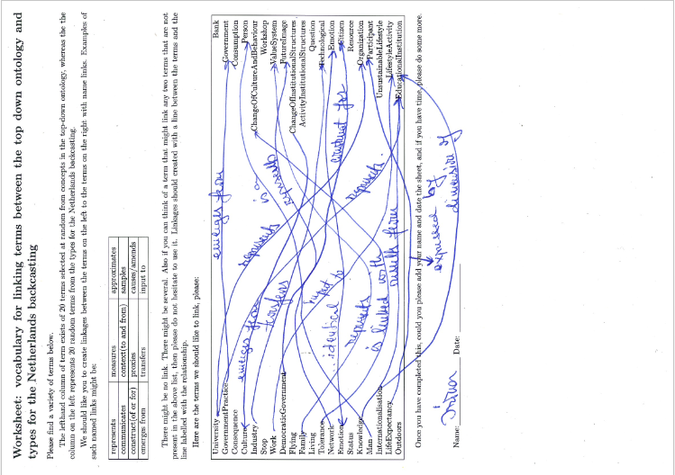

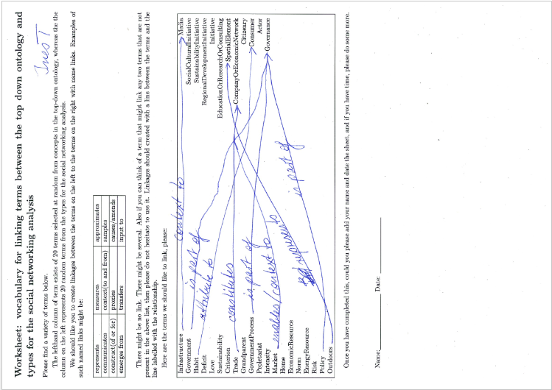

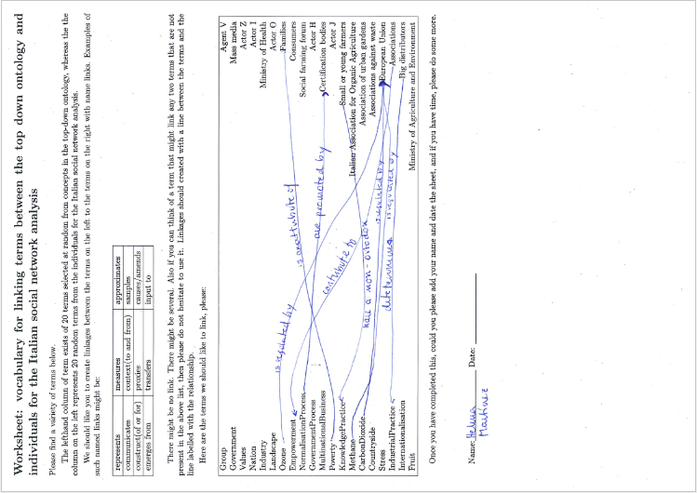

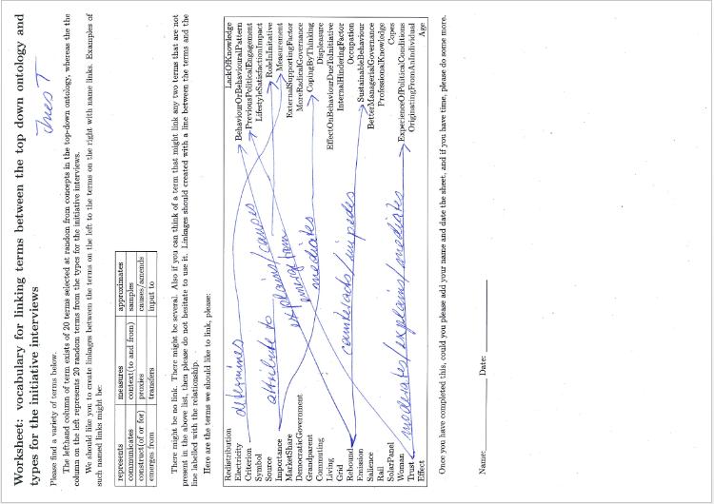

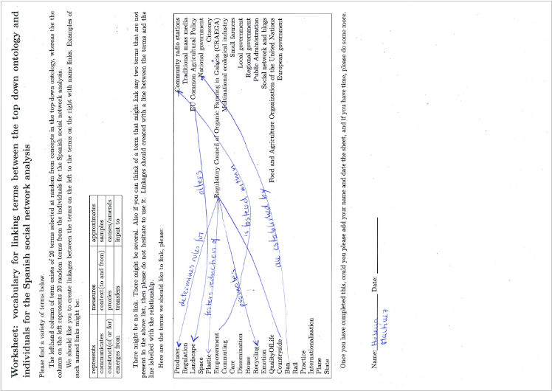

# Manual page for create_glamurs_ontology.pl

Name: create_glamurs_ontology.pl

A program to take a bunch of files and create an ontology from the lot

of them. It does using the import statement. In the process of doing so,

it will determine whether the entity is a top or bottom ontology and

create links between individuals based on the co-domain and range

relationships between the parent classes and object properties. This is

done in order to provide conditions on individuals as to what kind of

ontology they originated in. This is needed for consistent reasoning, so

the original domain of the instantiated term can be derived.

In addition any files in the --process-file parameter, and there may be

multiple instance can be processed to derive linkages between the

corresponding instantiated individuals included in this file. In general

if a file is to processed in this manner, then it is normally, but not

necessarily present as a parameter in --library.

Ontologies must be in the OWL functional format.

Author: Doug Salt

Date: November 2016

Version: 0.1

Parameters

-l | --library

This takes a pathname as a parameter. This may take multiple

arguments. This file is inserted into the resultant output ontology

verbatim. This can be useful for abstracting parts of the ontology

into logical or functionally similar units.

-o | --output-to

This takes a pathname as a parameter. This is the output file for

the resultant ontology. If this is not specified then the ontology

is printed to STDOUT.

-p | --process-files

This takes a pathname as a parameter. This may take multiple

arguments. These are sets of ontology statements that need

processing in some way. At the moment the only processing available

is to analyse sigma-represents and extract the domains and ranges of

these relations and automatically create an assertion between

mirrored instances of ontological concepts. These mirrored concepts

having been produced by the script:

create_terminology_ontolgy_wrapper.pl.

-n | --ontology-name

This is the namespace of the ontology. In our standards this is

normally filename of the ontology as well.

-D | --verbose

Print out verbose debug messages.

-H | --help

Print this document and exit.

-V | --version

Print version and exit.

There are also positional parameters consisting of a series of

pathnames. These pathnames represent the ontologies that are the

components of the ontology produced by this script. In order to include

these in the ontology as components, then all that is needed is to use

the OWL 2 ontology import statement of the IRI of the ontology in

question. In addition to, for easy reference when the resultant ontology

is analysed through some user friendly program like Protege then the

namespace of these ontologies are also created. This namespace is based

on the last unit of the IRI.

For example if we process the ontology example.owl with name space

"http://www.somewhere.com/ontologies/newone" then "newone" will be used

for the namespace for this component ontology.

Author

Doug Salt

# Manual page for create_terminology_ontology_wrapper.pl

Name: create_terminology_ontology_wrapper.pl

This program reads through an input ontology and finds each OWL 2

ontological entity. These being: class, data type object, property

object or individual.

Ontologies must be in the OWL functional format.

Each ontological entity is instantiated as an individual and then an

assertion is made as to the kind of entity it is, where an entity is one

of the primary divisions in an OWL ontology. That it is, it might be one

of a class, object property or data property, the assertion pointing at

actual instances that represent these.

Metadata is created between going in both directions between the

original ontological entity and the instantiated individual.

Author: Doug Salt

Date: November 2016

Version: 0.1

Parameters

-i | --import-ontology

This is to include any additional ontology in with the resultant

ontology. Any filename here will be read and the IRI of the ontology

extracted, and the namespace of the ontology imported and included

as a name space in the resultant ontology from running this script.

By least significant part of the IRI we can illustrate by example if

the ontology newone.owl has an IRI

http://ontologies.com/some/newone, then the least significant part

of the IRI is newone and this, by default will be used as the

imported ontologies namespace.

-s | --import-ontology-short-name

This can replace the imported ontologies default namespace with the

value supplied here.

-o | --output-to

This takes a pathname as a parameter. This is the output file for

the resultant ontology. If this is not specified then the ontology

is printed to STDOUT.

-n | --ontology-short-name

This is the namespace substituted for the input name space of the

ontology to be mirrored.

For example if we process the ontology example.owl with name space

"http://www.somewhere.com/ontologies/oldone" then instead of

"mirror-oldone", "mirror-newone" will be used for the namespace for

the resultant ontology, if "newone" is supplied in this parameter.

-T | --top-down-ontology

This is a flag and indicates that a top-down ontology is being

processed. This is a check and will cause the program to die, if the

analysis of the input ontology disagrees with this flag.

-D | --verbose

Print out verbose debug messages.

-H | --help

Print this document and exit.

-V | --version

Print version and exit.

This also takes one positional parameter - the pathname of the ontology

to be mirrored.

Author

Doug Salt

1. Although this is dependent upon the reasoner employed when evaluating the eventual ontology.